Teaching Case Template

Authors: Dr. Joseph Litner; Dr. Hillary Harper Reviewer: Sharon Griswold, MD MPH

Case Title: Endocarditis

Target Audience: medical students and residents

Primary Learning Objectives: key learning objectives of the scenario

1. Recognize the stigmata of endocarditis on physical examination
2. Order the appropriate diagnostic tests to evaluate for endocarditis
3. Appropriately treat and disposition the patient presenting with endocarditis

Secondary Learning Objectives: detailed technical goals, behavioral goals, didactic points

1. Apply the Modified Duke criteria to make a diagnosis of endocarditis
2. Interpret echocardiographic findings of valvular vegetation
3. Interpret chest radiography findings of pulmonary emboli suggestive of tricuspid
disease

Critical Actions Checklist
- Place patient on cardiac monitor with pulse oximetry
- Obtain bedside ECG
- Recognize endocarditis and initiate appropriate consultation with infectious disease; ICU
- Administer antibiotic therapy
- Recognize involvement of the right side of heart and request TEE
- Perform adequate fluid resuscitation, 2-3L
- Demonstrate / utilize effective communication techniques such as specifying order details and closed loop communication

Environment (if using as a simulation case)
- Room Set Up – ED room; monitored bay
  - Props – ECG; CXR; physical exam pictures included; TEE image
- Distractors – none

For Examiner Only

Author: Dr. Joseph Litner, Dr. Hillary Harper Reviewer: Sharon Griswold, MD MPH

Case Title: Bacterial Endocarditis

CASE SUMMARY

CORE CONTENT AREA

Cardiovascular

SYNOPSIS OF HISTORY/ Scenario Background

A 40 year old male with history of intravenous drug use is brought in by EMS complaining of aches and pains, fever and shortness of breath that has been getting worse over the past 2 days.

Past medical history: none
Medications: none scheduled
Allergies: Penicillin
Social history: Habits- tobacco; alcohol; IV drug use

SYNOPSIS OF PHYSICAL

Vital Signs: Temp 39.9 º C (103.8 º F) oral
BP 100/80
Pulse 120
Respiratory Rate 28
Pulse Oximetry 93% on room air

Physical Examination:
Pertinent Positives: CV- Tachycardic and a systolic murmur is present
Pulmonary- Diffuse rales
Extremities- Splinter hemorrhages seen in nails; Osler nodes (tender
subcutaneous nodules seen on the finger pads)
Janeway lesions (non-tender macular lesions on palms and
soles)

For Examiner Only

CRITICAL ACTIONS
Scenario branch points/ PLAY OF CASE GUIDELINES

Key teaching points or branch points that result in changes in patient’s condition

- Critical Action

Administer Oxygen

Cueing Guideline: Patient repeats that they feel short of breath.

- Critical Action

Thorough physical examination looking for stigmata of bacterial endocarditis such as the heart murmur; splinter hemorrhages; Osler’s nodes and Janeway lesions.

Cueing Guideline: Patient complains of pain on fingertips.

- Critical Action

Order appropriate labs- blood cultures (at least 2 sets); ESR and CRP and appropriate diagnostic tests- CXR, EKG, TEE

Cueing Guideline: Question of how to evaluate the heart murmur.

- Critical Action

Interpret labs; and interpret the tricuspid valve vegetation on TEE image and signs of septic emboli on CXR

Cueing Guideline: Reminder to the IVDU and which side of the heart would be more likely affected.

- Critical Action

Give antibiotics to cover staph and strep species.

Cueing Guideline: Ask what the most likely etiologic organisms are; allow ID consult.

For Examiner Only

HISTORY

Onset of Symptoms: Over the past 2 days the patient has complained of chills and feeling
warm and now has increasing trouble catching his breath.

Background Info: A 40 year old male with history of intravenous drug use is brought in by EMS complaining of aches and pains, fever and shortness of breath that has been getting worse over the past 2 days.

Chief Complaint: “I have felt chills then felt hot and had trouble breathing”

Past Medical Hx: None

Past Surgical Hx: None

Habits: Smoking: up to one pack of cigarettes/day if can get them
ETOH: several cans of beer on most days
Drugs: Intravenous drug use of heroin

Family Medical Hx: Unknown

Social Hx: Marital Status: Divorced
Children: none
Education: high school
Employment: works occasionally in construction

ROS: List pertinent positives and negatives:
GEN- Positive for chills alternating with feeling warm
HEENT- Neck stiffness and mild headache; no visual changes
CV- No chest pain or palpitations
Pulm- Shortness of breath; trouble catching breath
MSK- generalized aches
Neuro- no weakness; no dizziness
Derm- tender spots on tips of fingers

For Examiner Only

PHYSICAL EXAM

Patient Name: Mr. Jones Age & Sex: 40 y/o Male

General Appearance: Thin, disheveled male who appears uncomfortable but in no acute
distress

Vital Signs: Temp 39.9 º C (103.8 º F) oral
BP 100/80
Pulse 120
Respiratory Rate 28
Pulse Oximetry 93% on room air

Head: Normocephalic; Atraumatic

Eyes: PERRL; EOMI; anicteric

Ears: Tympanic membranes unremarkable

Mouth: Poor dentition but no sign of intra-oral abscess; mucous membranes moist

Neck: No LAD; no JVD seen; no carotid bruits; supple; no menigismus

Skin: Visible bruising and marks along arms from needle insertions

Chest: No crepitis; non tender to palpation

Lungs: Diffuse rales

Heart: Tachycardic rate; holosystolic murmur heard across precordium

Back: No midline ttp; no costovertebral angle tenderness to palpation

Abdomen: Normoactive bowel sounds; soft, non distended, non tender, no organomegaly

Extremities: Finger tips have tender subcutaneous nodules on finger pads; Nails with small splinter hemorrhages; Soles of feet and palms of hands with non tender erythematous macular lesions

Rectal: Normal tone; no gross blood

GU: No perineal lesions; normal

Neurological: Alert and oriented to person, place, time and date; CN 2-12 intact; Motor Strength 5/5 in UE and LE symmetrically; Reflexes 2+; Sensory- intact

Mental Status: Alert and oriented to person, place, time and date
For Examiner Only

STIMULUS INVENTORY

#1 Emergency Admitting Form

#2 CBC

#3 BMP

#4 U/A

#5 Cardiac Enzymes

#6 Toxicology

#7 CXR

#8 CT Head

#9 Ultrasound images or video clips

#10 Photos, videos or sound clips of patient’s presentation

#11 Debriefing materials

Learner Stimulus #1

ABEM General Hospital

Emergency Admitting Form

Name: Mr. Jones
Age: 40 years
Sex: Male
Method of Transportation: EMS
Person giving information: Patient
Presenting complaint: joint aches, fever, and difficulty breathing

Background: A 40 year old male with history of intravenous drug use is brought in by EMS complaining of aches and pains, fever and shortness of breath that has been getting worse over the past 2 days.

Triage or Initial Vital Signs
Temp 39.9 º C (103.8 º F) oral
BP 100/80
Pulse 120
Respiratory Rate 28
Pulse Oximetry 93% on room air

For Examiner Only

LAB DATA & IMAGING RESULTS

Stimulus #2
Complete Blood Count (CBC)
WBC 17,000/mm³
Hgb 10 g/dL
Hct 37%
Platelets 329,000/mm³
Differential
Neutrophil 13.9% Stimulus #5
Lymphs 2.1% Cardiac
Monos 0.9% Troponin 0.012 ng/ml
Eos 0.0%
Stimulus #6
Stimulus #3 Toxicology
Basic Metabolic Profile (BMP) Serum
Na⁺ 139 mEq/L Salicylate Neg
K⁺ 3.6 mEq/L Acetaminophen Neg
CO₂ 24 mEq/L Tricyclics Neg
Cl⁻ 105 mEq/L ETOH 70 mg/dl
Glucose 100 mg/dL
BUN 18 mg/dL Urine
Creatinine 1.0 mg/dL Cocaine Neg
Cannabinoids Neg PCP Neg
Stimulus #4 Amphetamines Neg
Urinalysis Opiates Pos
Color yellow Barbiturates Neg
Sp gravity 1.010 Benzodiazepines Neg
Glucose neg
Protein neg
Ketone neg
Leuk. Est. neg
Nitrite neg
WBC 0-1
RBC 0-1

Stimulus #7

EKG- Sinus tachycardia

Diagnostic Imaging
Stimulus #8
CXR: Multiple areas of round or wedge-shaped multiple peripheral opacities with poorly defined margins
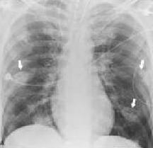

http://06-2010-icuroom.blogspot.com/
Stimulus #9
Head CT: Negative

Stimulus #10
TEE: Visible vegetation on tricuspid valve

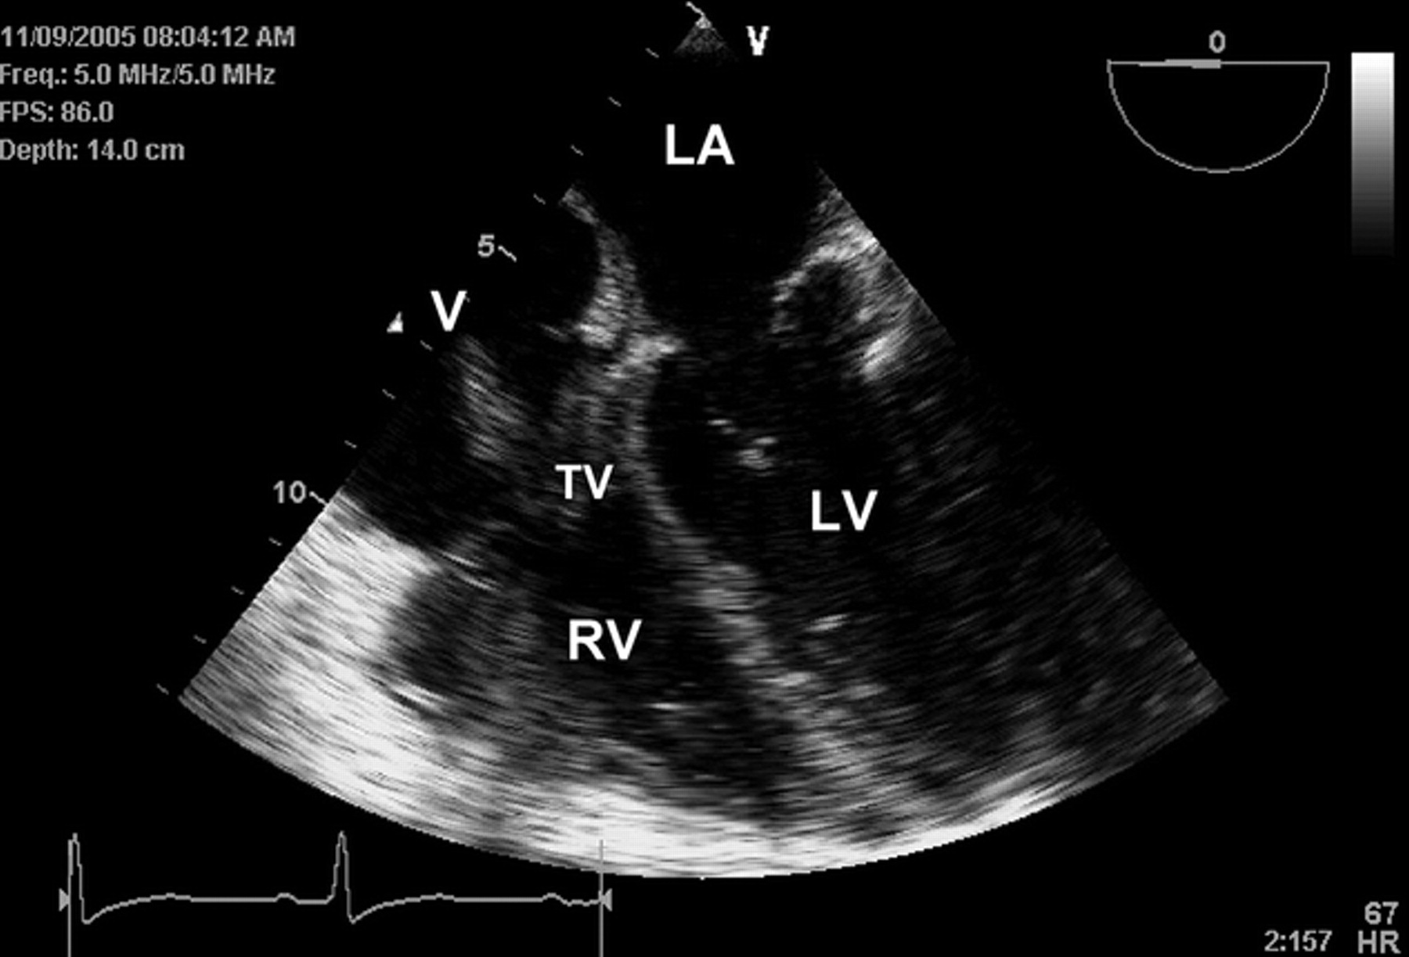

Source: Skubas N et al. Anesth Analg 2006;103:1410-1411

Feedback/ Assessment Forms

Bacterial Endocarditis

Candidate ________________________ Examiner _________________________

Critical Actions:

- Critical Action #1: Must address the abnormal vital sign on pulse oximetry prior to second cue.
- Critical Action #2: Must uncover at least one of the physical stigmata of endocarditis on exam for partial credit, and all for full point value.
- Critical Action #3: Must include at least 2 sets of blood cultures in lab testing for full credit.
- Critical Action #4: Must interpret the vegetation on tricuspid valve.
- Critical Action #5: Must include Vancomycin in antibiotic coverage.

Dangerous Actions: (Performance of one dangerous action results in failure of the case)

- Dangerous Action #1: Failure to address hypoxia.
- Dangerous Action #2: Failure to consider endocarditis in the differential.
- Dangerous Action #3: Failure to include appropriate antibiotic coverage.

Overall Score:

- Pass
- Fail

Optional Addendum 2:
Core Competency Assessment

Case Name Here

Candidate ________________________ Examiner _________________________

 | Does Not Meet Expectations | Meets Expectations | Exceeds Expectations
Patient Care
Medical Knowledge
Interpersonal Skills and Communication
Professionalism
Practice-based Learning and Improvement
Systems-based
Practice

For Examiner

Date: Examiner: Examinee(s):
Scoring: In accordance with the Standardized Direct Observational Tool (SDOT)

The learner should be scored (based on level of training) for each item above with one of the following:
NI = Needs Improvement
ME = Meets Expectations
AE = Above Expectations
NA= Not Assessed

Critical Actions | NI | ME | AE | NA | Category
Place patient on cardiac monitor with pulse oximetry |  |  |  |  | PC, MK, PBL
Obtain bedside ECG |  |  |  |  | PC, MK
Recognize endocarditis and initiate appropriate consultation with infectious disease; ICU |  |  |  |  | PC, MK, PBL
Administer antibiotic therapy |  |  |  |  | PC, MK, PBL
Recognize involvement of the right side of heart and request TEE |  |  |  |  | PC, MK, PBL
Perform adequate fluid resuscitation, 2-3 L |  |  |  |  | PC, MK, PBL
Demonstrate / utilize effective communication techniques such as specifying order details and closed loop communication |  |  |  |  | MK, ICS

The score sheet may be used for a variety of learners. For example, in using the case for 4th year medical students, the key teaching points of the case may be the recognition of shock and treatment with appropriate fluid resuscitation. Other items may be marked N/A= not assessed.

Category: One or more of the ACGME Core Competencies as defined in the SDOT

PC= Patient Care
Compassionate, appropriate, and effective for the treatment of health problems and the promotion of health
MK= Medical Knowledge
Residents are expected to formulate an appropriate differential diagnosis with special attention to life-threatening conditions, demonstrate the ability to utilize available medical resources effectively, and apply this knowledge to clinical decision making
PBL= Practice Based Learning & Improvement
Involves investigation and evaluation of their own patient care, appraisal and assimilation of scientific evidence, and improvements in patient care
ICS= Interpersonal Communication Skills
Results in effective information exchange and teaming with patients, their families, and other health professionals
P= Professionalism
Manifested through a commitment to carrying out professional responsibilities, adherence to ethical principles, and sensitivity to a diverse patient population
SBP= Systems Based Practice
Manifested by actions that demonstrate an awareness of and responsiveness to the larger context and system of health care and the ability to effectively call on system resources to provide care that is of optimal value

Debriefing Materials:

Please see attached powerpoint.

Add 4-6 keywords for future searching functions

Endocarditis; fever and heart murmur; IV/intervenous drug use

References

See Power Point

Has this work been previously published?
No

