Authors: Debra Heitmann, MD; Barbara Walsh, MD Reviewer: Sharon Griswold, MD MPH

Case Title: Endocarditis in an IV Drug User

Target Audience: Medical students and residents

Primary Learning Objectives:
1. Identify the signs and symptoms of infective endocarditis (IE)
2. Understand the management of suspected endocarditis
3. Recognition and management of respiratory failure
4. Recognition and initiate management of septic shock

Secondary Learning Objectives:
1. Realize the importance of a detailed social history in certain cases
2. Learn about infective endocarditis, its types, pathophysiology and treatment
3. Learn about the criteria used to diagnosis suspected IE and confirmed IE
4. Understand the complications of infective endocarditis

Critical actions checklist
    - Recognition of hypoxia (give O2 via NRB mask)
    - Implementation of AMS protocol (FSBG, naloxone, dextrose, thiamine)
    - Recognition and Management of respiratory failure (RSI, intubation)
    - Recognition, evaluation and management of endocarditis (ddx, testing and treatment)
    - Recognition and management of sepsis (specific testing, pressors, treatment)

Environment (if using as a simulation case)
- Room set up –ED examination room
a. Manikin set up
High Fidelity Simulator e.g. SimMan
Street Clothes shielding elbows
At start, no IVs, O2, monitor connected
VS - BP 90/52; HR 120; RR 24, T39.4 C; Pulse Ox 94%
Heart- Systolic murmur
Moulage - track marks on arms/hands,
Splinter hemorrhages on fingernails
Janeway lesion, few petechiae on extremities
Wet skin (diaphoresis)
- Props- Monitor with cardiac leads, POx,
Airway/Code Cart with full airway support/ACLS drugs, Oxygen,
IV angiocaths X 2, IV setup/NS
ECG, PCXR, defibrillator
Optional - Junk box containing insulin syringes (no needles)/stash in patient’s shirt pocket.

Actors (optional)
- Roles – Patient, nurse, assistants, consultant
- Who may play roles: Medical students, residents, nurses
a. Patient – He/she will be the voice of the simulator and provide the
HPI. The actor will act stuporous and try to withhold the history of
IVDU.
b. Nurse – Staff member who will facilitate getting labs, ECG, starting fluids etc. This person can help facilitate case progression with prompting.
c. Assistant - staff member to aid tasks/procedures.
d. Consultant – Cardiology specialist can be contacted on phone or in person. Main role is to obtain a verbal presentation of the case and prompt clinical questions to the participant.

For Examiner Only

Author: Debra Heitmann, MD and Barbara Walsh, MD
Reviewer: Sharon Griswold, MD MPH

Case Title: Endocarditis in an IV drug user

CASE SUMMARY

CORE CONTENT AREA

Infectious Disease
Cardiology

SYNOPSIS OF HISTORY/ Scenario Background
Chief Complaint: 19 year old male presents to the ED with shortness of breath and fever for several days. Symptoms have been slowly progressing. General malaise and fatigue. With further prompting patient reports he is an IV Drug User.

PMH: Depression, HIV negative, Hepatitis C positive
Meds: None, NKDA
Family/ Social History: Smokes, drinks, and does IVD heroin on a regular basis.
Depression and alcoholism in family

SYNOPSIS OF PHYSICAL
Initial scenario conditions: Vital signs, initial physical examination, any pertinent patient physiology.

Vital Signs: BP 90/52 HR 120 RR 24 T39.4 C POx 94%
PE: Pale, diaphoretic, tired and ill appearing,
AO X 2, narcotized affect
Lungs Diminished breath sounds bilaterally, fine rales scattered throughout, no retractions
Heart S1, S1, tachycardia, and II/VI SEM, no S3, no S4, no rub
Abdomen Diminished bowel sounds, nondistended, nontender
Skin Punctuate scars on bilateral arms, janeway spots and nailbeds with splinter hemorrhages, scant petechiae on extremities, and multiple tattoos (all aged)
Extremities 1+ pulses, cold

For Examiner Only

CRITICAL ACTIONS
Scenario branch points/ PLAY OF CASE GUIDELINES

Scenario Branch Points

1. Recognition of altered mental status and ill appearance

Details: Primary survey should take place. Patient placed on monitor. IV access should
be obtained and FSBG requested (135).

If AMS cocktail administered (Naloxone 0.2- 0.4mg IV, Dextrose (D50) if FSBG not checked, thiamine), patient becomes slightly more alert, AOx3, POx 95%

If no cocktail administered, patient becomes slightly less arousable.

Cueing Guideline: If no action taken, nurse can prompt "Doc, she is awfully sleepy and kind of confused, why do you think that is? Is there anything we can give her?”

2. Basic circulatory management (IV access, fluids)

Details: IV access should be obtained and 1-2 liters NS given.

If done promptly, VS HR 100 BP 100/40 POx 92%

If delayed or omitted VS HR 135 BP 80/40 POx 90%

Cueing Guideline: Nurse can prompt "Doc, his BP is 80/40, is there anything you would like to do about it?"

3. Recognition of impending respiratory failure
Management of respiratory failure (RSI, intubation)

Details: Despite initial resuscitative measures, patient continues to be more short of breath, becomes hypoxic, hypotensive and confused. More fluids accelerate the degree of respiratory failure.

Settings: VS HR 130 BP 100/50 POx 86% Lungs - Rhonchi, rales

Actions include - Oxygen supplementation, airway assessment, RSI/ETT, post ETT assessment, OGT
If done promptly: VS HR 100 BP 100/50 POx 97%
If delayed: POx decreases to 76% and pt becomes unresponsive
If no BVM or ETT unsuccessful: pt will rapidly desaturate to 50’s
If no further intervention: the pt will have an asystolic arrest

Cueing Guideline: Nurse can prompt, "Doc, his sat is down to 86% and he is still hypotensive. What do you want me to do?"

4. Recognition, evaluation and management of endocarditis (ddx, testing and treatment)

Details: Synthesize data of tachycardia, fever, hypotension, shortness of breath, with physical exam findings of track marks and the history of IVDA. High white count and new murmur with the current physical exam findings should suggest the picture of infective endocarditis. Patient needs target specific treatment.

Actions include: Administration of broad spectrum IV antibiotics, blood cultures x 3,
ESR and CRP for inflammatory markers, TTE/TEE to look at the heart, ID and CARDS consult.

If no antibiotics or infectious focused testing, no change in status but participant may fail case.

Cueing Guideline: Nurse can prompt, “Doc do you want any specific blood tests or cultures while I am sticking the patient? Are there any other tests you need me to call for? Are there any consultants that I should notify while the patient is in the ED?”

5. Recognition, evaluation and management of septic shock (pressors, treatment)

Details: Learner needs to deduce from the information provided that this patient is febrile, tachycardic with a new murmur, hypotensive, and hypoxic with the likely diagnosis of septic shock versus other modes of shock.

Actions include: IVF NS Liter #3, IV pressors, additional labs - lactate, consider central line placement, Critical Care consult.

If pressors are administered then BP rises to 110/60 and HR is 100.

If no pressors than BP drops to 80/50; HR 130

If 4-5 Liters are administered, patient's respiratory status rapidly deteriorates.

Cueing Guideline: Nurse can prompt, “Doc do you want to give anything else for the blood pressure?”

SCORING GUIDELINES
(Critical Action No.)

Criterion standards of performance by level of learner
MS PGY
 |  | 1 | 2 | 3 | 4 |  | 1 | 2 | 3
Obtaining relevant social history |  | X | X | X | X |  | X | X | X
Recognition of altered mental status |  |  | X | X | X |  | X | X | X
Establishment of team with role assignment |  |  |  |  | X |  | X | X | X
Basic circulatory management (IV access, fluids) |  |  |  | X | X |  | X | X | X
Recognition of hypoxia (give O2 via NRB mask) |  |  |  | X | X |  | X | X | X
Implementation of AMS protocol (FSBG, naloxone, dextrose, thiamine) |  |  |  |  | X |  | X | X | X
Recognition of impending respiratory failure |  |  |  |  | X |  | X | X | X
Management of respiratory failure(RSI, intubation) |  |  |  |  |  |  | X | X | X
Recognition of infectious endocarditis |  |  |  | X | X |  | X | X | X
Evaluation and management of endocarditis(ddx, specific testing and treatment) |  |  |  |  |  |  | X | X | X
Recognition of septic shock |  |  |  | X | X |  | X | X | X
Evaluation and management of sepsis(specific testing, pressors, treatment) |  |  |  |  |  |  | X | X | X
Post resuscitation assessment(VS, rpt CXR, ABG) |  |  |  |  |  |  | X | X | X
Cardiology consultation |  |  |  |  | X |  | X | X | X
ID consultation |  |  |  |  | X |  | X | X | X
Provides informative communication with patient |  |  |  | X | X |  | X | X | X
Demonstrates effective communication with nurse/staff |  |  |  | X | X |  | X | X | X
Disposition to ICU |  |  |  | X | X |  | X | X | X

For Examiner Only

HISTORY

Onset of Symptoms: Malaise - 6 days
Fever - 4 days
Myalgia, fatigue - 4 days
Shortness of breath

Background Info: Patient is a 19 year old male presenting with general malaise and fatigue for several days, 4 days of fever and recent shortness of breath. Symptoms have been progressing. Patient is weak. Has a chronic cough with phlegm. No chest pain or syncope. Denies recent sick contacts of exposures. No travel. History of depression.

Chief Complaint: "I feel like crap and having fevers"

Past Medical Hx: Multiple episodes of cellulitis including 2 abscesses needing I/D
patient unable to provide more hx (unknown MRSA status)

Past Surgical Hx: Appendectomy
I/D Skin Abscesses X 2

Habits: Smoking: 1 ppd X5 years
ETOH: 2-3 beers per day
Drugs: IV heroin

Family Medical Hx:

Social Hx: Marital Status: Single
Children: One, lives with the mom
Education: High school incomplete
Employment: Tattoo parlor

ROS: List pertinent positives and negatives:
Constitutional: Fatigue and malaise with fevers and night sweats

HEENT: no issues
Neck: no issues
Lungs: cough with phlegm chronically, shortness of breath
CV: occasional palpitations, no chest pain or syncope
Abdominal no issues
Extremities achy all over
Neurologic no issues
Skin rash on feet, not itchy

For Examiner Only

PHYSICAL EXAM

Patient Name: Johnson Ladykilla Age & Sex: 19 year old male

General Appearance: Ill appearing, diaphoretic, narcotized affect with decreased mental
status but able to answer questions, AO X 2

Vital Signs: BP 90/52 HR 120 RR 24 T39.4 C POx 94%

Head: Normal Scalp

Eyes: Pupils 2 mm and reactive, conjunctiva mildly injected, no discharge

Ears: Normal

Mouth: Oropharynx clear, many dental caries,

Neck: Supple, mild JVD, no adenopathy, no stridor

Skin: Diaphoretic, two scars from former I&D on the legs, bilateral posterior thighs, many punctuate marks on bilateral arms and hands, purpuric rash on bilateral feet

Chest: Normal

Lungs: Decreased breath sounds at the bases with fine crackles.

Heart: Regular rate rhythm, tachycardic, S1, S2, with II/VI murmur at the left sternal border

Back: Normal

Abdomen: Soft, nontender, nondistended, no rebound or guarding

Extremities: No swelling or erythema of the joints though pain reported with range of motion

Rectal: Deferred

Pelvic: N/A

Neurological: Cranial nerves intact, strength 5/5, 2+ reflexes throughout,
Sensation 5/5 to light touch, unable to assess gait due to abnormal VS and drowsiness.

Mental Status: Awake O X 2 (person, place) arousable to verbal stimuli, answers questions appropriately.
For Examiner Only

STIMULUS INVENTORY
Suggested items as relevant to the case

#1 Emergency Admitting Form

#2 FSBG

#3 CBC

#4 BMP

#5 ESR, CRP

#6 U/A

#7 ABG pre intubation

#8 ABG post intubation

#9 Cardiac Enzymes

#10 Toxicology

#11 ECG

#12 CXR preintubation

#13 CXR post intubation

#14 Photos

For Examiner Only

LAB DATA & IMAGING RESULTS

Stimulus #2 Stimulus #7
Finger Stick Blood Glucose (FSBG) Arterial Blood Gas
135 pH 7.30
pCO₂ 34mm Hg
Stimulus #3 pO₂ 85mm Hg
Complete Blood Count (CBC) O₂ Sat 80%
WBC 27.5/mm³
Hgb 11.5g/dL
Hct 34.2% Stimulus # 8
Platelets 205/mm³ Arterial Blood Gas ^{post intubation}
Differential pH 7.35
Segs 90% pCO₂ 42mm Hg
Bands 5% pO₂ 250mm Hg
Lymphs 4% O₂ Sat 96%%
Monos 1%
Eos 0% Stimulus #9
Cardiac Enzymes
Stimulus #4 Troponin 0.02 ng/ml
Basic Metabolic Profile (BMP)
Na⁺ 136mEq/L Stimulus #10
K⁺ 4.2 mEq/L Toxicology
CO₂ 10 mEq/L Serum
Cl⁻ 103mEq/L Salicylate Neg
Glucose 140mg/dL Acetaminophen Neg
BUN 25mg/dL Tricyclics Neg
Creatinine 1.3mg/dL ETOH 120mg/dl
Urine
Amphetamines Neg
Cannabinoids POS
Stimulus #5 PCP Neg
ESR = 30 Opiates POS
CRP = 15 Barbiturates Neg
Benzodiazepines Neg
Stimulus #6 Cocaine Neg
Urinalysis (U/A)
Color yellow Stimulus #11
Sp gravity 1.028 ECG Tachycardia
Protein neg
Glucose neg Diagnostic Imaging
Nitrite neg Stimulus #12
Ketone neg CXR: B/L fluffy infiltrates
Leuk. Est. neg Large heart
WBC 0-1 Stimulus #13
RBC 10 CXR #2 (post ETT) ETT in good position
B/L fluffy infiltrates

Learner Stimulus #1

ABEM General Hospital

Emergency Admitting Form

Name: Johnson Ladykilla
Age: 19 years
Sex: Male
Method of Transportation: Private car
Person giving information: Patient
Presenting complaint: "I feel like crap and I am having fevers"

Background: Patient is a 19 year old male presenting with general malaise and fatigue for several days, 4 days of fever and recent shortness of breath. Symptoms have been progressing. Patient is weak. Has a chronic cough with phlegm. No chest pain or syncope. Denies recent sick contacts of exposures. No travel. History of depression.

Triage or Initial Vital Signs
BP: 90/52
P: 120
R: 24
T : 39.4 C PO

Learner Stimulus # 2

Finger Stick Blood Glucose = 135

Learner Stimulus #3

Complete Blood Count (CBC)

WBC 27.5/mm³
Hgb 11.5g/dL
Hct 34.2%
Platelets 105/mm³
Differential
Segs 90%
Bands 5%
Lymphs 4%
Monos 1%
Eos 0%

Learner Stimulus #4

Basic Metabolic Profile (BMP)

Na⁺ 136mEq/L
K⁺ 4.2 mEq/L
CO₂ 10 mEq/L
Cl⁻ 103mEq/L
Glucose 140mg/dL
BUN 25mg/dL
Creatinine 1.3mg/dL

Learner Stimulus #5

ESR = 30
CRP = 15

Learner Stimulus # 6

Urinalysis (U/A)
Color yellow
Sp gravity 1.028
Protein neg
Glucose neg
Nitrite neg
Ketone neg
Leuk. Est. neg
WBC 0-1
RBC 10

Learner Stimulus #7

Arterial Blood Gas
pH 7.30
pCO₂ 34mm Hg
pO₂ 85mm Hg
O₂ Sat 80%

Learner Stimulus # 8

Arterial Blood Gas ^{post intubation}
pH 7.35
pCO₂ 42mm Hg
pO₂ 250mm Hg
O₂ Sat 96%%

Learner Stimulus #9

Cardiac Enzymes

Troponin 0.02 ng/ml

Learner Stimulus #10

Toxicology
Serum
Salicylate Neg
Acetaminophen Neg
Tricyclics Neg
ETOH 120mg/dl

Urine
Cocaine Neg
Cannabinoids POS
PCP Neg
Amphetamines Neg
Opiates POS
Barbiturates Neg
Benzodiazepines Neg

Learner Stimulus #11

ECG

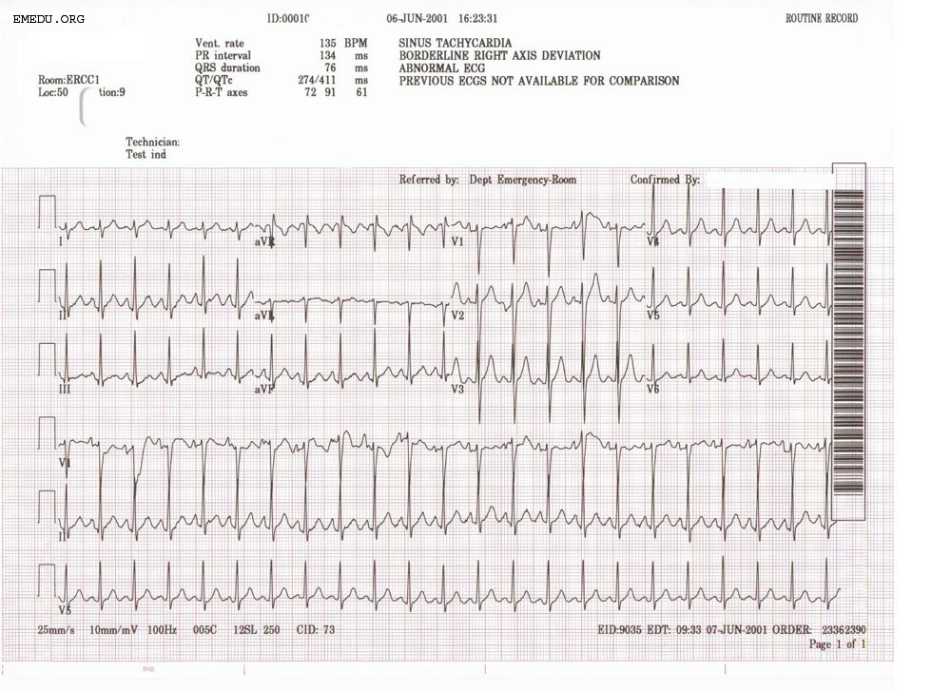

Learner Stimulus #12

CXR

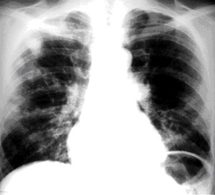

Learner Stimulus #13 Post intubation CXR

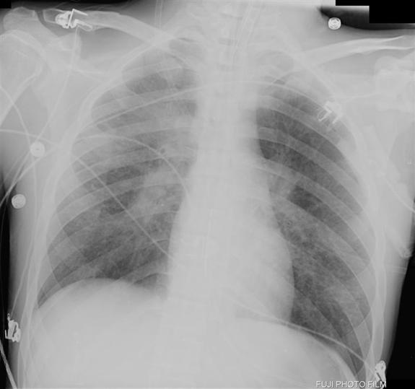

http://www.path.utah.edu/casepath/cv%20cases/CV%20Case%208%20comp.htm

Learner Stimuli #14

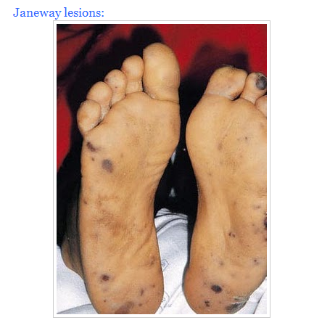

Optional Addendum 1

Feedback/ Assessment Forms (may choose form dependent on use of case)

Endocarditis in an IV drug user

Candidate ________________________ Examiner _________________________

Critical Actions
Obtain relevant social history
Recognition of altered mental status and ill appearance
Establish a team with role assignments
Recognition and treatment of hypoxia (give O2 via NRB mask)
Provides appropriate circulatory management (IV access, fluids)
Implementation of AMS protocol (FSBG, naloxone, dextrose, thiamine)
Recognition and treatment of impending respiratory failure
Management of respiratory failure(RSI, intubation)
Recognition of infectious endocarditis /possible sepsis
Evaluation and management of endocarditis (ddx, specific testing and treatment)
Recognition of septic shock
Evaluation and management of sepsis(specific testing, pressors, treatment)
Post resuscitation assessment(VS, rpt CXR, ABG)
Cardiology consultation
ID consultation
Provides informative communication with patient
Demonstrates effective communication with nurse/staff
Disposition to ICU

Dangerous Actions: (Performance of one dangerous action results in failure of the case)

- Dangerous Action #1
Failure to recognize and treat opiate induced respiratory distress (naloxone)
- Dangerous Action #2
Failure to manage respiratory failure (RSI, intubation)
- Dangerous Action #3
Evaluation and management of sepsis (specific testing, pressors, treatment)
Even if the dx of acute IE is missed, IV antibiotic and pressors must be initiated

Overall Score:
- Pass
- Fail
Optional Addendum 2:
Core Competency Assessment

Endocarditis in an IV drug user

Candidate ________________________ Examiner _________________________

 | Does Not Meet Expectations | Meets Expectations | Exceeds Expectations
Patient Care
Medical Knowledge
Interpersonal Skills and Communication
Professionalism
Practice-based Learning and Improvement
Systems-based
Practice

For Examiner
Endocarditis in an IV drug user
Date: Examiner: Examinee(s):

Scoring: In accordance with the Standardized Direct Observational Tool (SDOT)

The learner should be scored (based on level of training) for each item above with one of the following:
NI = Needs Improvement
ME = Meets Expectations
AE = Above Expectations
NA= Not Assessed

Critical Actions | NI | ME | AE | NA | Category
Obtaining relevant social history |  |  |  |  | PC, MK, ICS, P
Recognition of altered mental status ill appearance |  |  |  |  | PC, MK
Establishment of team with role assignment |  |  |  |  | PC, MK, PBL
Recognition of hypoxia (give O2 via NRB mask) |  |  |  |  | PC, MK, PBL
Basic circulatory management (IV access, fluids) |  |  |  |  | PC, MK, PBL
Implementation of AMS protocol (FSBG, naloxone, dextrose, thiamine) |  |  |  |  | PC, MK, PBL
Recognition of impending respiratory failure |  |  |  |  | PC, MK, PBL
Management of respiratory failure(RSI, intubation) |  |  |  |  | PC, MK, PBL
Recognition of infectious endocarditis  /possible sepsis |  |  |  |  | PC, MK, PBL
Evaluation and management of endocarditis(ddx, specific testing and treatment) |  |  |  |  | PC, MK, PBL
Recognition of septic shock |  |  |  |  | PC, MK, ICS, SBP, P
Evaluation and management of sepsis(specific testing, pressors, treatment) |  |  |  |  | PC, MK, ICS, SBP, P
Post resuscitation assessment(VS, rpt CXR, ABG) |  |  |  |  | PC, MK, ICS, SBP, P
Cardiology consultation |  |  |  |  | PC, MK, ICS, SBP, P
ID consultation |  |  |  |  | PC, MK, ICS, SBP, P
Provides informative communication with patient |  |  |  |  | PC, MK, ICS, SBP, P
Demonstrates effective communication with nurse/staff |  |  |  |  | PC, MK, ICS, SBP, P
Disposition to ICU |  |  |  |  | PC, MK, SBP

The score sheet may be used for a variety of learners. For example, in using the case for 4th year medical students, the key teaching points of the case may be the recognition of shock and treatment with appropriate fluid resuscitation. Other items may be marked N/A= not assessedCategory: One or more of the ACGME Core Competencies as defined in the SDOT

PC= Patient Care
Compassionate, appropriate, and effective for the treatment of health problems and the promotion of health
MK= Medical Knowledge
Residents are expected to formulate an appropriate differential diagnosis with special attention to life-threatening conditions, demonstrate the ability to utilize available medical resources effectively, and apply this knowledge to clinical decision making
PBL= Practice Based Learning & Improvement
Involves investigation and evaluation of their own patient care, appraisal and assimilation of scientific evidence, and improvements in patient care
ICS= Interpersonal Communication Skills
Results in effective information exchange and teaming with patients, their families, and other health professionals
P= Professionalism
Manifested through a commitment to carrying out professional responsibilities, adherence to ethical principles, and sensitivity to a diverse patient population
SBP= Systems Based Practice
Manifested by actions that demonstrate an awareness of and responsiveness to the larger context and system of health care and the ability to effectively call on system resources to provide care that is of optimal value

Debriefing Materials:

Infective Endocarditis (IE)
An infection of the endocardium which may involve the valves and extend to the myocardium of the heart. Risk factors include structural heart disease, prosthetic heart valves and intravenous drug use (IVDU). It is debated whether risk increased in patients following various surgical procedures of the gut, respiratory system or oral cavity. Clusters of vegetations can break off the heart valve, travel throughout the vascular system and occude vessels causing stroke or end organ damage.

Pathophysiology
- Almost always aerobic bacteria
- Left sided more common than right sided
- However, of right sided cases, most occur in IVDU (tricuspid valve)
- Bacteria: majority of cases are due to Staph and Strep
- The likelihood of systemic disease involving into IE varies according to the species of bacteria causing bacteremia. The most common organisms to cause IE:
Staphylococcus. aureus
Streptococci viridans
Strep bovis
Enterococci: E. faecalis much more likely than other enterococcal species
Group G Streptococcus much more likely than Groups A or C Strep
Diagnosis
- The diagnosis of IE is based on a thorough H/P, results of blood cultures, labs,
EKG, CXR and Echo.
- Debate exists on the criteria to dx; most accepted is the Duke Criteria. (see table 1)
- High suspicion of IE warrants early treatment until confirmed results are available.

Ancillary studies.
EKG Is often normal but if IE invades valve or septum, ischemia, ICVD or block may be present
IE complicated by heart failure may demonstrate ischemia

Laboratory Studies
Blood Cultures: minimum of three sets from three venipuncture sites
CBC f(Staph IE may demonstrate an elevated WBC and low PLTS)
ESR, CRP - May be elevated but is nonspecific to IE
Rheumatoid factor - Elevated value w/o hx of rheumatologic disease (minor Duke criteria)
UA - Most pts have hematuria, proteinuria and/or pyuria.
The presence of RBC casts may suggest glomerulonephritis (minor Duke criteria)

Debriefing Materials(cont'd):

Radiography
CXR The presence of multiple lung infiltrates suggest septic pulmonary emboli from tricuspid valve endocarditis.
ECHO
TTE - Relatively low sensitivity for vegetation; TEE should be considered.
However, normal valves(both function and morphology) reduces likelihood of IE.
(96% pts with nl valves/no vegetation on TTE has negative TEE)
TEE - More sensitive; may be preferred over TTE as first study in patients with prosthetic valves, technically difficult TTE e.g. obesity.

Treatment
The choice of antibiotics is based on the blood culture results. Initial empiric coverage is often includes Vancomycin until the bacteria is identified. The duration of therapy typically ranges from 4-6 weeks with complex IE and prosthetic valves receiving longer terms. Combination therapy has allowed reduction of the duration of therapy in some instances as short as two weeks. Combined intravenous and oral therapy has been successful in select patient populations.

For uncomplicated right sided IE, IV therapy for two weeks with semi-synthetic penicillinase-resistant beta lactam agent and an aminoglycoside has been successful. Numerous alternatives exist and small studies have explored use of oral therapy with mixed success.

Complications
Bacteremia/Sepsis Organisms travel through the blood stream and can cause micro-
abscesses in kidney, joints, muscle, brain, lungs, and liver
Cardiac
Heart failure – Is the most common cause of death and reason for surgery due to valvular insufficiency. If heart failure is refractory to medical management, surgical intervention with valve replacement may be required.
Peri-valvular abscess - IVDA is risk factor. Peri-valvular disease can extend into muscle leading to AVB.
Embolic Common;
Systemic - can result in arterial occlusion anywhere in body
Skin - Petechiae, Janeway lesions, splinter hemorrhages (see photo)
Pulmonary - associated with lung abscesses with tricuspid endocarditis (see photo)
Neurologic Stroke, chronic headaches
Musculoskeletal Muscle and joint microabscesses
Renal Abscesses, Glomerulonephritis

Table 1

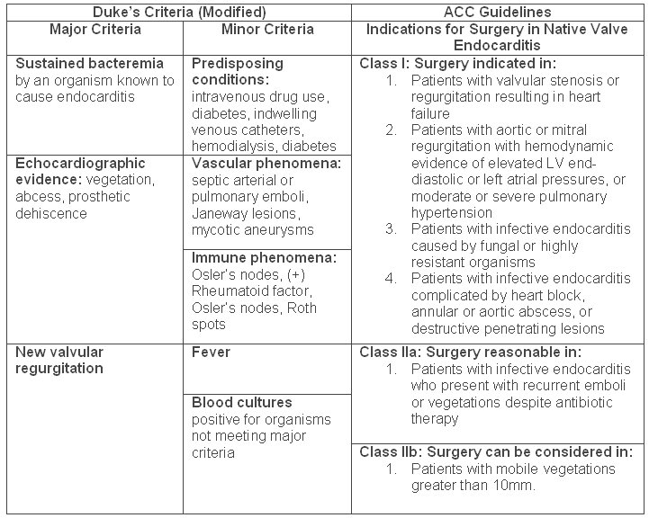
Retrieved from www.ispub.com/journal/the_internet_journal_of... | Remove frame

Copyright laws may apply. Published in: The Internet Journal of Infectious Disease

Retrieved from: cardiologylinks.webs.com/apps/photos/photo?ph...

CXR demonstrating multiple abscesses and cavitating lesions

Retrieved from: http://radiology.med.miami.edu/x10.xml

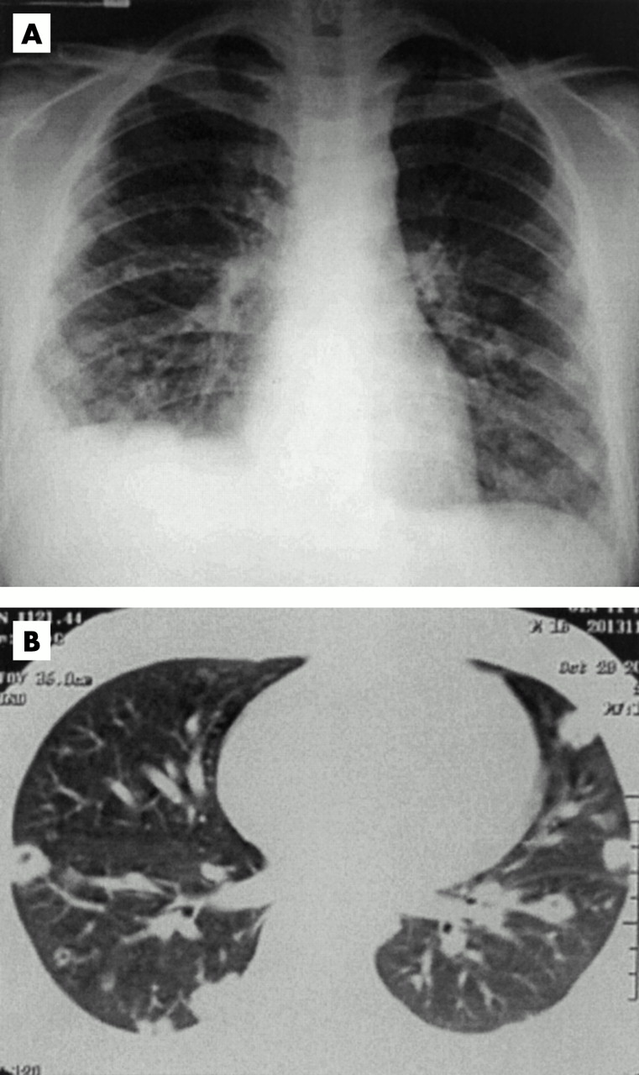

Retrieved from: http://imaging.consult.com/image/topic/dx/Pediatrics?title=Septic%20Pulmonary%20Emboli%20(Pediatric)&image=fig4&locator=gr4&pii=S1933-0332(07)70776-0

Gross pathology of subacute bacterial endocarditis involving mitral valve

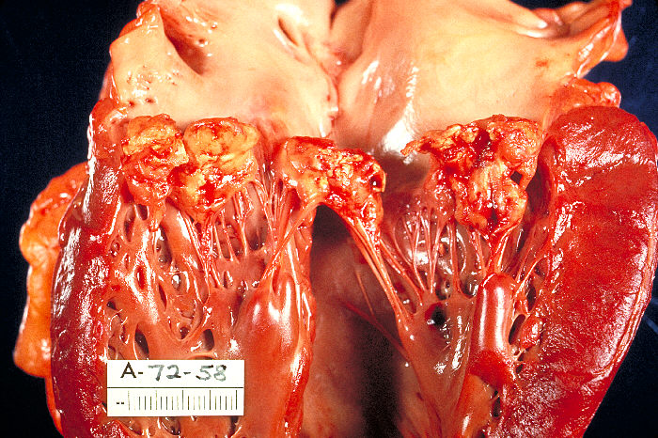

Retrieved from: http://phil.cdc.gov/phil/details.asp image no. 851

Add 4-6 keywords for future searching functions

Endocarditis, IV drug user, sepsis

References

Engemann, J & Sexton, DJ (2007, August, 17). Infective Endocarditis in Injection Drug Users.
retrieved November 7 2010, from UpToDate Web Site: http://wwwuptodate.com/online
Irani, WN, Grayburn, PA, Afridi, I. A negative transthoracic echocardiogram obviates the need
for transesophageal echocardiography in patients with suspected native valve
active infective endocarditis. Am J Cardiol 1996; 78:101.
Sexton, DJ (2010, May, 26). Diagnositc Approach to Infective Endocarditis. retrieved October 9
2010, from UpToDate Web Site: http://www.uptodate.com/online
Sexton, DJ (2009, November, 23). Epidemiology, Risk Factors and Microbiology of Infective
Endocarditis. retrieved November 6 2010, from UpToDate Web Site:
http://www.uptodate.com/online
Sexton, DJ (2009, July, 14). Antimicrobial Therapy of Native Valve Endocarditis. retrieved
November 7 2010, from UpToDate Web Site: http://www.uptodate.com/online
Spelman, D & Sexton, DJ (2010, May 3). Complications and Outcome of Infective Endocarditis .
retrieved November 6 2010, from UpToDate Web Site: http://wwwuptodate.com/online

Has this work been previously published?
Images and tables have been published previously. Please see citations/ references.

Photo Janeway lesions
Retrieved from: http:// cardiologylinks.webs.com/apps/photos/photo?ph...

Photo CXR
Retrieved from: http://radiology.med.miami.edu/x10.xml
http://www.path.utah.edu/casepath/cv%20cases/CV%20Case%208%20comp.htm

Photo CT
Retrieved from: http://imaging.consult.com/image/topic/dx/Pediatrics?title=Septic%20Pulmonary%20Emboli%20(Pediatric)&image=fig4&locator=gr4&pii=S1933-0332(07)70776-0

Photo pathology
Retrieved from: http://phil.cdc.gov/phil/details.asp image no. 851

Duke's Table Retrieved from: http://www.ispub.com/journal/the_internet_journal_of_infectious_diseases/volume_6_number_1_14/article/group_b_streptococcus_endocarditis_following_an_elective_abortion_a_case_report_and_review_of_literature.html

ECG
Retrieved from: http://www.emedu.org/ecg_lib/pages/STACH_15_jpg.htm

