Teaching Case: SVT Unresponsive to Adenosine

Author: Hans House, Kathryn Szajna Reviewer: Sharon Griswold

Case Title: SVT unresponsive to adenosine

Target Audience: med students, nurses, paramedics, and residents

Primary Learning Objectives: key learning objectives of the scenario
- Recognize supraventricular tachycardia (SVT) rhythm from ECG
- Demonstrate ability to apply treatment algorithm for SVT
3. Demonstrate ability to treat refractory SVT

Secondary Learning Objectives: detailed technical goals, behavioral goals, didactic points
- 1. Demonstrate understanding of the advantages and disadvantages of each therapy for SVT
- Identify potential reversible causes of SVT, caffeine, over the counter pseudoephedrine, adrenergic street drugs

- Demonstrate a supportive, caring attitude to the patient in distress
- Communicate clearly with health care team members

Critical actions checklist – a list to ensure the educational /assessment goals are met.
This may include:
- Place patient on cardiac monitor
- Order and interpret an ECG, recognizing rhythm as SVT
- Terminate the abnormal rhythm prior to disposition
- Provision of procedural sedation if cardioversion is used

Environment (if using as a simulation case)
- Room Set Up – Standard ED room with monitor
  - Manikin capable of generating heart rhythm. Set initial rhythm to SVT at 150 with sinus tachycardia at 80 as a waiting rhythm following one shock.
  - ECG of before and after cardioversion (provided with case) and normal chest x-ray.
- Distractors – consider addition of concerned family member (see actor below)

Actors (optional)
- For testing students and residents, actor may play role of nurse providing meds and may be portrayed by other learners
- For testing nurses and paramedics, actor may role of colleague providing meds and may be portrayed by other learners
- To assess Interpersonal Communication Skills with patients and family, consider adding actor to play concerned family member, who asks the code leader, “what’s going on? Is having a heart attack? Please help him!”

For Examiner Only

Author: Hans House, Kathryn Szajna Reviewer: Sharon Griswold

Case Title: SVT Unresponsive to Adenosine

CASE SUMMARY

CORE CONTENT AREA

Cardiovascular

SYNOPSIS OF HISTORY/ Scenario Background
.51 yo male complains of palpitations and chest discomfort. He has a history of a “fast heart rhythm”, had been taking metoprolol for it, but ran out of his medications and doesn’t have the money to buy more.

Medications: no meds except as above, NKDA
Social History: works at a fast food restaurant, smokes 15 cigarettes per day and drinks 5-6 beers per day.
Past Medical History: fast heart rhythm as above
Family History: noncontributory

SYNOPSIS OF PHYSICAL
Triage Vital signs: BP 128/80 | Pulse 161 | Temp(Src) 36.5 °C (97.7 °F) (Tympanic) | Resp 22 | Ht 1.905 m (6' 3") | Wt 83.915 kg (185 lb) | SpO2 100%

The patient is sitting on the edge of the gurney, appears slightly fatigued. He is a well developed, well nourished middle-aged African-American male. Physical examination is normal except for moist, slightly diaphoretic skin and a rapid, regular heartbeat heard by auscultation and felt on palpation of PMI and distal pulses.

For Examiner Only

CRITICAL ACTIONS
Scenario branch points/ PLAY OF CASE GUIDELINES

Key teaching points or branch points that result in changes in patient’s condition

- Critical Action

Place patient on cardiac monitor

Cueing Guideline: The nurse says, “His pulse at triage was pretty fast, do you want him on a monitor?”

- Critical Action

Order and interpret an ECG, recognizing rhythm as SVT

Cueing Guideline: The nurse says, “Wow, that’s fast. And I don’t see any p waves, do you think it’s A-fib or something else?”

- Critical Action

Terminate the abnormal rhythm prior to disposition

Cueing Guideline: The admitting consultant says, “I think it’s best if we terminate the rhythm there in the ED. Do you need some suggestions on medications to try?”

- Critical Action

Provision of procedural sedation if cardioversion is used

Cueing Guideline: The patient says, “Is this going to hurt? I think they knocked me out the last time they did this.”

SCORING GUIDELINES
(Critical Action No.)
1. Score down for not putting patient on monitor
2. Score down if learner interprets rhythm as ventricular tachycardia, atrial fibrillation, or sinus trachycardia. With the information provided, however, this would be hard to distinguish from atrial flutter.
3. If disposition is attempted before rhythm conversion, the patient begins to deteriorate, with a drop in blood pressure, the patient clutching his chest in pain, and (if still not adequately addressed) falls unconscious.
4. The patient screams in pain with the first shock and says, “Please don’t do that again! That hurts!” and score down.

Scenario branch points

- At presentation, patient is in SVT. A rapid heart rate is immediately apparent once the patient is placed on the monitor. It is difficult to tell if it is SVT vs. sinus tachardia, but it is narrow complex and regular
- The examinee may attempt vagal maneuvers first. The patient will tell them that he tried bearing down hard but it didn’t work. Attempting vagal maneuvers is appropriate but fruitless.
- The patient can given adenosine (rapid IV push) initially, neither 6mg nor 12mg has any noticeable effect on the heart rhythm. Both times however, the patient complains of a deep chest discomfort.
- The examinee has multiple options for termination of the dyshythmia:
  - Diltiazem (Cardizem) 25 mg slow IV: the patient will slow to 140 with the first dose, but the rhythm will terminate to normal sinus rhythm at 80 after the second dose (50 mg total). If the patient gives less than 25 mg with each dose, the rhythm will not terminate until a total of 50 mg has been given
  - Verapamil 5 mg – 10 mg slow IV: the patient will slow to 140 with the first dose, but the rhythm will terminate to normal sinus rhythm at 80 after the second dose (20 mg total). If the patient gives less than 10 mg with each dose, the rhythm will not terminate until a total of 20 mg has been given
  - Synchronized cardioversion: the rhythm responds to 50 J and one shock. The patient should be appropriately sedated with propofol, etomidate, methohexital, ketamine, etc. and given appropriate analgesia.
  - Intravenous beta-blockers could also be used at the examiner’s discretion, but should NOT be given in addition to the calcium channel blockers used above. The combination of IV beta-blockers and calcium channel blockers used together have additive reductions in heart rate, cardiac conduction, and reduction in cardiac contractility. Ventricular asystole, sinus arrest, and heart block have been reported.
- When the rhythm terminates, the patient is in NSR at 80
- Labs, when ordered, should include a TSH
- Once the patient is stabilized the patient can be admitted for further work up and possible ablation or discharged home after an appropriate observation period with plans to follow up for electrophysiology testing

For Examiner Only

HISTORY

Onset of Symptoms: Awoke with these symptoms one hour ago

Background Info: 51 yo with a history of a “fast heart rhythm”, had been taking a medication for it, but ran out and doesn’t have the money to buy more. Hasn’t taken any recent over the counter medications.

Chief Complaint: 51 year old male with chief complaint “my heart is racing”

Past Medical Hx: 1. Rapid heart rate
2. Depression and anxiety

Past Surgical Hx: Appendectomy, age 9, Left tib-fib fracture, age 34

Habits: Smoking: 15 cigarettes per day
ETOH: 5 to 6 beers per day
Drugs: denies cocaine and other illicit substances

Family Medical Hx: None

Social Hx: Marital Status: Single
Children: None
Education: High school only
Employment: Works in fast food restaurant

ROS: At present, the patient does complain of some sub-sternal chest discomfort that he rates as a 4/10, but denies any radiation. He complains that it feels difficult for him to catch his breath and feels slightly nauseated. He denies any associated symptoms including as fevers, recent illness, cough, headache, syncope, back pain, swelling, orthopnea, vomiting, or diarrhea

For Examiner Only

PHYSICAL EXAM

Patient Name: Matthew Black Age & Sex: 51 yo male

General Appearance: Well-developed, well-nourished male in mild distress

Vital Signs: BP 122/80 HR 161 RR 22 T 36.5

Head: NCAT

Eyes: Pupils 2 mm bilateral and reactive. No conjunctival injection.

Ears: No bulging or erythema of TMs.

Mouth: Mucous membranes moist.

Neck: Supple. Trachea midline. No JVD. No thyromegaly.

Skin: Warm, dry. No rashes.

Chest: No chest wall tenderness to palpation.

Lungs: Mild expiratory wheezing bilaterally. Decreased breath sounds bilateral bases.

Heart: Tachycardic but regular. No murmurs, rubs, gallops or extra sounds. No carotid or abdominal aortic bruits.

Back: Normal inspection. No CVA tenderness.

Abdomen: Soft, non-distended, non-tender. BS in all quadrants. No hepatosplenomegaly.

Extremities: No pedal edema. DP and PT full and equal bilaterally.

Rectal: Patient refuses

Neurological: No focal deficits. Moves all extremities without difficulty.

Mental Status: AOx3. No focal deficits

For Examiner Only

STIMULUS INVENTORY

#1 Emergency Admitting Form

#2 CBC

#3 BMP

#4 TSH

#5 Cardiac Enzymes

#6 Toxicology

#7 CXR

#8 ECG pre-treatment

#9 ECG post-treatment

For Examiner Only

LAB DATA & IMAGING RESULTS

Stimulus #2
Complete Blood Count (CBC)
WBC 9.2/mm³
Hgb 12.9g/dL
Hct 35%
Platelets 227/mm³
Differential
Segs 50% Stimulus #5
Bands 1 % Cardiac Enzymes
Lymphs 38% Troponin < 0.03 ng/ml
Monos 9 %
Eos 2 %
Stimulus #6
Stimulus #3 Toxicology
Basic Metabolic Profile (BMP) Serum
Na⁺ 138mEq/L Salicylate Neg
K⁺ 3,9mEq/L Acetaminophen Neg
CO₂ 23mEq/L Tricyclics Neg
Cl⁻ 106mEq/L ETOH <0.4 mg/dl
Glucose 97mg/dL
BUN 14mg/dL Urine
Creatinine 0.9mg/dL Cocaine Neg
Cannabinoids Neg PCP Neg
Stimulus #4 Amphetamines Neg
TSH 1.28 uUI/ml Opiates Neg
Barbiturates Neg
Benzodiazepines Neg

Diagnostic Imaging

Stimulus #7
CXR: Negative

Stimulus #8
ECG at presentation: SVT

Stimulus #9
ECG after treatment: NSR, with early repolarization and possible peaked t-waves

Learner Stimulus #1

ABEM General Hospital

Emergency Admitting Form

Name: Matthew Black
Age: 51 years
Sex: Male
Method of Transportation: Private car
Person giving information: Patient
Presenting complaint: “my heart is racing”

Background: 51 yo with a history of a “fast heart rhythm”, had been taking a medication for it, but ran out and doesn’t have the money to buy more.

Triage or Initial Vital Signs
BP: 122/80
P: 161
R: 22
T : 35.6

Learner Stimulus #2

Complete Blood Count (CBC)

WBC 9.2/mm³
Hgb 12.9g/dL
Hct 35%
Platelets 227/mm³
Differential
Segs 50 %
Bands 1 %
Lymphs 38 %
Monos 9 %
Eos 2 %

Learner Stimulus #3

Basic Metabolic Profile (BMP)

Na⁺ 138 mEq/L
K⁺ 3.9 mEq/L
CO₂ 23 mEq/L
Cl⁻ 106 mEq/L
Glucose 97 mg/dL
BUN 14 mg/dL
Creatinine 0.9 mg/dL
Learner Stimulus #4

TSH 1.28 uUI/ml

Learner Stimulus #5

Troponin < 0.03 ng/ml
Learner Stimulus #6

Serum Toxicology
Salicylate Neg
Acetaminophen Neg
Tricyclics Neg
ETOH <0.4 mg/dl

Urine Toxicology
Cocaine Neg
Cannabinoids Neg
PCP Neg
Amphetamines Neg
Opiates Neg
Barbiturates Neg
Benzodiazepines Neg

Learner Stimulus #7

CXR:
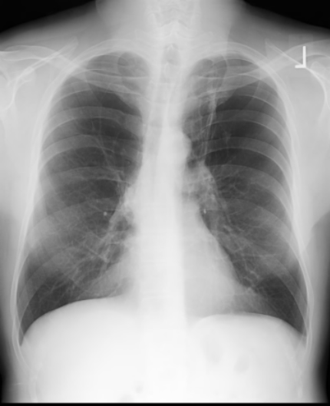

Learner Stimulus #8

ECG at presentation
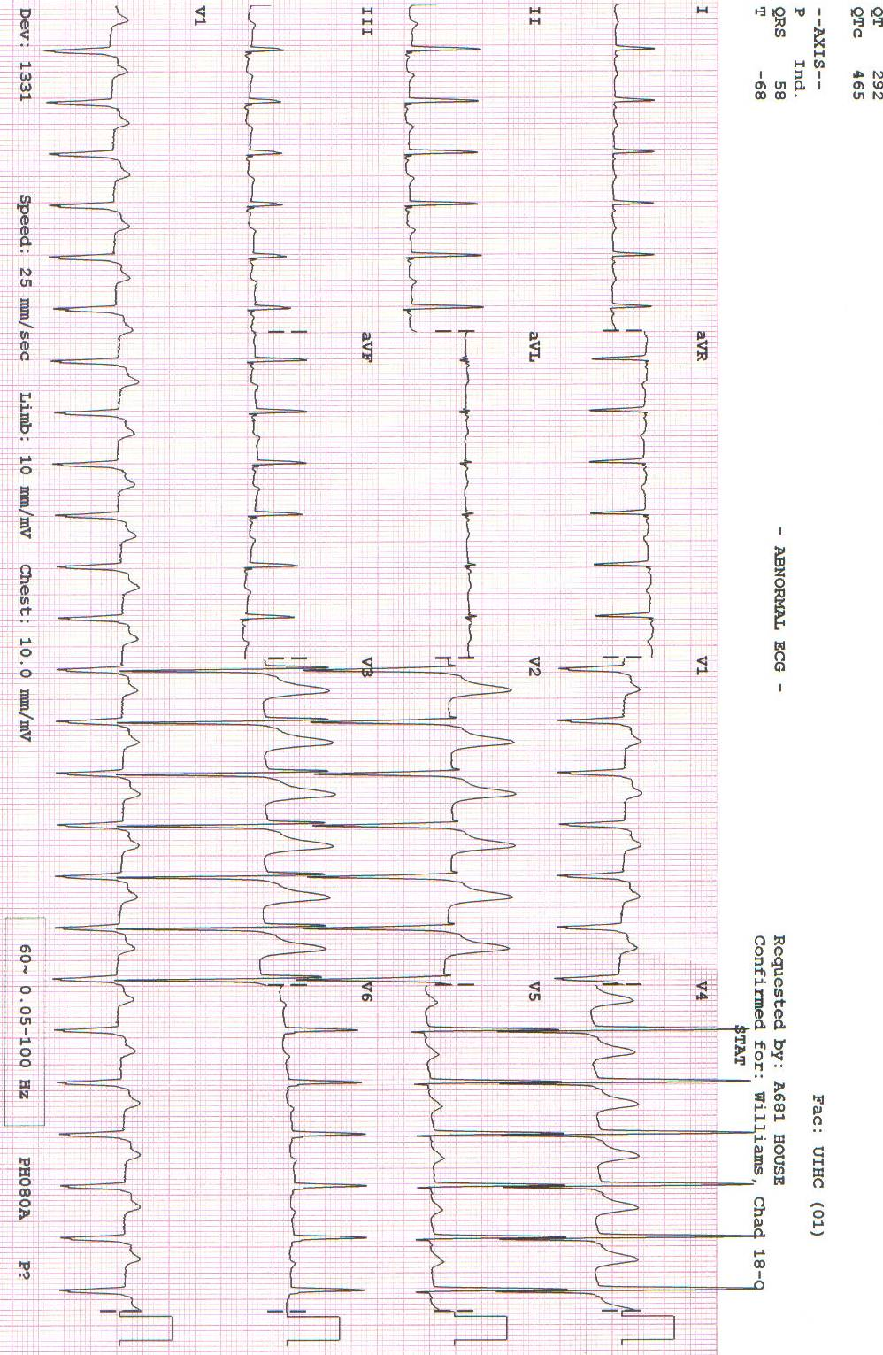
Learner Stimulus #9

ECG after treatment
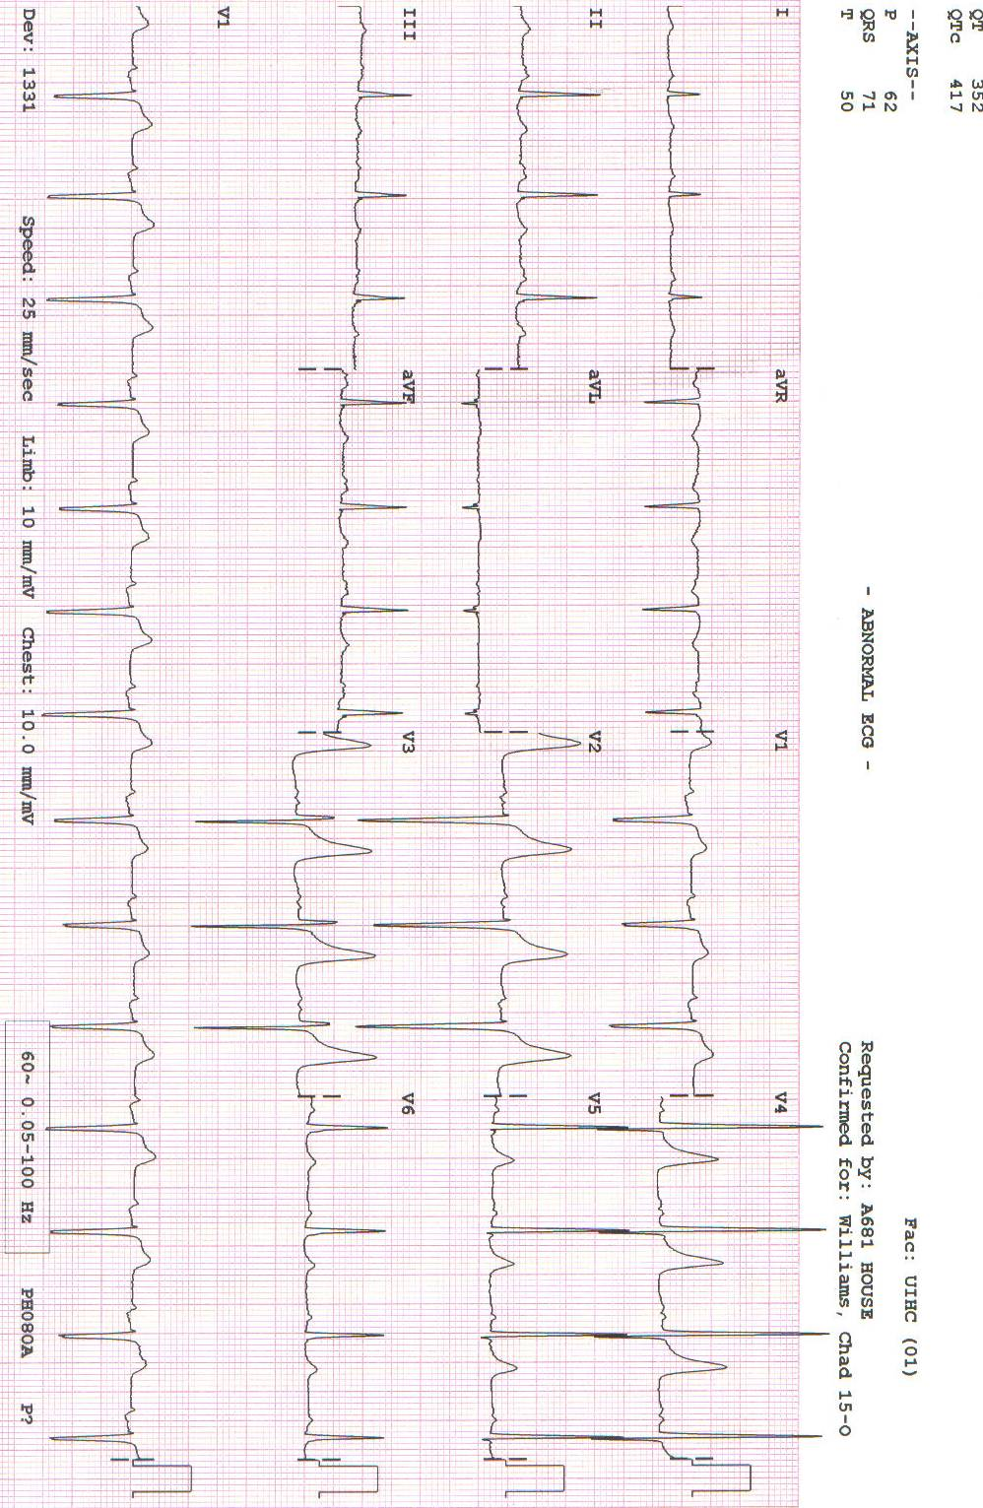
Optional

Feedback/ Assessment Forms
SVT Unresponsive to Adenosine

Candidate ________________________ Examiner _________________________

Critical Actions:

- Place patient on cardiac monitor
- Order and interpret an ECG, recognizing rhythm as SVT
- Terminate the abnormal rhythm prior to disposition
- Provision of procedural sedation if cardioversion is used

Dangerous Actions: (Performance of one dangerous action results in failure of the case)

- Use of excessive dose of electricity (e.g. 360 J)
- Lack of synchronizing during cardioversion

Overall Score:

- Pass
- Fail

Optional Addendum 2:
Core Competency Assessment

SVT Unresponsive to Adenosine

Candidate ________________________ Examiner _________________________

 | Does Not Meet Expectations | Meets Expectations | Exceeds Expectations
Patient Care
Medical Knowledge
Interpersonal Skills and Communication
Professionalism
Practice-based Learning and Improvement
Systems-based
Practice

For Examiner

Date: Examiner: Examinee(s):
Scoring: In accordance with the Standardized Direct Observational Tool (SDOT)

The learner should be scored (based on level of training) for each item above with one of the following:
NI = Needs Improvement
ME = Meets Expectations
AE = Above Expectations
NA= Not Assessed
Critical Actions | NI | ME | AE | NA | Category
Place patient on cardiac monitor |  |  |  |  | PC, MK, PBL
Obtain bedside ECG |  |  |  |  | PC, MK
Recognize SVT |  |  |  |  | PC, MK
Administer adenosine |  |  |  |  | PC, MK
Recognize failure of adenosine |  |  |  |  | PC, MK, PBL
Administer diltiazem or verapamil or synchronized cardioversion |  |  |  |  | PC, MK, PBL
Provide procedural sedation prior to cardioversion (or n/a) |  |  |  |  | PC, MK, P
Order follow up ECG after cardioversion |  |  |  |  | PC, MK
Order appropriate labs including TSH |  |  |  |  | PC, MK
Communicate with the patient and explain diagnosis and treatment |  |  |  |  | P. ICS
Demonstrate / utilize effective communication techniques such as specifying order details and closed loop communication |  |  |  |  | SBP, ICS

The score sheet may be used for a variety of learners. For example, in using the case for 4th year medical students, the key teaching points of the case may be the recognition of shock and treatment with appropriate fluid resuscitation. Other items may be marked N/A= not assessed.

Category: One or more of the ACGME Core Competencies as defined in the SDOT

PC= Patient Care
Compassionate, appropriate, and effective for the treatment of health problems and the promotion of health
MK= Medical Knowledge
Residents are expected to formulate an appropriate differential diagnosis with special attention to life-threatening conditions, demonstrate the ability to utilize available medical resources effectively, and apply this knowledge to clinical decision making
PBL= Practice Based Learning & Improvement
Involves investigation and evaluation of their own patient care, appraisal and assimilation of scientific evidence, and improvements in patient care
ICS= Interpersonal Communication Skills
Results in effective information exchange and teaming with patients, their families, and other health professionals
P= Professionalism
Manifested through a commitment to carrying out professional responsibilities, adherence to ethical principles, and sensitivity to a diverse patient population
SBP= Systems Based Practice
Manifested by actions that demonstrate an awareness of and responsiveness to the larger context and system of health care and the ability to effectively call on system resources to provide care that is of optimal value

Debriefing Materials:

Powerpoint lecture attached for teaching, including diagrams of re-entry dysrhythmia generation.

Keywords: SVT, adenosine, ACLS, tachycardia

References
Yealy DM, Delbridge TR. Dysrhythmias. In: Rosen’s Emergency Medicine, 7th Edition, Mark JA, Ed. Mosby-Elsevier, Philadelphia, PA 2010: 1016-1022.

Has this work been previously published? no

Optional: Simulation Flowchart or diagram to demonstrate branch points in the evolution of the case; changes in patient status, VS, etc.

Optional: Simulation Equipment Checklist

ENVIRONMENT
This scenario requires (checked boxes):
Simulator
Type:
 | Standardized Patient
√ |  | Non-Invasive BP Cuff |  |  | ETT
√ |  | 2 lead EKG |  |  | LMA
√ |  | Pulse Oximeter |  |  | Laryngoscope
 |  | Arterial Line |  |  | Fiberoptic scope
 |  | CVP |  |  | Gum Bougie
 |  | PA Catheter
 |  | Temperature Probe | √ |  | Crash Cart
 |  | Capnograph |  |  | Central line set up
 |  | Resp Rate Monitor |  |  | Chest tube set up
 |  |  |  |  | Ultrasound Machine

√ | SP for family member
 | Additional nurse SP
 | Other SP

