Author: Lance Hoffman, Chad Branecki Reviewer: Sarah Farris

Case Title: STEMI with concurrent LBBB

Target Audience: Resident Physicians

Primary Learning Objectives:
1. Recognize the clinical presentation of an acute myocardial infarction
2. Identify ECG findings suggestive of AMI with a concurrent LBBB
3. Initiate appropriate therapy for an acute STEMI, including emergent revascularization

Secondary Learning Objectives:
1. Employ strategies to confirm STEMI with concurrent LBBB such as identifying a wall motion abnormality on echocardiography or comparison of a current and prior ECG.
2. Effectively communicate the diagnosis and treatment of a STEMI to patients

Critical actions checklist:

Orders an ECG within the first few minutes of the evaluation
- Correctly interprets the ECG as a LBBB with a concurrent STEMI
- Administers an appropriate dose of aspirin to the patient (162-325mg PO and chewed)
- Uses additional data to confirm the presence of a STEMI, such as comparison with a prior ECG or identifying a wall motion abnormality on bedside echocardiography
- Initiates emergent revascularization appropriate to the practice setting, such as thrombolytics or cardiac catheterization

Environment (if using as a simulation case)
- Case can be run as simulation scenario. Sim lab should be set up as typical
critical care resuscitation room
- Employ high fidelity simulation mannequin, capable of intravenous lines, intubation, and transmitting ECG data to monitor
- Will need ECG, CXR viewer, possible bedside echocardiogram, code cart, and thrombolytic intravenous medication box

Actors (optional)
- Roles – paramedic, nurse, ED tech, Cardiology consultant
- Who may play them – EMT, nurse, ED tech, attending physician
- Action Role – Consultant may act as prompt, asking for prior ECG, or additional
data prior to taking patient to cath lab.

For Examiner Only

Author: Lance Hoffman Reviewer: Sarah Farris

Case Title: STEMI with concurrent LBBB

CASE SUMMARY

CORE CONTENT AREA

Cardiovascular – Acute STEMI

SYNOPSIS OF HISTORY
This 62 y/o man drove himself to the ED from work for evaluation of 4 hours of chest pressure. The discomfort started when he was at work shortly after eating lunch while he was changing the oil filter on a customer’s car.

ROS: Pertinent positives: chest pressure with discomfort radiating interscapularly, diaphoresis, nausea, mild dyspnea

Pertinent negatives: fevers, headache, cough, neck/shoulder/arm pain, abdominal pain, vomiting, diarrhea, leg pain, leg swelling, rashes

Past Medical Hx: Hypertension, Hypercholesterolemia, LBBB for at least 2 years

Past Surgical Hx: Appendectomy (2 years ago corresponding with initial identification of LBBB)

Medications: atenolol, lisinopril, hydrochlorothiazide, simvastatin

Allergies: No allergies

Habits: Smoking: life-long non-smoker
ETOH: averages 2 beers nightly
Drugs: life-long non-user

Family Hx: Hypertension, Hypercholesterolemia, Coronary Artery Disease

Social Hx: Marital Status: divorced > 20 years ago
Children: none
Education: high school graduate
Employment: automotive mechanic

For Examiner Only

SYNOPSIS OF PHYSICAL
Patient Name: Cisco Perez Age & Sex: 62y/o male

General Appearance: Diaphoretic, 80 kg male, sitting up in exam bed, mildly anxious/restless

Vital Signs: BP=155/88 P=64 R=22 T (oral)=98.8F Pulse Oximetry (RA)=93%

An otherwise normal physical exam consistent with uncomplicated acute myocardial infarction is present.

For Examiner Only

CRITICAL ACTIONS
Scenario branch points/ PLAY OF CASE GUIDELINES

Key teaching points or branch points that result in changes in patient’s condition

- Orders an ECG within the first few minutes of the evaluation

Cueing Guideline: If no ECG is ordered, have nurse ask candidate if there is anything a tech can do, or call for. The nurse will be busy starting an IV.

- Correctly interprets the ECG as a LBBB with a concurrent STEMI

Cueing Guideline: Have the EKG tech/RN ask, “Why does this look so different compared to most ECGs we order?”

- Administers an appropriate dose of aspirin to the patient (162-325mg PO and chewed)

Cueing Guideline: RN could ask if patient needs to be NPO at this time

- Uses additional data to confirm the presence of a STEMI, such as comparison with a prior ECG or identifying a wall motion abnormality on bedside echocardiography

Cueing Guideline: Patient’s Primary care provider could call on phone and “ask if he could be of any assistance.” Have a tech ask of the physician “do you think his ECG looks like that all the time?”

- Initiates emergent revascularization appropriate to the practice setting, such as thrombolytics or cardiac catheterization

Cueing Guideline: In opening code cart, RN could ask if MD needs anything out of the IV Thrombolytic box

SCORING GUIDELINES
(Critical Action No.)
1. Quickly places patient on cardiac monitor and ECG is ordered
2. Identifies a LBBB, with concerning changes for STEMI
3. Aspirin is given prior to any additional revascularization therapy
4. Utilized other resources to obtain old EKG, or bedside echocardiogram
5. Call is placed to interventional cardiologist regarding cardiac catheterization or directed to give thrombolytic therapy

For Examiner Only

HISTORY

Onset of Symptoms: 4 hours ago

Background Info: This 62 y/o man drove himself to the ED from work for evaluation of 4 hours of chest pressure. The discomfort started when he was at work shortly after eating lunch while he was changing the oil filter on a customer’s car.

Chief Complaint: “My chest hurts.”

Past Medical Hx: Hypertension, Hypercholesterolemia, LBBB for at least 2 years

Past Surgical Hx: Appendectomy (2 years ago corresponding with initial identification of LBBB)

Medications: Atenolol, lisinopril, hydrochlorothiazide, simvastatin

Allergies: No allergies

Habits: Smoking: life-long non-smoker
ETOH: averages 2 beers nightly
Drugs: life-long non-user

Family Hx: Hypertension, Hypercholesterolemia, Coronary Artery Disease

Social Hx: Marital Status: divorced > 20 years ago
Children: none
Education: high school graduate
Employment: automotive mechanic

ROS: Pertinent positives: chest pressure with discomfort radiating interscapularly, diaphoresis, nausea, mild dyspnea

Pertinent negatives: fevers, headache, cough, neck/shoulder/arm pain, abdominal pain, vomiting, diarrhea, leg pain, leg swelling, rashes

For Examiner Only

PHYSICAL EXAM

Patient Name: Cisco Perez Age & Sex: 62y/o male

General Appearance: Diaphoretic, 80 kg male, sitting up in exam bed, mildly anxious/restless

Vital Signs: BP=155/88 P=64 R=22 T (oral)=98.8F Pulse Oximetry (RA)=93%

Head: Normal

Eyes: PERRL, no scleral icterus

Ears: Normal

Mouth: normal moisture and dentition

Neck: no JVD, no lymphadenopathy, normal non-tender thyroid

Skin: mildly diaphoretic without rash

Chest: non-tender, no subcutaneous emphysema

Lungs: breath sounds equal bilaterally without wheezes or rales

Heart: easily audible S1 S2 without S3 or S4, no murmurs

Back: non-tender

Abdomen: soft, non-tender, non-distended, well-healed RLQ appendectomy scar

Extremities: no edema, 2/4 symmetric pulses in radial and dorsal pedal arteries

Rectal: normal tone, heme negative

Neurological: normal

Mental Status: mildly anxious/restless in bed

For Examiner Only

STIMULUS INVENTORY

#1 Emergency Admitting Form

#2 CBC

#3 BMP

#4 U/A

#5 ABG

#6 Cardiac Enzymes

#7 Toxicology

#8 CXR

#9 CT

#10 2D Cardiac Echo

#11 ECG (current)

#12 ECG (7 months prior)

For Examiner Only

LAB DATA & IMAGING RESULTS

Stimulus #2 Stimulus #5
Complete Blood Count (CBC) Arterial Blood Gas (with supp oxygen)
WBC 21.0/mm³ pH 7.36
Hgb 14.4g/dL pCO₂ 40mm Hg
Hct 40.7% pO₂ 109mm Hg
Platelets 307/mm³ O₂ Sat 100%
Differential
Segs 84% Stimulus #6
Bands 2% Cardiac Enzymes
Lymphs 11% CK 100ng/mL
Monos 2% CK-MB 5.5ng/mL
Eos 1% Troponin 0.12ng/mL (elevated)

Stimulus #7
Stimulus #3 Toxicology
Basic Metabolic Profile (BMP) Serum
Na⁺ 137mEq/L Salicylate Neg
K⁺ 3.4mEq/L Acetaminophen Neg
CO₂ 26mEq/L Tricyclics Neg
Cl⁻ 102mEq/L ETOH 0mg/dl
Glucose 188mg/dL
BUN 11mg/dL Urine
Creatinine 0.9mg/dL Cocaine Neg
Cannabinoids Neg PCP Neg
Stimulus #4 Amphetamines Neg
Urinalysis (U/A) Opiates Neg
Color yellow Barbiturates Neg
Sp gravity 1.010 Benzodiazepines Neg
Glucose neg
Protein neg Stimulus #8
Ketone neg CXR normal
Leuk Est neg
Nitrite neg Stimulus #9
WBC 0-2/hpf Head CT: normal
RBC 0-2/hpf

For Examiner Only

LAB DATA & IMAGING RESULTS

Stimulus #10
2D Cardiac Echo: WMA with EF 45%

Stimulus #11
ECG (current): NSR, LAD, LBBB, ST elevation with pseudonormalization of T waves

Stimulus #12
ECG (7 months ago): NSR, LAD, LBBB, lateral T wave inversion

Learner Stimulus #1

ABEM General Hospital

Emergency Admitting Form

Name: Cisco Perez
Age: 62 years
Sex: Male
Method of Transportation: Private car
Person giving information: Patient
Presenting complaint: “My chest hurts.”

Background: This 62 y/o man drove himself to the ED from work for evaluation of 4 hours of chest pressure. The discomfort started when he was at work shortly after eating lunch while he was changing the oil filter on a customer’s car.

Triage or Initial Vital Signs
BP: 155/88
P: 64
R: 22
T : 98.8F orally
RA Pulse Oximetry: 93%

Learner Stimulus #2

Complete Blood Count (CBC)

WBC 21.0/mm³
Hgb 14.4g/dL
Hct 41.9%
Platelets 307/mm³
Differential
Segs 84%
Bands 2%
Lymphs 11%
Monos 2%
Eos 1%

Learner Stimulus #3

Basic Metabolic Profile (BMP)

Na⁺ 137 mEq/L
K⁺ 3.4 mEq/L
CO₂ 26 mEq/L
Cl⁻ 102 mEq/L
Glucose 188 mg/dL
BUN 11 mg/dL
Creatinine 0.9 mg/dL

Learner Stimulus #4

Urinanlysis (U/A)

Color Yellow
Sp gravity 1.010
Glucose Negative
Protein Negative
Ketone Negative
Leuk. Esterace Negative
Nitrate Negative
WBC 0-2/hpf
RBC 0-2/hpf

Learner Stimulus #5

Arterial Blood Gas (with supplemental oxygen)

pH 7.36
pCO₂ 40 mm Hg
pO₂ 109 mm Hg
O₂ Sat 100%

Learner Stimulus #6

Cardiac Enzymes

CK 100 ng/ml
CKMB 5.5 ng/ml
Troponin 0.12 ng/ml (elevated)

Learner Stimulus #7

Toxicology
Serum
Salicylate Negative
Acetaminophen Negative
Tricyclics Negative
ETOH 0 mg/dl

Urine
Cocaine Negative
Cannabinoids Negative
PCP Negative
Amphetamines Negative
Opiates Negative
Barbiturates Negative
Benzodiazepine Negative

Learner Stimulus #8

Radiology Report

Chest X-ray Normal without mediastinal widening, pneumothorax, consolidation, cardiomegaly or effusion

Learner Stimulus #9

Radiology Report:

Head CT Normal

Learner Stimulus #10

Echocardiogram

2-D Transthoracic echo Decreased wall motion in the anterior and septal portions of heart with an estimated LVEF of 45%

Learner Stimulus #11

ECG

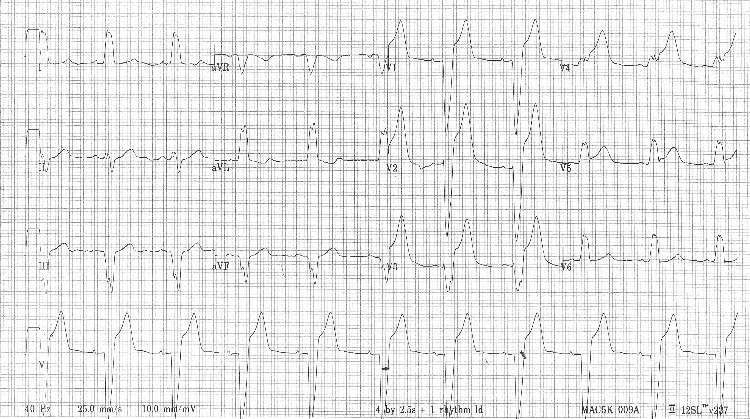

Learner Stimulus #12

ECG (7 months prior)

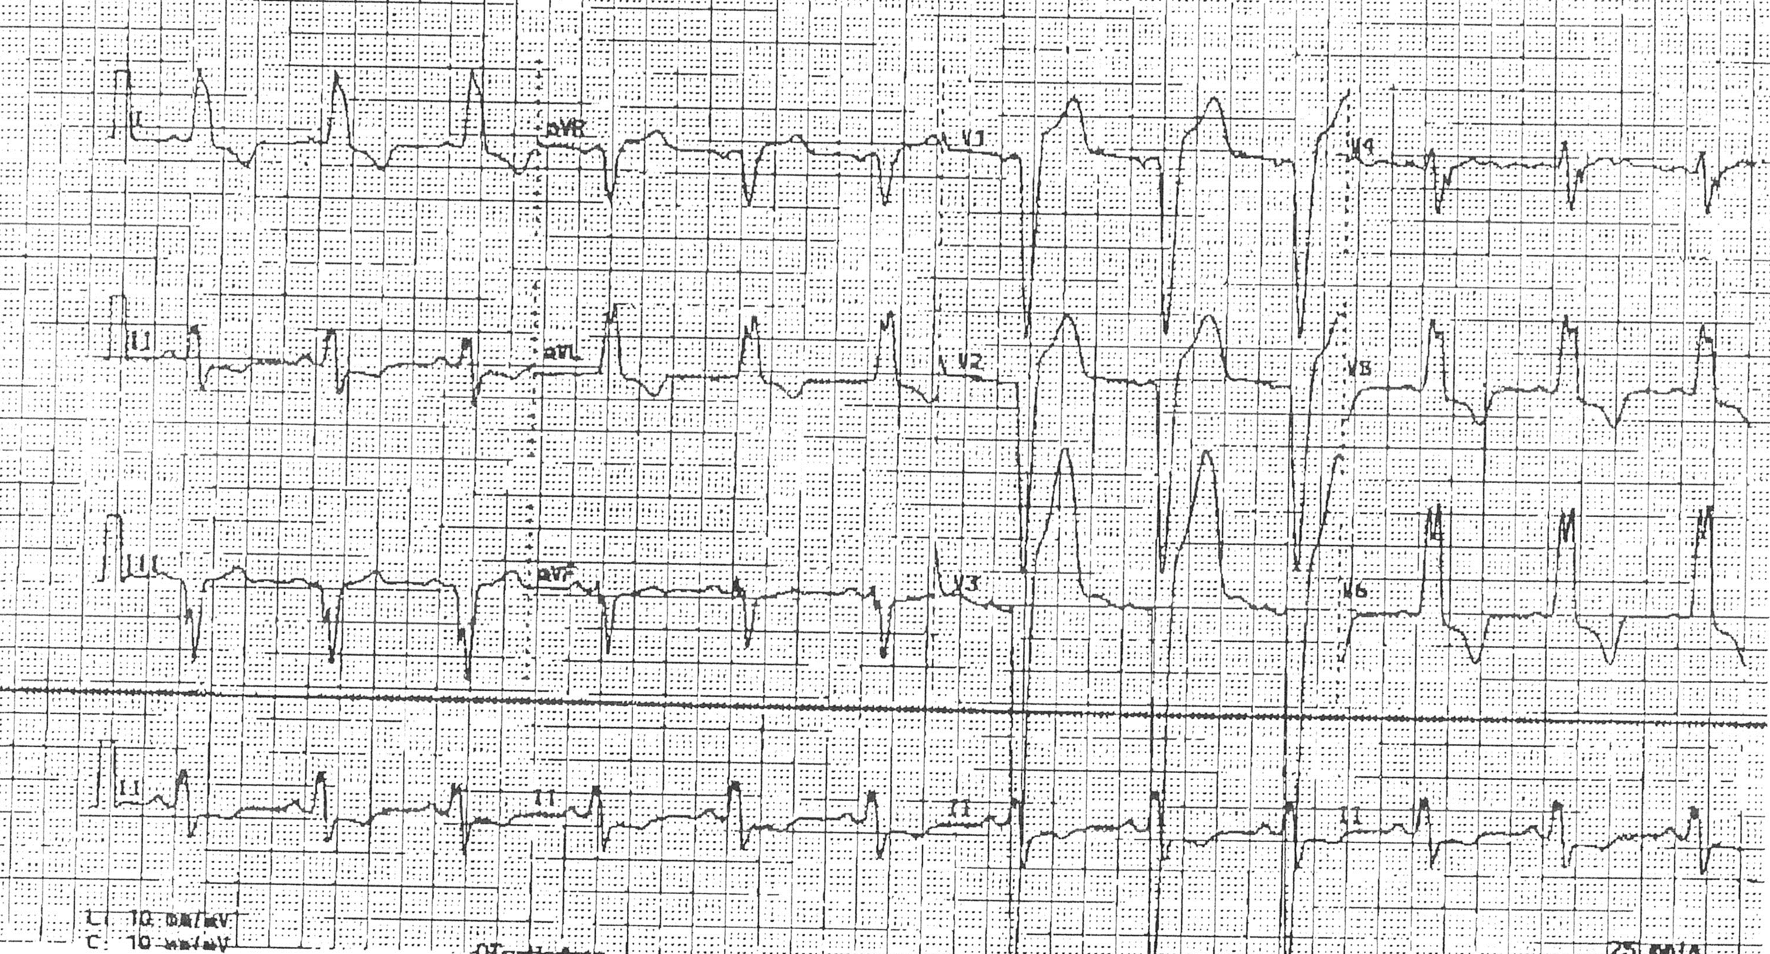
Optional

Feedback/ Assessment Forms (may choose form dependent on use of case)

Case Name Here

Candidate ________________________ Examiner _________________________

Critical Actions:

- Quickly places patient on cardiac monitor and ECG is ordered
- Identifies a LBBB, with concerning changes for STEMI
- Aspirin is given prior to any additional revascularization therapy
- Utilized other resources to obtain old ECG, or bedside echocardiogram
- Call is placed to interventional cardiologist regarding cardiac catheterization or directed to give thrombolytic therapy

Dangerous Actions: (Performance of one dangerous action results in failure of the case)

- Failure to place patient on Cardiac Monitor and order ECG within 5 minutes of arrival
- Identifies a LBBB, but does not recognize concerning changes consistent with STEMI
- Aspirin not given prior to revascularization therapy
- Does not try to obtain prior ECG, or stat bedside echocardiogram
- Failure to initialize cardiac catheterization or thrombolytic therapy

Overall Score:

- Pass
- Fail

For Examiner
Date: Examiner: Examinee(s):
Scoring: In accordance with the Standardized Direct Observational Tool (SDOT)

The learner should be scored (based on level of training) for each item above with one of the following:
NI = Needs Improvement
ME = Meets Expectations
AE = Above Expectations
NA= Not Assessed
Critical Actions | NI | ME | AE | NA | Category
Quickly places patient on cardiac monitor and ECG is ordered |  |  |  |  | PC, MK, PBL
Correctly interprets the ECG as a LBBB with a concurrent STEMI |  |  |  |  | PC, MK
Administers an appropriate dose of aspirin to the patient (162-325mg PO and chewed) |  |  |  |  | PC, MK, PBL,SBP
Uses additional data to confirm the presence of a STEMI, such as comparison with a prior ECG or identifying a wall motion abnormality on bedside echocardiography |  |  |  |  | PC, MK, PBL
Initiates emergent revascularization appropriate to the practice setting, such as thrombolytics or cardiac catheterization |  |  |  |  | PC, MK, PBL, ICS

Category: One or more of the ACGME Core Competencies as defined in the SDOT

PC= Patient Care
Compassionate, appropriate, and effective for the treatment of health problems and the promotion of health
MK= Medical Knowledge
Residents are expected to formulate an appropriate differential diagnosis with special attention to life-threatening conditions, demonstrate the ability to utilize available medical resources effectively, and apply this knowledge to clinical decision making
PBL= Practice Based Learning & Improvement
Involves investigation and evaluation of their own patient care, appraisal and assimilation of scientific evidence, and improvements in patient care
ICS= Interpersonal Communication Skills
Results in effective information exchange and teaming with patients, their families, and other health professionals
P= Professionalism
Manifested through a commitment to carrying out professional responsibilities, adherence to ethical principles, and sensitivity to a diverse patient population
SBP= Systems Based Practice
Manifested by actions that demonstrate an awareness of and responsiveness to the larger context and system of health care and the ability to effectively call on system resources to provide care that is of optimal value

Debriefing Materials:

- LBBB, Ventricular Paced Rhythm and LVH can all mimic and confound the diagnosis of AMI.
- Criteria for LBBB will be: primarily negative QRS in V1 with poor R wave progression and monophasic R waves in V5 and V6. QRS duration of 0.12 secs or greater in limb leads. Broad slurred R in V6 with absent q, depressed ST segment and inverted T wave. Usually a broad slurred R in I and avl. Deep S wave in V1-V2 and normal PR interval.
- In the presence of acute infarction (as compared to prior ECG) there is actual ST elevation > 2mm V4 and V5. The ST segments are clearly elevated and have concerning concave morphology. The T waves also demonstrate pseudonormalization compared to the prior ECG obtained 7 months ago.

Keywords for future search
LBBB, STEMI, AMI, Chest Pain, ST segment changes

References
Zack Pm, Aker UT, Kennedy HL. Pseudonormalization of T-waves During Coronary Angioplasty. Catheterization and Cardiovascular Diagnosis. May-June 1987; 13(3): 191-3.

Loperfido LA, et al. Significance of Transient ST-T Segment Changes During Dobutamine Testing in Q Wave Myocardial Infarction. Mar 1996; 27(3): 599-605.

Brady WJ, et al. Electrocardiographic ST-segment Elevation: The Diagnosis of Acute Myocardial Infarction by Morphologic Analysis of the ST Segment. Academic Emergency Medicine. Oct 2001; 8(10): 961-7.

Smith SW. Upwardly Concave ST Segment Morphology is Common in Acute Left Anterior Descending Coronary Occlusion. The Journal of Emergency Medicine. 2006; 31(1): 69-77.

Has this work been previously published? No

Optional: Simulation Equipment Checklist

ENVIRONMENT
This scenario requires (checked boxes):
X | Simulator  Type:
X | Standardized Patient
X |  | Non-Invasive BP Cuff |  |  | ETT
X |  | 2 lead EKG |  |  | LMA
X |  | Pulse Oximeter |  |  | Laryngoscope
 |  | Arterial Line |  |  | Fiberoptic scope
 |  | CVP |  |  | Gum Bougie
 |  | PA Catheter
 |  | Temperature Probe | X |  | Crash Cart
 |  | Capnograph | X |  | Central line set up
 |  | Resp Rate Monitor |  |  | Chest tube set up
 |  |  | X |  | Ultrasound Machine

 | SP for family member
X | Additional nurse SP
 | Other SP

