Author: Chris Brooks Reviewer: Sharon Griswold

Case Title: Ciguatera Toxin Poisoning

Target Audience: medical students and residents

Primary Learning Objectives:
1. Learn to treat patient symptomatically during work-up
2. Learn about Ciguatera Poisoning

Critical actions checklist
- Provide symptomatic relief.
- Recognize ciguatera toxin poisoning.
- Provide specific therapy.
- Obtain EKG.
- Explain the diagnosis to the patient.
- Report the diagnosis to the local health authorities

For Examiner Only

Author: Chris Brooks Reviewer: Sharon Griswold

Case Title: Ciguatera Toxin Poisoning

CASE SUMMARY

CORE CONTENT AREA
Toxicology

SYNOPSIS OF HISTORY/ Scenario Background

The patient is a middle-aged male who contracts ciguatera toxin poisoning from eating amberjack at a local restaurant. He went out to dinner with friends and had raw oysters, salad, and the amberjack special. The contaminated fish was taken from the Gulf of Mexico and shipped to the restaurant by a local seafood supplier.

The patient’s symptoms include nausea, abdominal discomfort, diarrhea, intense myalgias, and neurologic symptoms. Pt has burning and tingling in the hands and feet. For example, the patient is unable to stand on a tile floor with bare feet because of the discomfort.

SYNOPSIS OF PHYSICAL

Physical exam is essentially unremarkable.
For Examiner Only

CRITICAL ACTIONS
Scenario branch points/ PLAY OF CASE GUIDELINES

- Critical Action

Provide symptomatic relief. An IV should be started and fluids should be administered. Normal saline by bolus infusion is preferred. Pain medication including an anti-inflammatory and / or narcotic should be given. Anti-emetics for nausea should be given.
Cueing Guideline: Patient asks, “Doctor, I really feel terrible. Is there anything that you can do?”

- Critical Action

Recognize ciguatera toxin poisoning.
Cueing Guideline: If the examinee is unable to recognize that this is ciguatera toxin poisoning, he may use the computer in the ED to “surf the web”. The examinee must be able to know to search for marine toxins and the CDC web page will be available. Patient asks, “Doctor, what’s wrong with me? Was it something I ate last night?”

- Critical Action

Provide specific therapy. Give a mannitol infusion to the patient. Dose should be approximately 1 gm / kg, typically a 100 gm infusion. Tricyclic antidepressants or NSAID’s can also be prescribed when the patient is discharged.
Cueing Guideline: Patient asks, “Doctor, is there an antidote that you can give me?”

- Critical Action

Obtain EKG.
Cueing Guideline: Nurse says, “His heart rate seems slow to me.”

- Critical Action

Explain the diagnosis to the patient. The patient should be educated that this is ciguatera poisoning. Patient education should include nature of disease (toxin), prognosis (generally good but some patients have persistent symptoms) and strategies to avoid reoccurrence in the future.
Cueing Guideline: Patient says, “I’m going to sue that restaurant. They should have known better than to serve that bad fish.”

- Critical Action
Report the outbreak to the local health authority.
It is important to notify public health departments about even one person with marine toxin poisoning. Public health departments can then investigate to determine if a restaurant, or fishing area has a problem. This prevents other illnesses.
Cueing Guideline: The nurse taking care of the patient asks, “Are we supposed to report this?.”

SCORING GUIDELINES
(Critical Action No.)
1. Score up for IV administration of fluids, pain medication and anti-emetics.
2. Score up for knowledge of toxin. Also score up for rapid use of on-line resources or consultation with toxicology service.
3. Score up for mannitol infusion. Score down for therapy directed at other toxins.
4. Obtain EKG.
5. Score up for reassurance and details provided about prognosis and epidemiology.

For Examiner Only

HISTORY

Onset of Symptoms: Symptoms began about 1 AM with nausea, diarrhea, myalgias (primarily of the occipital & chest muscles), and burning / tingling in the hands and feet.

Background Info: Patient went out to dinner last night with friends. He developed symptoms during the night and presents at 7 AM after being up all night. If asked a friend who ordered the same dinner is also ill.

Chief Complaint: “I feel terrible.”

Past Medical Hx: Ulcerative Colitis
Migraine Headache

Medications: Verapamil SR 240 mg QD
Nortriptyline 50 mg QHS
Mesalamine 800 mg BID
Azothiaprine 100 mg QD

Allergies: Butalbital

Past Surgical Hx: Internal fixation of trimalleolar ankle fracture 2 years previously

Habits: Smoking: Quit smoking 20 years ago
ETOH: Social only (mixed drinks & single malt scotch)
Drugs: None

Family Medical Hx: Mother: Deceased, breast cancer
Father: Hypertension, diabetes, and coronary heart disease

Social Hx: Marital Status: Married
Children: 2
Education: PhD in chemical engineering
Employment: Manager for chemical company

ROS: Ulcerative Colitis well controlled on Mesalamine and Azothiaprine
Migraines well controlled on Verapamil and Nortriptyline
All other ROS items are non-contributory. No diarrhea, fever or concern for sepsis.
For Examiner Only

PHYSICAL EXAM

Patient Name: Jack Coral Age & Sex: 51 year old male

General Appearance: Well-developed, well-nourished male in moderate distress

Vital Signs: BP 116/72 P 58 R 16 T 37.2 C

Head: Normal Exam

Eyes: Normal Exam

Ears: Normal Exam

Mouth: Mucosa somewhat dry, otherwise normal

Neck: Without tenderness or rigidity

Skin: No rashes, some diaphoresis is present, skin color is normal

Chest: Tenderness over the pectoral muscles is present

Lungs: Clear to auscultation

Heart: Regular rhythm without murmurs, rubs, or gallops

Back: Normal Exam

Abdomen: Normal Exam

Extremities: Normal Exam

Rectal: Patient refuses

Pelvic: N/A

Neurological: Normal Exam

Mental Status: Normal
For Examiner Only

STIMULUS INVENTORY

#1 Emergency Admitting Form

#2 CBC

#3 BMP

#4 U/A

#5 Cardiac Enzymes

#6 Toxicology

#7 EKG

#8 CXR

#9 CDC Web Page: “Marine Toxins”
For Examiner Only

LAB DATA & IMAGING RESULTS

Stimulus #2
Complete Blood Count (CBC) Stimulus #5
WBC 14.6 /mm³ Cardiac Enzymes
Hgb 13.3 g/dL Myoglobin 52 ng/ml
Hct 40 % Troponin < 0.7 ng/ml
Platelets 365K /mm3
Differential
Segs 60 % Stimulus #6
Bands 0 % Toxicology
Lymphs 30 % Serum
Monos 10 % Salicylate Neg
Eos 0 % Acetaminophen Neg
Tricyclics Pos
Stimulus #3 ETOH Neg
Basic Metabolic Profile (BMP) Urine
Na+ 140 mEq/L Cocaine Neg
K+ 3.9 mEq/L Cannabinoids Neg
CO2 24 mEq/L PCP Neg
Cl- 112 mEq/L Amphetamines Neg
BUN 30 mg/dL Opiates Neg
Creatinine 1.2 mg/dL Barbiturates Neg
Glucose 110 mg/dL Benzodiazepines Neg

Stimulus #4 Stimulus #7
Urinalysis (U/A) EKG Sinus Bradycardia
Color yellow
Sp gravity 1.018 Stimulus #8
Glucose neg CXR Normal
Blood neg
Protein neg Stimulus #9
Ketone 1 + CDC Web Page
Leuk. Est. neg (“Marine Toxins”)
Nitrite neg
WBC 0-1 Verbal Reports Pulse Ox 98% (RA)
RBC 0-1
Learner Stimulus #1

ABEM General Hospital

Emergency Admitting Form

Name: Jack Coral
Age: 51 years
Sex: Male
Method of Transportation: Private car
Person giving information: Patient
Presenting complaint: “I feel terrible.”

Background: Patient went out to dinner last night with friends. He developed symptoms during the night and presents at 7 AM after being up all night.

Triage or Initial Vital Signs
BP: 116/72
P: 58
R: 16
T: 37.2 C

Learner Stimulus #2

Complete Blood Count (CBC)
WBC 14.6 /mm³
Hgb 13.3 g/dL
Hct 40 %
Platelets 365K /mm3
Differential
Segs 60 %
Bands 0 %
Lymphs 30 %
Monos 10 %
Eos 0 %

Learner Stimulus #3

Basic Metabolic Profile (BMP)
Na+ 140 mEq/L
K+ 3.9 mEq/L
CO2 24 mEq/L
Cl- 112 mEq/L
BUN 30 mg/dL
Creatinine 1.2 mg/dL
Glucose 110 mg/dL

Learner Stimulus #4

Urinalysis (U/A)
Color yellow
Sp gravity 1.018
Glucose neg
Blood neg
Protein neg
Ketone 1 +
Leuk. Est. neg
Nitrite neg
WBC 0-1
RBC 0-1

Learner Stimulus #5

Cardiac Enzymes
Myoglobin 52 ng/ml
Troponin < 0.7 ng/ml

Learner Stimulus #6

Toxicology
Serum
Salicylate Neg
Acetaminophen Neg
Tricyclics Pos
ETOH Neg
Urine
Cocaine Neg
Cannabinoids Neg
PCP Neg
Amphetamines Neg
Opiates Neg
Barbiturates Neg
Benzodiazepines Neg

Learner Stimulus #7

EKG
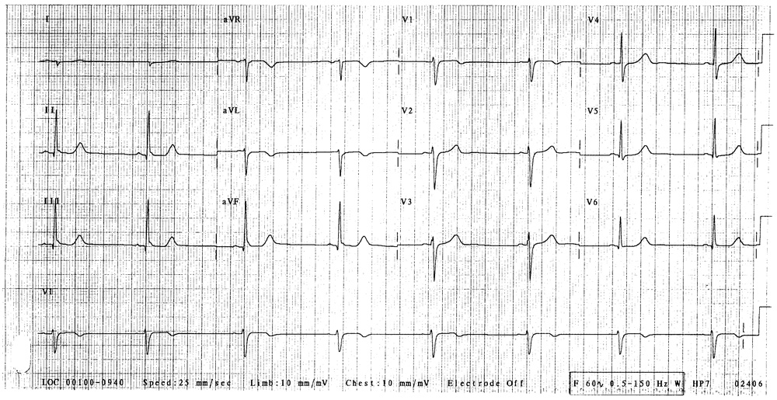
Learner Stimulus #8

CXR
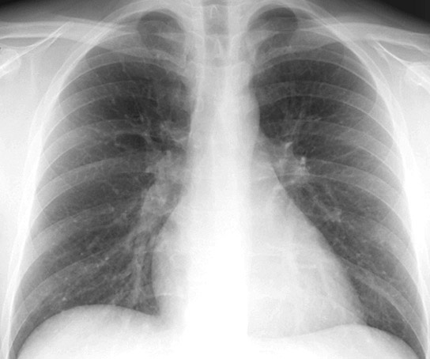
For Examiner

Date: Examiner: Examinee(s):
Scoring: In accordance with the Standardized Direct Observational Tool (SDOT)

The learner should be scored (based on level of training) for each item above with one of the following:
NI = Needs Improvement
ME = Meets Expectations
AE = Above Expectations
NA= Not Assessed

Critical Actions | NI | ME | AE | NA | Category
Provide symptomatic relief. |  |  |  |  | PC, MK
Recognize ciguatera poisoning. |  |  |  |  | PC, MK, PBL
Obtain EKG |  |  |  |  | PC, MK, PBL
Provide specific therapy. |  |  |  |  | PC, MK, PBL
Explain diagnosis to the patient. |  |  |  |  | PC, MK, ICS, P, SBP
Report case to local authorities |  |  |  |  | SBP

The score sheet may be used for a variety of learners. For example, in using the case for 4th year medical students, the key teaching points of the case may be the recognition of shock and treatment with appropriate fluid resuscitation. Other items may be marked N/A= not assessed.

Category: One or more of the ACGME Core Competencies as defined in the SDOT

PC= Patient Care
Compassionate, appropriate, and effective for the treatment of health problems and the promotion of health
MK= Medical Knowledge
Residents are expected to formulate an appropriate differential diagnosis with special attention to life-threatening conditions, demonstrate the ability to utilize available medical resources effectively, and apply this knowledge to clinical decision making
PBL= Practice Based Learning & Improvement
Involves investigation and evaluation of their own patient care, appraisal and assimilation of scientific evidence, and improvements in patient care
ICS= Interpersonal Communication Skills
Results in effective information exchange and teaming with patients, their families, and other health professionals
P= Professionalism
Manifested through a commitment to carrying out professional responsibilities, adherence to ethical principles, and sensitivity to a diverse patient population
SBP= Systems Based Practice
Manifested by actions that demonstrate an awareness of and responsiveness to the larger context and system of health care and the ability to effectively call on system resources to provide care that is of optimal value
Learner Stimulus #9 CDC Web Page: “Marine Toxins”

http://www.cdc.gov/ncidod/dbmd/diseaseinfo/marinetoxins_g.htm. Retrieved May 17, 2011

What can be done to prevent these diseases?
It is important to notify public health departments about even one person with marine toxin poisoning. Public health departments can then investigate to determine if a restaurant, oyster bed, or fishing area has a problem. This prevents other illnesses. In any food poisoning occurrence, consumers should note foods eaten and freeze any uneaten portions in case they need to be tested. A commercial test has been developed in Hawaii to allow persons to test sport caught fish for ciguatoxins

Marine Toxins

What are marine toxins?
Marine toxins are naturally occurring chemicals that can contaminate certain seafood. The seafood contaminated with these chemicals frequently looks, smells, and tastes normal. When humans eat such seafood, disease can result.

What sort of diseases do marine toxins cause? The most common diseases caused by marine toxins in United States in order of incidence are scombrotoxic fish poisoning, ciguatera poisoning, paralytic shellfish poisoning, neurotoxic shellfish poisoning and amnesic shellfish poisoning.

Scombrotoxic fish poisoning also known as scombroid or histamine fish poisoning, is caused by bacterial spoilage of certain finfish such as tuna, mackerel, bonito, and, rarely, other fish. As bacteria break down fish proteins, byproducts such as histamine and other substances that block histamine breakdown build up in fish. Eating spoiled fish that have high levels of these histamines can cause in human disease. Symptoms begin within 2 minutes to 2 hours after eating the fish. The most common symptoms are rash, diarrhea, flushing, sweating, headache, and vomiting. Burning or swelling of the mouth, abdominal pain, or a metallic taste may also occur. The majority of patients have mild symptoms that resolve within a few hours. Treatment is generally unnecessary, but antihistamines or epinephrine may be needed in certain instances. Symptoms may be more severe in patients taking certain medications that slow the breakdown of histamine by their liver, such as isoniazide and doxycycline.

Ciguatera poisoning or ciguatera is caused by eating contaminated tropical reef fish. Ciguatoxins that cause ciguatera poisoning are actually produced by microscopic sea plants called dinoflagellates. These toxins become progressively concentrated as they move up the food chain from small fish to large fish that eat them, and reach particularly high concentrations in large predatory tropical reef fish. Barracuda are commonly associated with ciguatoxin poisoning, but eating grouper, sea bass, snapper, mullet, and a number of other fish that live in oceans between latitude 35° N and 35° S has caused the disease. These fish are typically caught by sport fishermen on reefs in Hawaii, Guam and other South Pacific islands, the Virgin Islands, and Puerto Rico. Ciguatoxin usually causes symptoms within a few minutes to 30 hours after eating contaminated fish, and occasionally it may take up to 6 hours. Common nonspecific symptoms include nausea, vomiting, diarrhea, cramps, excessive sweating, headache, and muscle aches. The sensation of burning or "pins-and-needles," weakness, itching, and dizziness can occur. Patients may experience reversal of temperature sensation in their mouth (hot surfaces feeling cold and cold, hot), unusual taste sensations, nightmares, or hallucinations. Ciguatera poisoning is rarely fatal. Symptoms usually clear in 1 to 4 weeks.

Paralytic shellfish poisoning is caused by a different dinoflagellate with a different toxin, than that causing ciguatera poisoning. These dinoflagellates have a red-brown color, and can grow to such numbers that they cause red streaks to appear in the ocean called "red tides." This toxin is known to concentrate within certain shellfish that typically live in the colder coastal waters of the Pacific states and New England, though the syndrome has been reported in Central America. Shellfish that have caused this disease include mussels, cockles, clams, scallops, oysters, crabs, and lobsters. Symptoms begin anywhere from 15 minutes to 10 hours after eating the contaminated shellfish, although usually within 2 hours. Symptoms are generally mild, and begin with numbness or tingling of the face, arms, and legs. This is followed by headache, dizziness, nausea, and muscular incoordination. Patients sometimes describe a floating sensation. In cases of severe poisoning, muscle paralysis and respiratory failure occur, and in these cases death may occur in 2 to 25 hours.

Neurotoxic shellfish poisoning is caused by a third type of dinoflagellate with another toxin that occasionally accumulates in oysters, clams, and mussels from the Gulf of Mexico and the Atlantic coast of the southern states. Symptoms begin 1 to 3 hours after eating the contaminated shellfish and include numbness, tingling in the mouth, arms and legs, incoordination, and gastrointestinal upset. As in ciguatera poisoning, some patients report temperature reversal. Death is rare. Recovery normally occurs in 2 to 3 days.

Amnesic shellfish poisoning is a rare syndrome caused by a toxin made by a microscopic, red-brown, salt-water plant, or diatom called Nitzchia pungens. The toxin produced by these diatoms is concentrated in shellfish such as mussels and causes disease when the contaminated shellfish are eaten. Patients first experience gastrointestinal distress within 24 hours after eating the contaminated shellfish. Other reported symptoms have included dizziness, headache, disorientation, and permanent short-term memory loss. In severe poisoning, seizures, focal weakness or paralysis, and death may occur.

How can these diseases be diagnosed? Diagnosis of marine toxin poisoning is generally based on symptoms and a history of recently eating a particular kind of seafood. Laboratory testing for the specific toxin in patient samples is generally not necessary because this requires special techniques and equipment available in only specialized laboratories. If suspect, leftover fish or shellfish are available, they can be tested for the presence of the toxin more easily. Identification of the specific toxin is not usually necessary for treating patients because there is no specific treatment.

How can these diseases be treated? Other than supportive care there are few specific treatments for ciguatera poisoning, paralytic shellfish poisoning, neurotoxic shellfish poisoning, or amnesic shellfish poisoning. Antihistamines and epinephrine, however, may sometimes be useful in treating the symptoms of scombrotoxic fish poisoning. Intravenous mannitol has been suggested for the treatment of severe ciguatera poisoning.

Are there long-term consequences to these diseases? Ciguatera poisoning has resulted in some neurologic problems persisting for weeks, and in rare cases, even years. Symptoms have sometimes returned after eating contaminated fish a second time. Amnesic shellfish poisoning has resulted in longterm problems with short-term memory. Long-term consequences have not been associated with paralytic shellfish poisoning, neurotoxic shellfish poisoning, and scombrotoxic fish poisoning.

How common are these diseases? Every year, approximately 30 cases of poisoning by marine toxins are reported in the United States. Because healthcare providers are not required to report these illnesses and because many milder cases are not diagnosed or reported, the actual number of poisonings may be much greater. Toxic seafood poisonings are more common in the summer than winter because dinoflagelates grow well in warmer seasons. It is estimated from cases with available data that one person dies every 4 years from toxic seafood poisonings.
Marine toxins, Ciguatera, foodborne illness

References
http://www.cdc.gov/ncidod/dbmd/diseaseinfo/marinetoxins_g.htm. Retrieved May 17, 2011

