Author: Colleen Bush, MD Reviewer: Deepi Goyle, MD
Sharon Griswold, MD MPH

Case Title: Hyperosmolar Hyperglycemic State

Target Audience: EM Residents

Primary Learning Objectives:

1. Describe the assessment and management of altered mental status
2. Recognize and initiate appropriate treatment of hyperglycemia (not DKA)
3. Demonstrate understanding of stressors that cause HHS
4. Obtain relevant history from family and EMS.

Secondary Learning Objectives:

1. Describe the assessment and initial management of altered mental status in the elderly.
2. Initiate appropriate fluid management for the treatment of HHS
3. Initiate appropriate insulin management of HHS

Critical actions checklist:

- Demonstrates the knowledge of primary assessment to look for causes of AMS (PC, MK, PBL) DON’T M (Dextrose, Oxygen, Narcan, Thiamine, Monitor and IV in the primary survey)
- Demonstrates prompt recognition of hyperglycemia and dehydration.
- Initiation of immediate fluid resuscitation including advanced access (PC, MK) should be done immediately after primary survey (large bore IVs, CVC access or IO may be acceptable).
- initiation of appropriate IV insulin therapy of 0.1 units/kg/hr (PC, MK) promptly after analyzing BMP and ABG
- Initiation of treatment of UTI with Levofloxacin or Ceftriaxone IV (or another antibiotic based on regional biograms) (PC, MK) immediately on discovery, prior to discussion with ICU
- Demonstrates effective communication of the management and treatment with patient’s daughter (P, ICS) as soon as patient is stabilized
- If patient deteriorates, performs endotracheal intubation (PC)
- Arranges admission of the patient to appropriate level of care - ICU (SBP, PC).

For Examiner Only

Author: Colleen Bush, MD Reviewer: Deepi Goyle, MD
Sharon Griswold, MD MPH

Case Title: Hyperglycemic Hyperosmolar State

CASE SUMMARY

CORE CONTENT AREA

Endocrine Emergencies

SYNOPSIS OF HISTORY/ Scenario Background

66 year old white female found by her daughter this morning after not answering phone all weekend. She was initially minimally responsive, medics attempted IV unsuccessfully. Fingerstick glucose reads “high” (if asked), Narcan gives no response (if asked). Patient placed on O2 and transported. Immediate access by IO or central line is needed and acknowledgement of significantly elevated blood sugar with the response of IV resuscitation is necessary or the patient’s mental status further deteriorates and she requires intubation. Aggressive fluid resuscitation, treatment with insulin, identification of urinary tract infection as the stressor that provoked HHS and communication with family are the key elements of the case. Patient should be admitted to ICU.

Past medical history: Diabetes, hypertension, possibly a previous MI
Medications and allergies: Lantus, Novolog, Glucophage, HCTZ, aspirin
Family and social history: Widowed, lives alone, non-smoker, non-drinker

SYNOPSIS OF PHYSICAL

VS: P 115 BP 88/62 RR 20 T 38.7 R Pox 99% on NRB

Initial physical shows an older-than-stated-age female who only responds by moaning. Skin is pale, warm and dry, poor turgor, mouth very dry. She’s tachycardic and mildly tachypneic.

For Examiner Only

CRITICAL ACTIONS
Scenario branch points/ PLAY OF CASE GUIDELINES

- Critical Action
Demonstrates the knowledge of primary assessment to look for causes of AMS (PC, MK, PBL) DON’T M (Dextrose, Oxygen, Narcan, Thiamine, Monitor and IV in the primary survey.

Cueing Guideline: Have nurse convey that the paramedics had mentioned the patient’s glucose read “HI” prior to arrival..

2. Critical Action

Initiation of immediate fluid resuscitation including advanced access (PC, MK) should be done immediately after primary survey (large bore IVs, CVC access or IO may be acceptable).

Cueing Guideline: Nurse tells candidate they are unable to find an IV site after 3
attempts.

- Critical Action

Aggressive fluid resuscitation (2-4 L in ED)

Cueing Guideline: Have nurse ask if candidate wants any more fluid after first fluid bolus of 1L is administered. (The nurse may suggest, “the first liter is in, what would you like me to do with the fluids?”)

4. Critical Action

Administration of IV insulin drip 0.1 units/kg/hr of regular insulin (+/- bolus)

Cueing Guideline: If the candidate requests insulin without specific direction the nurse may ask “How would you like that given?”

- Critical Action

Initiation of treatment of UTI with Levofloxacin or Ceftriaxone IV (or another antibiotic based on regional biograms) (PC, MK) immediately on discovery, prior to discussion with ICU

Cueing Guideline: Have patient’s daughter ask if patient has pneumonia like last time she was in the hospital to cue the candidate to review for infection.

6. Critical Action

Demonstrates effective communication of the management and treatment with patient’s daughter (P, ICS) as soon as patient is stabilized

Cueing Guideline: Have volunteer say that patient’s daughter is in the waiting room requesting to speak to the daughter if candidate hasn’t asked to speak to her prior to disposition

7. Critical Action

Arranges admission of the patient to appropriate level of care (ICU).

Cueing Guideline: When candidate asks to speak with admitting doctor, ask whether they want the hospitalist or the ICU physician.

SCORING GUIDELINES
(Critical Action No.)
- Score up for immediate bedside glucose, score down if not asked until prompted, patient’s condition deteriorates if not assessed immediately (needs intubation)
- Score up for immediate access obtained by candidate, score down if asks nursing to keep trying after 3 attempts at peripheral IV.
- Score up for at least 2L of IVF bolus during case, score down for not bolusing 2L, patient’s
deteriorates if aggressive fluids are not started immediately after access obtained (needs
intubation).
- Score up for appropriate insulin dripof 0.1 units/kg/hr, score down for subcutaneous insulin
- Score up for placement of Foley catheter to assess urine output (necessary for consideration of potassium replacement)
5. Score up for thorough evaluation of fever, score down if this is not addressed (urine, blood,
pulmonary, +/- CNS evaluation). Treat UTI with appropriate antibiotics.
6. Score up for asking to speak with daughter to gain more history, score down for delaying
speaking with her.
- Score down for attempt to admit to floor bed

For Examiner Only

HISTORY

Onset of Symptoms: Patient found by daughter this morning. Has not seen or spoken to her in 2 days.

Background Info: Eleanor Brown, a 66 year old female presents by EMS after being found at home unresponsive by her daughter this morning.

Vital Signs: P 126 BP 88/64 RR 28 T 38.7 R Pox 98% on NRB O2

Chief Complaint: Patient only moans to your questioning. Her daughter says that her mother was fine 2 days ago and when she couldn’t get her on the phone this morning, she became worried. On her arrival, her mother was in bed and didn’t appear to have been out of bed for the past few days. She wouldn’t respond to the daughter, who called 911.

Past Medical Hx: DM for 12 years
HTN
Was told she may have had an MI in the distant past

Past Surgical Hx: Cholecystectomy 20 years ago

Habits: Smoking: None
ETOH: None
Drugs: None

Family Medical Hx: Patient’s parents are both deceased from complications of diabetes

Social Hx: Marital Status: Widowed 4 years ago.
Children: One adult daughter living here, one adult daughter living in
Florida
Education: Some college
Employment: Retired bookkeeper

ROS: Unable to obtain due to patient’s depressed mental status
For Examiner Only

PHYSICAL EXAM

Patient Name: Eleanor Brown Age & Sex: 66 year old female

General Appearance: Well-developed, well-nourished female lying quietly, appears pale

Vital Signs: P 126 BP 88/64 RR 28 T 38.7 R Pox 98% on NRB O2

Head: Grossly atraumatic

Eyes: PERRL, conjunctivae pink

Ears: Clear

Mouth: Mucous membranes dry, no lesions

Neck: Supple, no lymphadenopathy

Skin: Pale, warm, dry, poor turgor, no rashes

Chest: Symmetrical rise

Lungs: No wheezes, rales, rhonchi. Tachypneic.

Heart: Tachycardia, regular rhythm, no murmurs, rubs, gallops

Back: Mild erythema over sacral prominence

Abdomen: Flat, hypoactive bowel sounds, no organomegaly, not apparently tender

Extremities: Moves all extremities equally, atraumatic, capillary refill approximately 4 seconds

Rectal: Normal tone, brown heme negative stool in vault

Pelvic: Deferred

Neurological: Lies quietly with eyes closed, moans to painful stimulus and localizes to painful stimulus.

Mental Status: Moans to stimuli, opens eyes occasionally, unable to answer questions.

For Examiner Only

STIMULUS INVENTORY

#1 Emergency Admitting Form

#2 CBC

#3 BMP

#4 U/A

#5 ABG

#6 Cardiac Markers

#7 Serum Osmolality

#8 CSF

#9 EKG

#10 CXR

#11 Head CT

For Examiner Only

LAB DATA & IMAGING RESULTS

Stimulus #2 Stimulus #5
Complete Blood Count (CBC) Arterial Blood Gas
WBC 18, 500/mm³ pH 7.38
Hgb 15.0g/dL pCO₂ 35 mmHg
Hct % pO₂ 102 mmHg
Platelets 285/mm³ O₂ Sat 96%
Differential
Segs 80% Stimulus #6
Bands 7% Cardiac Enzymes
Lymphs 13% Myoglobin 98 ng/ml
Monos 0% Troponin < 0.03 ng/ml
Eos 0%
Stimulus #7
Stimulus #3 Serum Osmolality
Basic Metabolic Profile (BMP)
Na⁺ 122 mEq/L 326 mOsm/kg
K⁺ 3.3 mEq/L
CO₂ 21 mEq/L
Cl⁻ 95 mEq/L Calculated serum Osm:
Glucose 990 mg/dL 2(Na) + BUN/2.8 + Gluc/18
BUN 70 mg/dL 2(122) + 70/2.8 + 990/18 = 324
Creatinine 2.20 mg/dL Osmo Gap: 326 - 324 = 2

Stimulus #4
Urinalysis (U/A) Stimulus #8
Color yellow Lumbar Puncture
Sp gravity 1.030 Clear fluid
Glucose >1000 WBC 0
Protein 30 RBC 0
Ketone neg Protein 50
Leuk. Est. + 3 Glucose 120
Nitrite Positive Culture sent
WBC 688
RBC 15

Stimulus #9

EKG

Sinus tachycardia

Stimulus #10

Chest Xray

No infiltrate

Stimulus #11

Head CT

No abnormality

Verbal reports

Accucheck ”HI”

After 1 L IVF, P 115 BP 95/66

After 2nd L IVF patient more alert P 107 BP 105/72 Accucheck will still read “HI” Repeat glucose 820

If patient not treated with fluids immediately, becomes entirely unresponsive with hypoventilation. After intubation, pulse ox 98%

Learner Stimulus #1

ABEM General Hospital
Emergency Admitting Form

Name: Eleanor Brown
Age: 64 years
Sex: Female
Method of Transportation: EMS
Person giving information: Adult daughter
Presenting complaint: Unresponsive

Background: Eleanor Brown, a 64 year old female presents by EMS after being found at home unresponsive by her daughter this morning.

Triage or Initial Vital Signs
BP: 88/64
P: 126
R: 28
T : 38.7 rectally

Learner Stimulus #2

Complete Blood Count (CBC)

WBC 18,500 /mm³
Hgb 15.0g/dL
Hct %
Platelets 285 /mm³
Differential
Segs 80%
Bands 7%
Lymphs 13%
Monos 0%
Eos 0%

Learner Stimulus #3

Basic Metabolic Profile (BMP)

Na⁺ 122 mEq/L
K⁺ 3.3 mEq/L
CO₂ 21 mEq/L
Cl⁻ 95 mEq/L
Glucose 990 mg/dL
BUN 70 mg/dL
Creatinine 2.20 mg/dL

Learner Stimulus #4

Urinalysis (U/A)

Color yellow
Sp gravity 1.030
Glucose >1000
Protein 30
Ketone neg
Leuk. Est. + 3
Nitrite Positive
WBC 688
RBC 15

Learner Stimulus #5

Arterial Blood Gas

pH 7.38
pCO2 35 mmHg
pO2 102 mmHg
% Sat 96 %

Learner Stimulus #6

Cardiac Markers

Myoglobin 98 ng/mL
Troponin I < 0.03 ng/mL

Learner Stimulus #7

Serum Osmolality

326 mOsm/kg

Learner Stimulus #8

Lumbar Puncture

Clear fluid
WBC 0
RBC 0
Protein 50
Glucose 120

Culture sent

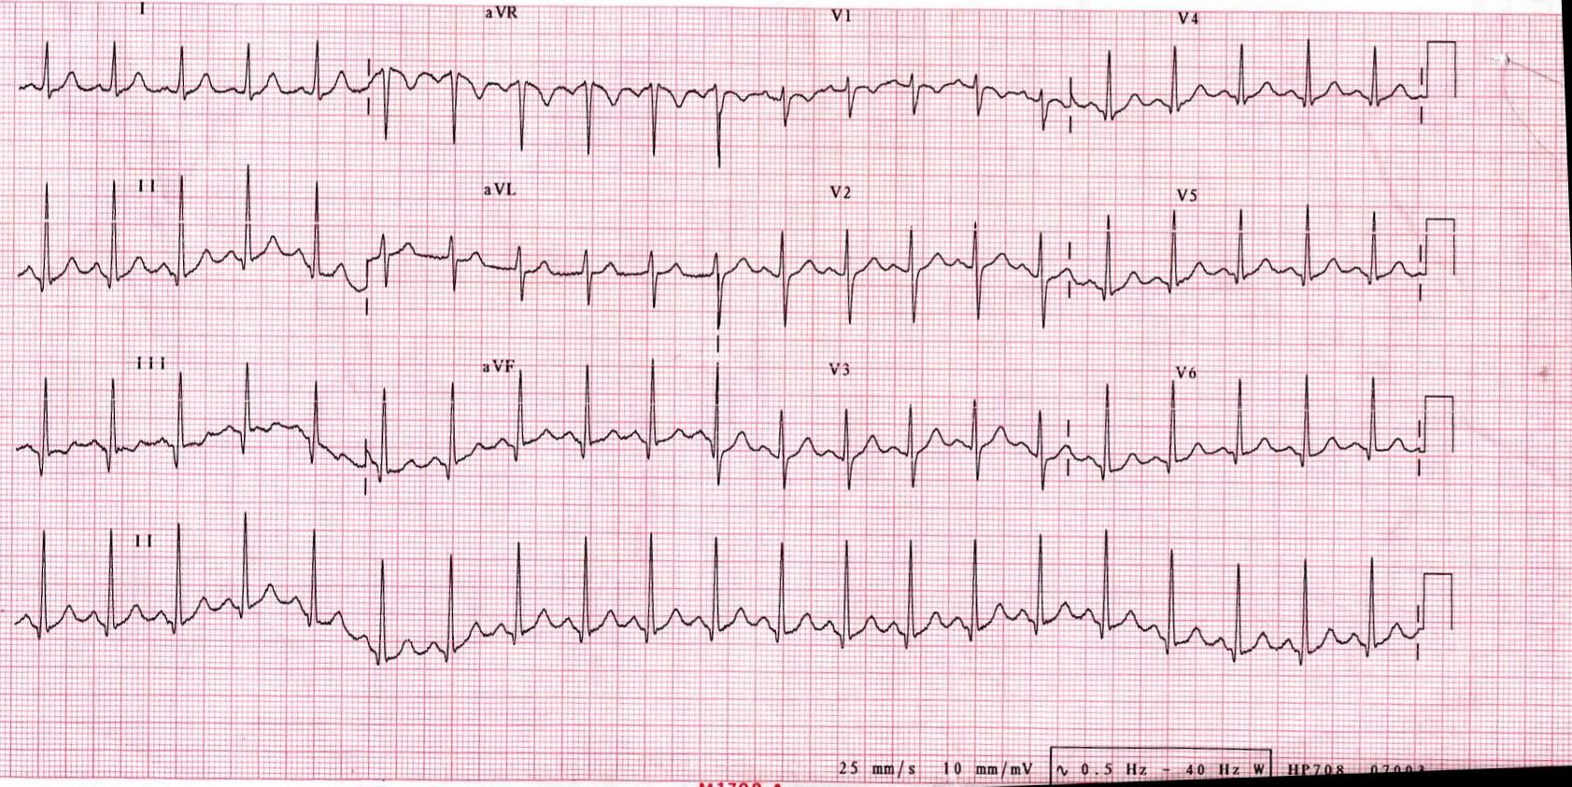
Stimulus #9
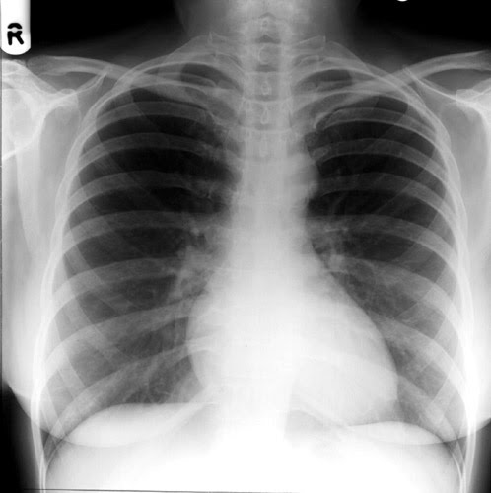
Stimulus #10
Stimulus #11

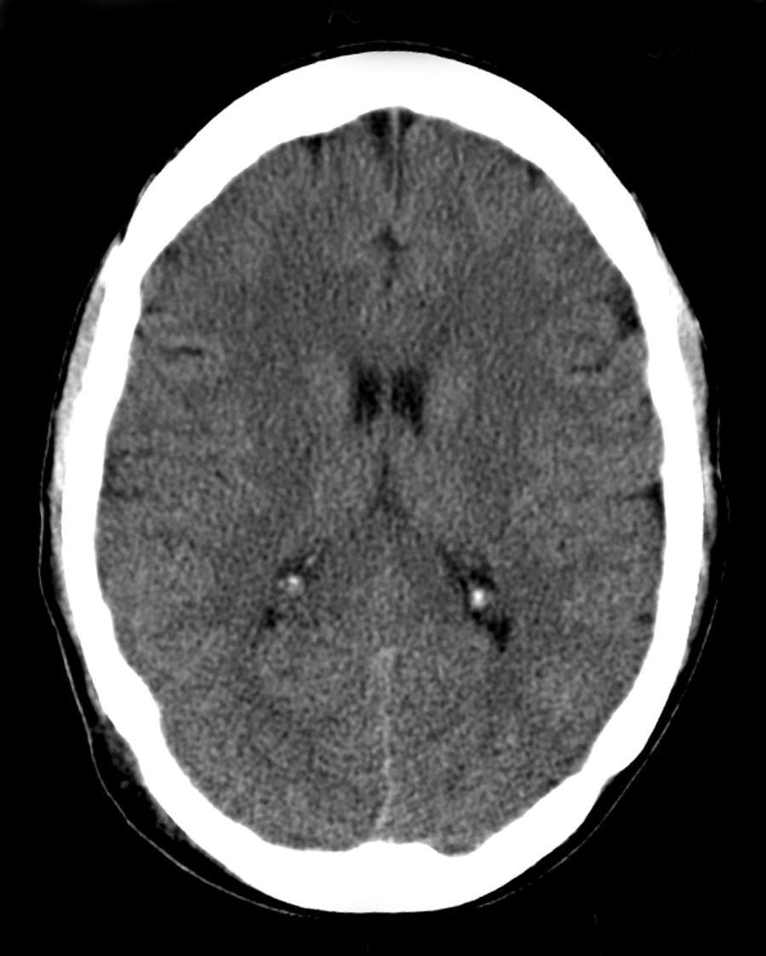

Feedback/ Assessment Forms

Hyperosmolar Hyperglycemic State

Candidate ________________________ Examiner _________________________

Critical Actions:

- Demonstrates knowledge of primary assessment to look for causes of AMS (PC, MK, PBL) DON’T M _{IV} (Dextrose, Oxygen, Narcan, Thiamine, Monitor and IV in the primary survey.
- Initiation of advanced access (PC, MK) should be done immediately after primary survey (large bore IV’s, CVC access or IO may be acceptable) .Alternative to peripheral IV should be initiated IV/IO/central line after 3 peripheral IV attempts.
- Initiation of immediate aggressive fluid resuscitation
- Initiation of appropriate insulin therapy at 0.1units/kg/hour
- Initiation of treatment of UTI with Levofloxain or Ceftriaxone IV as a source of infection(PC, MK)
- Demonstrates effective communication of the management and treatment with patient’s daughter (P, ICS) as soon as patient is stabilized
- Admission to ICU bed

Dangerous Actions: (Performance of one dangerous action results in failure of the case)

- Dangerous Action #1 Failure to evaluate causes of AMS (CT head, EKG, infection eval, glucose)
- Dangerous Action # 2 Refusal to speak with patient’s daughter

Overall Score:

- Pass
- Fail

For Examiner

Date: Examiner: Examinee(s):
Scoring: In accordance with the Standardized Direct Observational Tool (SDOT)

The learner should be scored (based on level of training) for each item above with one of the following:
NI = Needs Improvement
ME = Meets Expectations
AE = Above Expectations
NA= Not Assessed
Critical Actions | NI | ME | AE | NA | Category
Place patient on cardiac monitor with pulse oximetry |  |  |  |  | PC, MK, PBL
Obtain bedside blood glucose |  |  |  |  | PC, MK
Obtain access: external jugular IV/ IO/ central access |  |  |  |  | PC, MK, PBL
Initiate aggressive fluid resuscitation (2-4L in ED) |  |  |  |  | PC, MK, PBL
Initiation of IV insulin drip of 0.1 units/kg/hr |  |  |  |  | PC, MK, PBL
Recognize likelihood for infectious stressor, identify and treat |  |  |  |  | PC, MK, PBL
Search for other causes of altered mental status - CT, EKG in secondary survey |  |  |  |  | PC, MK, PBL
Assess possible need for potassium replacement (Foley, serum K, EKG) |  |  |  |  | PC, MK, PBL
Demonstrate / utilize effective communication techniques with anxious family member |  |  |  |  | MK, ICS, P

The score sheet may be used for a variety of learners. For example, in using the case for 4th year medical students, the key teaching points of the case may be the recognition of shock and treatment with appropriate fluid resuscitation. Other items may be marked N/A= not assessed.

Category: One or more of the ACGME Core Competencies as defined in the SDOT

PC= Patient Care
Compassionate, appropriate, and effective for the treatment of health problems and the promotion of health
MK= Medical Knowledge
Residents are expected to formulate an appropriate differential diagnosis with special attention to life-threatening conditions, demonstrate the ability to utilize available medical resources effectively, and apply this knowledge to clinical decision making
PBL= Practice Based Learning & Improvement
Involves investigation and evaluation of their own patient care, appraisal and assimilation of scientific evidence, and improvements in patient care
ICS= Interpersonal Communication Skills
Results in effective information exchange and teaming with patients, their families, and other health professionals
P= Professionalism
Manifested through a commitment to carrying out professional responsibilities, adherence to ethical principles, and sensitivity to a diverse patient population
SBP= Systems Based Practice
Manifested by actions that demonstrate an awareness of and responsiveness to the larger context and system of health care and the ability to effectively call on system resources to provide care that is of optimal value

Debriefing Materials
Hyperglycemic Hyperosmolar State – Debriefing

Patient History

HHS usually develops in patients with preexisting type 2 diabetes (insulin resistance), although for about 20% of patients, HHS is the first time they are diagnosed with DM. Occurs more often in those older than 65 years. Common precipitating factors of HHS include impaired thirst (elderly and/or after stroke), conditions that cause dehydration (dialysis, excessive diuresis, burns), infection, surgery, pregnancy, critical illness and medications. It develops more slowly than DKA, with polydipsia, polyuria and weight loss often preceding admission by several days.

Physical Exam

The common term “hyperosmolar nonketotic coma” is misleading because mild ketosis can exist and coma is rare. Neurologic manifestations can be more severe than in DKA because hyperosmolarity is present to a greater degree. Findings can range from confusion to seizures to focal deficits to obtundation or true coma. Findings also frequently include moderate to severe clinical dehydration, with varying degrees of tachycardia, tachypnea, hypotension, dry mucous membranes and poor skin turgor. Patients generally do not have the fruity breath or Kussmaul respirations as in DKA because the ketosis is minimal to absent.

Lab and Imaging Studies

Glucose > 600 mg/dl (often >1000 mg/dl)

Serum Osmolality > 330 mOsm/kg

Arterial pH usually greater than 7.3

Serum bicarbonate > 18 mEq/L

Possible mild ketonuria or ketonemia

Other studies should be done to rule out precipitants of HHS or other causes of altered mental state.

Management

Mortality rates in HHS are much higher than in DKA and have been reported to range from 10% to 50%.

Fluid deficits average 9L in HHS, aggressive fluid resuscitation is imperative (2-3 L over the first several hours). Use .9% NaCl in hypovolemic shock and when serum sodium is low; .45% NaCl should be given when the serum sodium is normal or high. Correct half of the fluid deficit in first 8 hours, remainder over 24 hours

Total body potassium deficits average 4-6 mEq/kg. Replacement should be started with addition of 20-40 mEq of KCl to each liter of fluid and carefully monitored after anuric renal failure is ruled out. Serum magnesium and phosphorus levels may also be artificially high secondary to volume depletion.

Insulin infusion should be started early. Bolus with 0.05 - 0.1 units/kg followed by a drip of 0.05 - 0.1 units/kg/hr with hourly glucose checks is standard therapy. Bolus is debated in terms of necessity. Add 5% dextrose to rehydration fluid as glucose improves to about 300 mg/dl.

Administration of bicarbonate should be reserved for patients whose pH is < 7.0 (usually only seen in DKA).

References:
Piccini and Nilsson: The Osler Medical Handbook, 2nd Ed, 2006

“Hyperosmolar Hyperglycemic State” in eMedicine. Found at www.emedicine.com. 2010

“Protocol for Management of Adult Patients with Hyperglycemic Hyperosmolar State (HHS)” and “Diagnostic Criteria for DKA and HHS” found at www.spectrum.diabetes.journals.org. 2010

Rosen’s Emergency Medicine, 7th Ed, 2009

Keywords
hyperosmolar, HHNK, hyperosmolar nonketotic coma, hyperosmolar hyperglycemic state.

Has this work been previously published?
No

