Authors: Maya Lin, MD Reviewer: Sharon Griswold, MD
Christine Yang-Kauh, MD

Case: Thyroid Storm

Target Audience: med students, nurses, paramedics, residents, other

Primary Learning Objectives:
- Recognition and management of thyroid storm
- Recognition and management of secondary atrial fibrillation with rapid ventricular response
- Recognition and management of secondary hyperthermia

Secondary Learning Objectives:
- Utilization of alternative historians in patient with altered mental status
- Identification of substance abuse
- Devise a treatment plan for patient with thyroid storm in the setting of cocaine use
- Arrange an appropriate disposition plan

Critical Actions:
- Obtain history of hyperthyroidism (History and Physical Examination)
- Obtain history or discover evidence of cocaine use (History and Physical Examination)
- Adequate fluid resuscitation (Patient Therapy)
- Monitor (Patient Therapy)
- Timely acquisition of and correct interpretation of EKG (History and Physical Examination)
- Diagnosis and treatment of atrial fibrillation (Medical Logic and Patient Therapy)
- Treatment of fever with Tylenol and cooling pads (Medical Logic and Patient Therapy)
- Diagnosis and treatment of thyroid storm (Medical Logic and Patient Therapy)
- ICU admission (Patient Therapy)

Environment:
1. Room Set Up
a. Manikin Set Up
b. Props-- Clothing with baggie of coke in pocket (if desired)

2. Distractors
a. Pt’s clothes are tight, layered, difficult to remove, dirty
b. Pt’s husband is concerned and asking the physician for an explanation of what is going on. He is scared because they have a young child at home
c. Delay in EKG tech arriving to do EKG, if the physician does not remember receiving the EKG, prompt to remind him to ask for it again.
Actors:
- Roles: Husband, EMT, Nurses, Residents
- Who may play them: medical students, residents, etc.
For Examiner Only

Authors: Maya Lin, MD Reviewer: Sharon Griswold, MD
Christine Yang Kauh, MD

Case: Thyroid Storm
CASE SUMMARY
CORE CONTENT AREA
Endocrinology, Toxicology

SYNOPSIS OF CASE
This is a 45 year old female in Thyroid Storm due to underlying untreated hyperthyroidism and triggered by recent cocaine use. The medical history must be obtained from her husband, and an appropriate review of systems and physical will reveal further cues to underlying hyperthyroidism. It is critical that a social history is obtained, or that the patient is undressed which will allow a bag of cocaine to fall from her pocket, revealing the cocaine use.

Initial measures include adequate hydration and management of the tachycardia and fever. Tachycardia should spur an EKG and ongoing monitoring. Rapid atrial fibrillation can be treated with calcium channel blockers but will show improvement once thyroid medication is started. Beta blockers should be avoided due to existing hypertension and cocaine use. The fever should be managed with Tylenol and active cooling methods as needed.

Most importantly, antithyroid medication and steroids must be given to treat thyroid storm. This will also provide the most relief for the tachycardia and other symptoms. Extra points are given for planning to administer an iodine compound more than an hour after the PTU or methimazole. On the other hand, giving iodine too early is a dangerous action. Endocrine consult and poison control or toxicology consult should be called. The patient must be admitted to an ICU bed.

SYNOPSIS OF HISTORY
The patient is agitated and unable to provide a coherent history. Her husband is present at bedside. When asked, he states that she has had a 3-day history of nausea, vomiting, diarrhea, abdominal pain, agitation, nervousness, and palpitations. Additional history reveals that the patient was diagnosed with hyperthyroidism, but lost her job and insurance coverage and has not followed up with her doctor or filled her prescriptions. When asked specifically about drug use, her husband states that she has recently started using cocaine again at least once a day in the mornings as a “pick-me-up.” A relevant review of systems will also reveal a decrease in appetite and a weight loss of 30 pounds over the past 2 months.

SYNOPSIS OF PHYSICAL
The patient has the classic findings of hyperthyroidism that will be obvious under specific examination. She is thin, diaphoretic, with exophthalmos and thyromegaly. In this acute illness, she is tachycardic, hypertensive and hyperthermic by vital signs, and her physical exam shows she is also dehydrated, agitated and anxious with a resting tremor, and has mild diffuse abdominal tenderness without peritoneal signs.

For Examiner Only
Critical Actions
- Critical Action: Obtain Temperature (Patient Therapy)

This critical action is met by noting incomplete vital signs and requesting the temperature.

Cueing Guideline: Nurse or husband states “She’s so hot, I think she’s burning up”.

- Critical Action: Obtain History of Hyperthyroidism (History and Physical Examination)

This critical action is met by asking her husband.

Cueing Guideline: Husband is anxious and asks if there is anything he can do to help.

- Critical Action: Obtain History of or Discover Evidence of Cocaine Use (History and Physical Examination)

This critical action is met by asking her husband or by doing a full physical exam including a secondary survey that reveals a small bag of white powder in the patient’s pants pocket. Subsequent drug screen should be sent.

Cueing Guideline: Patient can state that she feels hot and wants to change her clothes. Nurse could say “what is that in her pocket?” if rectal temp is requested. Or husband can say “I’m concerned that the drugs are causing this!” Depending on participants’ level of training.

- Critical Action: Administer Adequate Fluid Resuscitation (Patient Therapy)

This critical action is met by aggressive treatment of hypovolemia. There are no contraindications to fluid in this case. The patient should receive at least 2L of NS.

Cueing Guideline: Patient can say “ I’m so thirsty! I need a drink! Please!”

- Critical Action: Monitor (Patient Therapy)

This critical action is met by ensuring that the patient is placed on cardiac monitoring, with blood pressure, and pulse oximetry.
Cueing guideline: Nurse or husband noted that patient’s heart rate seems to be very fast.

- Critical Action: Timely Acquisition of and Correct Interpretation of ECG (History and Physical Examination)

This critical action is met by obtaining an ECG and interpreting it as rapid atrial fibrillation within the early stages of the case.

Cueing Guideline: The patient’s husband remembers patient stating that she felt had palpitations.

- Critical Action: Treatment of Rapid Atrial Fibrillation (Medical Logic and Patient Therapy)

This critical action is met by recognizing the rhythm and administering a calcium channel blocker.

Beta blockers should be avoided due to the risk of severe hypertensive crisis in the presence of cocaine. B1 selective beta blocker such as atenolol or metoprolol should not be used. Non selective beta blockers such as propranolol can be debated.

Cueing Guideline: Nurse or husband may ask, “What are you going to do for her fast heart rate?”

- Critical Action: Management of Fever (Medical Logic and Patient Therapy)

This critical action is met by identification of fever and treatment with acetaminophen. Aspirin should NOT be used due to its effects on protein binding of FT4 and T3. Active cooling with a cooling blanket can be helpful for severe hyperthermia.

Cueing guideline: The examiner may note the nurse, tech, or husband saying “she feels really hot to the touch”.

- Critical Action: Treatment of Thyrotoxicosis with PTU or Methimazole (Medical Logic and Patient Therapy)

This critical action is met by inhibition of hormone synthesis with PTU 400mg or methimazole 20mg orally.

Steroids (Hydrocortisone 100 mg IV or Dexamethasone 8 mg IV) should be given to block the peripheral effects of T4 conversion and for stress dose steroids.

Although it would be beyond the timeframe of the case, blockage of hormone release with iodine ( KI 5 drops orally or Lugol’s solution 10 drops orally or NaI 1g IV) more than an hour AFTER PTU or Methimazole to avoid encouraging further synthesis of thyroid hormones is a bonus. Points should be taken off for administering it without delay since it could stimulate further hormone release, constituting a harmful action.

Typically Propranolol is given for the cardiac symptoms, but should be avoided here due to the cocaine in her system. Ativan and calcium channel blockers should be considered.

Cueing guideline: The examiner may note that lab calls to report low TSH, elevated FT4 and FT3. (Only if these tests are ordered by participants).

- Critical Action: ICU Admission (Patient Therapy)

This critical action is met by requesting and admitting to the intensive care unit. The body’s stores of hormone can continue to be released for weeks despite inhibition of synthesis. The patient will need to be monitored closely, especially in the acute setting when cocaine metabolites could trigger another thyroid storm.

Cueing Guideline: Husband asks if she has to stay in the hospital, PMD says, “she sounds pretty sick”.

SCORING GUIDELINES
(CRITICAL ACTION NO.)
1. Score down if temperature not obtained
2, Score down if history is not obtained from husband.
3. Score down if cocaine use is not discovered.
4. Score down if IVF are not administered. Score up if administers at least 2L of normal
saline.
5. Score down if patient is not placed on cardiac monitor.
6. Score down if EKG is not obtained and interpreted correctly within 5 minutes.
7. Score down if beta blockers are used.
8. Hyperthermia should be treated with acetaminophen. Score up for active cooling.
Score down if Aspirin is used to treat fever.
9. Score down if patient does not administer PTU or methimazole. Score up for “stress
dose” steroids. Score up for waiting 1 hour prior to administering iodine-containing
compounds. Score down if iodine administered earlier.
10. Score down if not admitted to an ICU bed.
For Examiner Only

HISTORY

Onset of Symptoms: 3 Days

Background Info: This is 45 year old woman presents with 3 day history of nausea, vomiting, diarrhea, abdominal pain, agitation, nervousness, and palpitations. No chest pain or difficulty breathing. The patient is too agitated and uncomfortable to provide a history.

Chief Complaint: Agitation and palpitations

Past Medical Hx: “Gland problem” that she was recently diagnosed with but has not been to the doctor to follow up, hasn’t filled her prescription and can’t remember the name of the medication.
Last Meal: 3 days ago

Past Surgical Hx: Cholecystectomy 5 years ago

Allergies: NKDA

Habits: Smoking: social
Drugs: Dabbled in drugs in college. Recently has been using cocaine again. 1-2 times a day as far as husband can tell.
ETOH: social

Family Medical Hx: Father: died of MI at age 65
Mother: also had the same gland problem
Siblings: none

Social Hx: Married: Yes
Children: 7 year old son
Employed: recently lost her job and lost health insurance coverage
Education: College
PMD: Dr. P Smith

ROS: Nausea, Vomiting (non-bilious, non-bloody 2-3 times a day), diarrhea (loose), abdominal pain, feelings of nervousness, and palpitations. No chest pain, no difficulty breathing.

For Examiner Only
PHYSICAL EXAM

Patient Name: Susan Flower Age & Sex: 45 year old female

General Appearance: Consistent with stated age, agitated, anxious, very thin ~ 100 lbs, diffusely diaphoretic, sitting up in bed, fidgety.

Vital Signs:
BP 190/ 90
P 140, irregularly irregular
R 20/min
O2 Sat 99%
FS 210
T 105 (IF REQUESTED)

Head: No evidence of trauma. Hair is very fine and thin. (IF ASKED)

Eyes: PERRL, EOMI, exophthalmos (IF ASKED)

Ears: normal

Mouth: Dry mucus membranes

Nose: nasal septum intact (IF ASKED)

Neck: Supple, nontender, negative Kernig’s and Brudzinski’s
+Nontender thyromegaly and thyroid bruit (ONLY IF ASKED)

Skin: Hot, moist, flushed

Chest: Nontender, + symmetric rise

Lungs: Clear to auscultation, equal breath sounds, no wheezing, rales or rhonchi

Heart: Tachycardic, irregularly irregular, normal S1, S2, no murmur, rub, or gallop

Back: no midline or cva tenderness

Abdomen: diffuse moderate tenderness throughout abdomen, + BS, soft, no rebound, guarding or mass

Extremities: no edema

Rectal: + tone, - guaiac

Pelvic: Normal (Not necessary)

Neurologic: Fine resting tremor. Reflexes normal. 5-/5 motor exam in all extremities. Normal cerebellar exam. Anxious, fast and pressured speech.

Mental Status: Alert, agitated. Answers some questions briefly, but loses her train of thought. Oriented to person and place only.
For Examiner Only

STIMULUS INVENTORY

#1 Emergency Admitting Form

#2 Complete Blood Count

#3 Basic Metabolic Panel

#4 Liver Function Tests

#5 Cardiac Enzymes

#6 Urinalysis

#7 Urine Pregnancy Test

#8 Thyroid Panel

#9 Toxicology

#10 EKG

#11 CXR

For Examiner Only
LAB DATA & IMAGING RESULT

Stimulus #2 Stimulus #6
Complete Blood Count (CBC) Urinalysis (U/A)
WBC 13,400 /mm³ Bili Negative
Hgb 14.8 gm/dL Blood Negative
Hct 42% Ketone Negative
Platelets 230,000 /mm³ Leuk Negative
Differential RBC 0/HPF
Segs 60% WBC 0/HPF
Lymphs 20% Casts 0/HPF
Monos 4% Nitrite Negative
Eos 7% Protein Negative
Specific Gravity 1.002
Urine pH 5
Stimulus #3 Urobilinogen 0.2 EhrU/dL
Basic Metabolic Profile (BMP)
Na⁺ 140 mEq/L Stimulus #7
K⁺ 4.9 mEq/L Urine Pregnancy Negative
Cl⁻ 100 mEq/L
HCO₃ 23 mEq/L Stimulus #8
Glucose 201 mg/dL Thyroid Panel
BUN 30 mg/dL TSH 0.1 mIU/ml
Creatinine 1.4 mg/dL Free T4 100.0 mcg/dL
Ca 12 mg/dL T3 320 ng/dL

Stimulus #4 Stimulus #9
LFTs Toxicology
ALT 30 U/L Urine
Albumin 8.0 U/L Marijuana Negative
AST 80 U/L Cocaine Positive
Total Bili 2.5 mg/dL Amphetamines Negative
Direct Bili <0.5 mg/dL Benzodiazepines Negative
Barbiturates Negative
Stimulus #5 Phencyclidine Negative
Cardiac Enzymes
Troponin <0.01 ng/ml Serum
Tylenol Undetectable
Salicylates Undetectable
Alcohol Undetectable

Stimulus #10
EKG

Stimulus #11
CXR
Learner Stimulus #1

ABEM General Hospital
Emergency Admitting Form

Name: Susan Flowers
Age: 45
Sex: Female
Method of Transportation: Private Vehicle
Person giving information: Husband
Presenting complaint: Agitation and palpitations

Background: 3-day history of nausea/vomiting, abdominal pain, agitation, nervousness, and palpitations.

Vital Signs
BP 190/ 90
P 140
R 20/min
O2 Sat 99%
FS 210

Learner Stimulus #2

Complete Blood Count (CBC)

WBC 13,400 / mm3
Hgb 14.8 gm/dL
Hct 42%
Plt 230,000/mm3

Diff
Segs 60%
Lymphs 20%
Monos 4%
Eos 7%

Learner Stimulus #3

Basic Metabolic Profile (BMP)
Na⁺ 140 mEq/L
K⁺ 4.9 mEq/L
HCO3⁻ 23 mEq/L
Cl⁻ 100 mEq/L
Glucose 201 mg/dL
BUN 30 mg/dL
Creatinine 1.4 mg/ dL
Ca 12 mg/dL

Learner Stimulus #4

Liver Function Tests (LFTs)
ALT 30 U/L
Albumin 8.0 U/L
AST 80 U/L
Direct Bili <0.5mg/dL
Total Bili 2.5 mg/dL

Learner Stimulus #5

Cardiac Enzymes
Troponin T <0.01

Learner Stimulus #6

Urinalysis(U/A)
Bili negative
Blood negative
Ketone negative
Leuk negative
RBC 0/HPF
WBC 0/HPF
Casts 0/HPF
Nitrite negative
Protein negative
Specific Gravity 1.002
Urine pH 5
Urobilogen 0.2 HerU/dl

Learner Stimulus #7

Urine pregnancy test: Negative

Learner Stimulus #8

Thyroid Panel
TSH 0.1 mIU/ml
Free T4 100.0 mcg/dl
T3 320ng/dL

Learner Stimulus #9

Toxicology

Urine
Marijuana Negative
Cocaine Positive
Opiates Negative
Amphetamines Negative
Benzodiazepines Negative
Barbituates Negative
Phencyclidine Negative

Serum
Tylenol Undetectable
Salicylates Undetectable
Alcohol Undetectable
Learner Stimulus #10

ECG
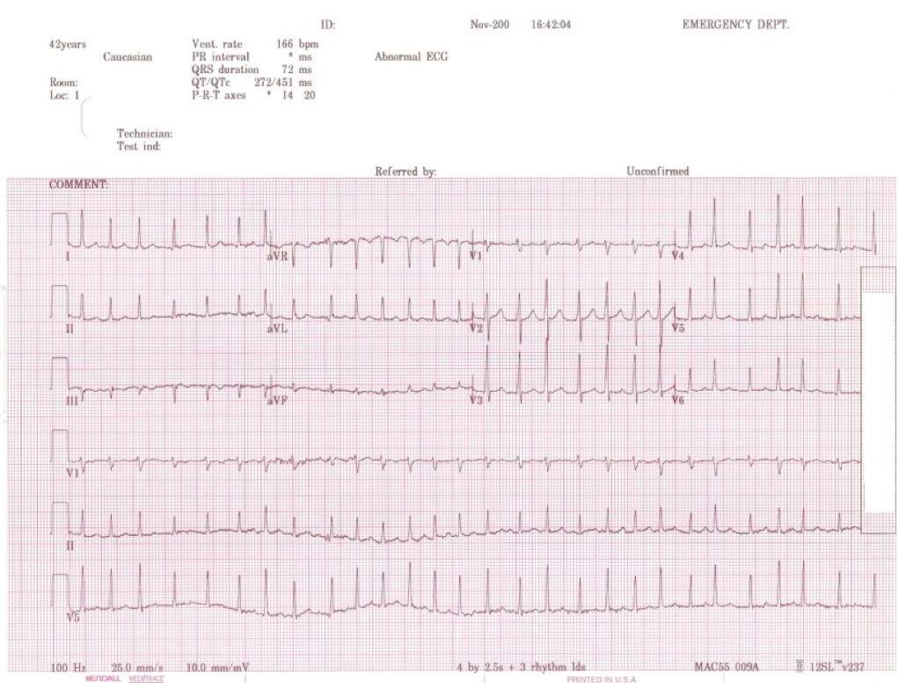

http://www.sixforksems.com/pg-pk-ekg-apr-07-diag.html

Learner Stimulus #11

CXR
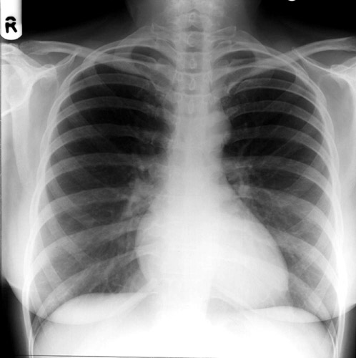
http://www.medicine.cu.edu.eg/english/students/study/x_ray_surgery/xray/chest/131.htm

Feedback/Assessment Form
Thyroid Storm

Candidate ________________________ Examiner _________________________

Critical Actions:

- Critical Action #1 Obtain temperature
- Critical Action #2 Obtain history of hyperthyroidism from husband
- Critical Action #3 Ascertain history/find evidence of cocaine use
- Critical Action #4 Aggressive fluid resuscitation
- Critical Action #5 Placement on cardiac monitor
- Critical Action #6 Timely acquisition of EKG with correct interpretation
- Critical Action #7 Rate control of AF RVR with calcium channel blockers
- Critical Action #8 Management of hyperthermia
- Critical Action #9 Treatment of thyrotoxicosis with PTU or Methimazole
- Critical Action #10 Disposition to ICU

Dangerous Actions: (Performance of one dangerous action results in failure of the case)

- Dangerous Action #1 Giving B1-specific beta-blockers such as metoprolol or
atenolol in acute cocaine use (Unopposed alpha may lead to severe hypertension)
- Dangerous Action #2 Administering aspirin (Releases T3, T4 from protein
binding resulting in greater free, active hormone)
- Dangerous Action #3 Giving iodine containing compounds (KI, NaI or Lugol’s
solution) earlier than 1 hour after PTU or methimazole
(Stimulates further hormone production)

Overall Score:

- Pass
- Fail

For Examiner
Date: Examiner: Examinee(s):
Scoring: In accordance with the Standardized Direct Observational Tool (SDOT)
The learner should be scored (based on level of training) for each item above with one of the following:
NI = Needs Improvement
ME = Meets Expectations
AE = Above Expectations
NA= Not Assessed

Critical Actions | NI | ME | AE | NA | Category
Obtain temperature |  |  |  |  | PC, MK, PBL
Obtain history of hyperthyroidism |  |  |  |  | PC, ICS
Discover cocaine use in non-judgmental fashion |  |  |  |  | PC, ICS, P
Perform adequate fluid resuscitation, 2L |  |  |  |  | PC, MK, PBL
Place patient on cardiac monitor with pulse oximetry |  |  |  |  | PC, MK, PBL
Obtain bedside ECG |  |  |  |  | PC, MK
Diagnose and treat AF RVR in the setting of acute cocaine use |  |  |  |  | PC, MK, PBL
Management of hyperthermia |  |  |  |  | PC, MK, PBL
Treatment of thyrotoxicosis |  |  |  |  | PC, MK, PBL
Discussion with intensivist and admission to ICU |  |  |  |  | PC, ICS, MK, P, PBL, SBP
Demonstrate / utilize effective communication techniques such as specifying order details and closed loop communication |  |  |  |  | MK, ICS

The score sheet may be used for a variety of learners. For example, in using the case for 4th year medical students, the key teaching points of the case may be the recognition of shock and treatment with appropriate fluid resuscitation. Other items may be marked N/A= not assessed.

Category: One or more of the ACGME Core Competencies as defined in the SDOT
PC= Patient Care
Compassionate, appropriate, and effective for the treatment of health problems and the promotion of health
MK= Medical Knowledge
Residents are expected to formulate an appropriate differential diagnosis with special attention to life-threatening conditions, demonstrate the ability to utilize available medical resources effectively, and apply this knowledge to clinical decision making
PBL= Practice Based Learning & Improvement
Involves investigation and evaluation of their own patient care, appraisal and assimilation of scientific evidence, and improvements in patient care
ICS= Interpersonal Communication Skills
Results in effective information exchange and teaming with patients, their families, and other health professionals
P= Professionalism
Manifested through a commitment to carrying out professional responsibilities, adherence to ethical principles, and sensitivity to a diverse patient population
SBP= Systems Based Practice
Manifested by actions that demonstrate an awareness of and responsiveness to the larger context and system of health care and the ability to effectively call on system resources to provide care that is of optimal value

Discussion: Thyroid Storm Triggered by Cocaine Use

Susan Flower has thyroid storm due to uncontrolled hyperthyroidism and triggered by cocaine use.

Thyroid storm, or thyrotoxic crisis, is a rare but life-threatening state caused by a sudden overwhelming excess of thyroid hormone. Due to the hormone’s widespread actions, the presentation and severe complications of thyroid storm can involve virtually any combination of organ systems. The diagnosis is a clinical one, since there is no test that can distinguish between hyperthyroidism and thyroid storm. Unfortunately, there is also no single pathognomonic finding or criterion to make the diagnosis. A careful history and high suspicion are essential since the most common findings of high fever, tachycardia, and CNS irritation (agitation, tremulousness, delirium or psychosis) can be symptomatic of many conditions of high morbidity. Furthermore, the involvement of other systems only serves to widen the differential.

This patient’s differential diagnosis includes abdominal or CNS infection, psychiatric issue or drug overdose, particularly once the history of cocaine use and recent stressors is uncovered. Since the history of recent drug use is second hand it cannot be considered complete and coingestion must be considered.

Although thyroid storm can occur from excess exogenous hormone, it is most commonly due to an exacerbation of undertreated hyperthyroidism by some sort of trigger. The most common cause of hyperthyroidism is Grave’s disease which typically is seen in women in their 40’s and 50’s. Toxic multinodular and toxic uninodular goiters are less common causes. Trauma, surgery or manipulation of the thyroid, infection or an iodine load can act as inciting events.

The mechanism of the progression from hyperthyroidism to thyrotoxicosis to a thyroid storm is not well understood. Despite patients having signs of adrenergic hyperactivity, the levels of catecholamines are not elevated. However, adrenergic blockade is used to help control symptoms. Regardless of thyroid hormone’s inotropic and chronotropic effects on the heart, thyroid levels are not necessarily elevated during thyroid storm. Thyroid storm is a hypermetabolic state likely due to a combination of adrenergic hyperactivity and a stressor, in an environment of untreated hyperthyroidism.

Signs and symptoms of a patient in thyroid storm include agitation, nervousness, palpitations, high fever, heat intolerance, dyspnea, chest pain, mood swings, weight loss of up to 40 lbs, flushed skin, fine hair. Physical exam will reveal a wide pulse pressure; sinus tachycardia disproportionate to fever that can progress to atrial tachyarrhythmia, lid retraction, lid lag, exophthalmos, extraocular muscle palsies, and proximal myopathy. Cardiac symptoms such as atrial fibrillation and heart failure can occur without any underlying heart disease and are usually refractory to digitalis but improve with treatment of hyperthyroid state. Late progression of thyroid storm is shock and high output heart failure

Clinical recognition of thyroid storm is necessary. Diagnostic tests may confirm hyperthyroidism, but there is no threshold that would indicate thyroid storm. Primary thyroid hyperfunction is shown by elevated free T4 and free T3 and a depressed TSH. A low TSH, normal FT4 and elevated FT3 is also diagnostic. Rarely, thyroid tests may be within a normal range, further obscuring the diagnosis. Hyperglycemia, hypercalcemia, normocytic, normochromic anemia, leukocytosis, decreased cholesterol, and elevated LFTs may be seen.

The clinical diagnosis is further complicated by its broad range of presentation. Thyroid storm has been seen to present with the symptoms of a stroke, liver failure, congestive heart failure, ventricular arrhythmias, multisystem organ failure, psychosis, or even coma.

Earlier recognition and treatment of hyperthyroidism and increased preoperative testing has made thyroid storm very rare, occurring only in 1-2% of patients with hyperthyroidism.

Mortality is high if untreated. Thyroid storm was a death sentence in the early 1900’s. However mortality declined to about 20% due to early recognition and aggressive treatment. Death is now more likely due to the conditions precipitating the thyroid storm. Thus, the identification and management of the triggering condition is just as important as the early diagnosis and treatment of the thyrotoxic crisis.

There are 5 key steps to the management of thyroid storm
(1) Inhibiting hormone synthesis,
(2) Blocking of hormone release,
(3) Preventing the peripheral conversion of T4 to T3,
(4) Blocking the peripheral effects of the hormones,
(5) Providing supportive care.

Thioamides, such as PTU and methimazole, inhibit thyroidal peroxidase, thereby preventing hormone synthesis. They do not interfere with hormone release. Onset: 1-2 hours.

Methimazole
Dosing: 20 mg orally every 4 hours
Lasts longer than PTU.
Does not inhibit peripheral conversion so requires coadministration with a medication that does (e.g. steroids).
Not to be used in 1st trimester pregnancy .

Propothiouracil (PTU)
Dosing: initial dose of 600-1000mgPO/PR
200-250mg every 4-6 hours thereafter.
Extra benefit of inhibiting peripheral conversion.
FDA black box warning for potential to cause liver failure.
As a result, now considered 2nd line.
Indications: allergy to methimazole, 1st trimester pregnancy

Iodine containing compounds inhibit thyroid hormone release. This is necessary because the body has stores of T4 and T3 which will continue to be released for weeks. Caution must be maintained to give iodine more than an hour after the administration of medications inhibiting synthesis, otherwise it can be used as raw materials and cause a greater exacerbation.

Lugol’s iodine solution
10 drops every 8 hours

Saturated Solution of Potassium Iodide (SSKI)
5 drops orally every 8 hours

Steroids are the mainstay in blocking T4 to T3 conversion. They also correct relative adrenal insufficiency. Their immunosuppressant activity may also treat underlying autoimmune hyperthyroidism if present. They have been shown to improve survival.

Dexamethasone
Dosing: 2mg IV every 6 hours.

Hydrocortisone
Dosing: 100mg IV

Beta adrenergic blockade is of major importance in the management of the symptoms of hyperthyroidism for the treatment of associated dysrhythmias, hyperpyrexia, tremors, palpitations, and anxiety. Dramatic improvement can be seen in as little as 10 minutes after it is given.

Care must be taken if contraindications to beta-blockade, such as CHF, active asthma exacerbation, or acute cocaine use (as in this patient) are present. For patients in whom beta blockade is contraindicated, calcium channel blockade may be used.

This patient’s atrial fibrillation with rapid ventricular response should be rate controlled, first by treating the fever and dehydration, then by pharmacologic means. Propranolol is often the first choice of beta blocker for thyroid storm. Although it is better to avoid beta blockers in this patient due to concern for severe hypertension from unopposed alpha adrenergic activity in the setting of acute cocaine use and the existing hypertension, propranolol may be a better choice than metoprolol or atenolol which are beta1 selective. A calcium channel blocker is preferred in this case.

Propranolol
Non-selective beta blocker
Dosing: Slow 1-2mg boluses IV every 10-15 minutes
Extra benefit of blocking peripheral conversion of T4 to T3

Supportive care includes fever treatment with Acetaminophen. Aspirin is contraindicated because it displaces thyroid hormone from thyroglobulin. Ice packs and cooling blankets may also be used.

Attempts should be made to identify the trigger and treat if possible.

The patient should show improvement of signs and symptoms within 12-24 hours of initiation of treatment and should be monitored in an ICU setting.

Keywords for future searching functions: thyrotoxicosis, thyroid storm, cocaine, atrial fibrillation

References

Borczuk, Pierre MD. Atrial Fibrillation. eMedicine. 2010. July 10. http://emedicine.medscape.com/article/757370-overview

Schraga, Erik D MD. Hyperthyroidism, Thyroid Storm, and Grave’s Disease. eMedicine. 2010. April 23. http://emedicine.medscape.com/article/767130-overview

Sternlicht, Jeffrey and Wogan, John M. “Thyroid and Adrenal Disorders.” Rosen’s Emergency Medicine: Concepts & Clinical Practice. Ed. Marx, John MD, Hockberger, Robert MD, Walls, Ron MD. New York: Elsevier Health Sciences, 2005. 2383-2392

Rao, Rama B. and Hoffman, Robert S. “Cocaine and Other Sympthomimetics.” Rosen’s Emergency Medicine: Concepts & Clinical Practice. Ed. Marx, John MD, Hockberger, Robert MD, Walls, Ron MD. New York: Elsevier Health Sciences, 2005. 1985-1989.

Not previously published

