Author: Debra Heitmann, MD Reviewer: Danielle Hart, MD

Case Title: Human Fight Bite with Deep Tissue Infection

Target Audience: Medical Students, Residents

Primary Learning Objectives: key learning objectives of the scenario
1. Demonstrate a targeted initial approach to evaluation of penetrating hand injuries.
2. Identify the signs, symptoms and complications of human bite injuries to the hand.
3. Develop an approach to the management of infected human bite injuries to extremities.

Secondary Learning Objectives: detailed technical goals, behavioral goals, didactic points
1. Understand the value of taking a thorough history.
2. Understand the pathophysiology of infections from human bites.

Critical actions checklist

1. Obtains true mechanism of injury through HPI
2. Obtains tetanus & HepB vaccination history, and administers Td or TdaP, HepB IgG, and starts hepB vaccination series
3. Performs complete neurovascular exam of the hand
4. Initiates appropriate IV antibiotics to cover gram positives, eikenella & anaerobes
5. Orders Xray of hand
6. Consultation of Hand or Orthopedics service for exploration, irrigation & drainage of wound / deep space infection in OR, and admission for IV antibiotics. Participant should provide a clear summary of findings & diagnosis during this encounter.
7. Provides informative communication with patient

Environment
- Room Set Up – ED examination room
- Mannequin set up
  - None - Standardized Patient Case
  - Moulage - dominant hand moulaged to show a bleeding, purulent, ecchymotic wound over dorsum of MCP joint of ring/pinky fingers, bandage gauze for wound
  - Lines – peripheral IV catheters
  - Fluids – NS or LR
  - Airway equipment - none
  - Drugs / medications
    - Pain medications (IV opiates)
    - Antibiotics to cover human oral flora
- Props
  - EKGs – none
  - X-rays – hand
  - Labs – CBC, BMP, INR, PTT
d. Photos: infected hand from fight bite (optional)

Actors
- Roles – patient, nurse, consultant
Aside from the patient role, the other roles are optional depending on available actors.
- Who may play them – faculty, nurses, other residents, other students, standardized patients
- Action Role – what role do they serve in the scenario?
Patient - the young man is the primary individual that provides the history and demonstrates the hand injury. He is to act reluctant, minimizing the injury and withhold information until prompted further to communicate circumstances of the injury.
Nurse - staff member who will facilitate carrying out orders and delivering medications. Obedient but questions why the need for tests. He/she can also facilitate the case with prompts if needed.
Consultant - the role of Hand Surgery consultant that can be contacted on the phone or arrive in person. The main role is to obtain a verbal presentation of the case and prompt clinical questions to the participant.
For Examiner Only

Author: Debra Heitmann, MD Reviewer: Danielle Hart, MD

Case Title: Human Fight Bite with Deep Tissue Infection

CASE SUMMARY

CORE CONTENT AREA

Musculoskeletal
Infectious Disease

SYNOPSIS OF HISTORY/ Scenario Background
Chief complaint with inaccurate mechanism of injury given freely. All further information must be requested.

Chief Complaint 31 year old male presents to the ED c/o acute hand pain after having fallen 3 days prior. The hand is painful and swollen.

With further questioning & prompting only, patient admits to having punched someone in the face and cut his knuckle, perhaps on the teeth of the victim.

Past medical history Past fracture of opposite hand
Medications and allergies None; NKDA
Family and social history Smoker, Drinker, smokes cannabis
No relevant family history

Vaccination history Last tetanus unknown
Has not had hepatitis B vaccination series

SYNOPSIS OF PHYSICAL

Vital Signs BP: 140/70 P: 110 R: 18 T : 99.0

PE: Right dominant hand demonstrates contusion/laceration of MCP joint of rIng finger with signs of deep tissue infection
hand and fingers are swollen
skin - dorsum of hand is erythematous, ecchymotic, warm
laceration over ring finger MCP( #4) shows purulent/serous discharge
tenderness is present near the wound and along the ring/pinky fingers including palpation of the tendon sheath
fingers have ROM but painful to extend
For Examiner Only

CRITICAL ACTIONS
Scenario branch points/ PLAY OF CASE GUIDELINES

- Critical Action
Patient is prompted to provide a more thorough HPI that reveals a fight bite has occurred.

Details: Patient first states that injury occurred as a result of a fall. Patient should act reluctant or impatient to provide further details. With further prompting, patient reveals that the injury occurred, in fact, not from a fall but a fight. He punched the face/mouth of another man while drinking in a bar. He noticed the cut and bleeding immediately following the punch. He is unsure if his hand struck the teeth of the victim.

Cueing Guideline: If not prompted and case progresses, pt can ask during management "Doc, if I cut this on something other than the ground like .....uh, somebody's jewelry or something, is that more dangerous? "

- Critical Action
Obtains tetanus & HepB vaccination status and administers Td or TdaP, HepB IgG and starts HepB vaccination series.

Detail: Patient should answer questions accurately about PMHx if prompted – states last Td unknown and that he has not had the HepB vaccination series.

Cueing Guideline: If immunization history is omitted, patient can ask during discussion of
treatment, "Doc, i just need the antibiotics and that's all? i am not gonna get something
like AIDS or hepatitis, am I?"

- Critical Action
Performs complete neurovascular exam of the hand

Detail: Patient should cite extreme pain and tenderness to area of laceration and area
surrounding the wound. Testing of motor exam should produce pain proximal and on
palmar side to suggest spread of infection.

Cueing Guideline: If diagnosis of deep tissue infection or worse is minimized, patient can prompt "Doc, how come when i move my fingers, my hand is killing me up here (pointing to the wrist) when the cut is down here at the knuckle?"

- Critical Action
Initiates appropriate IV antibiotics to cover gram positives, eikenella and anaerobes

Detail: Purulence and extent of the infected wound mandates intravenous antibiotics not oral.

Cueing Guideline: If oral antibiotics are chosen, patient and can ask "Are you sure that I can go home with this? This looks really bad and really hurts." If patient’s antibiotic choice does not cover human oral flora, then the nurse can ask, “Are you sure doctor? I haven’t seen that antibiotic used for this type of hand injury before.”

- Critical Action
Orders Xray of hand

Detail: Evidence of direct trauma whether due to fall or disclosed punch warrants an Xray.

Cueing Guideline: If Xray is omitted, patient can prompt "Doc, do you think it's broken?"

- Critical Action
Consultation of Hand / Orthopedics service
Provides clear summary of findings / diagnosis to consultant
Requests operative exploration, irrigation, and drainage of the wound, and admission

Detail: Severity of infected wound necessitates consult and admission to Hand / Orthopedics service. The conversation should be a comprehensive description of findings, test results and clinical impression, with the participants stating that the patient will need to go to the operating room for exploration, irrigation, and drainage.

Cueing Guideline: Any omitted portion of discussion can be prompted by the consultant through opened ended questions, such as "So what do you think is going on?" or “So, what would you like me to do with him?” If further prompting is required, the consultant can ask about the depth of the wound, extent of the infection, or signs of tendon laceration.

- Critical Action
Provides informative communication with patient

Detail: Patient should be kept informed of plans, impression, and provider should answer questions when they arise.

Cueing Guideline: If patient is not well informed, he should inquire further. If still inadequately informed, he can become dissatisfied and upset that he “doesn’t know what is going on.”

SCORING GUIDELINES

1. Participants are scored for the number of critical actions rather than speed of decision making.
2. Emphasis on critical actions can be customized to the level of learner. For instance, medical students may be expected to complete a thorough H/P but may not realize wound exploration is essential.

MS PGY
 |  | 1 | 2 | 3 | 4 |  | 1 | 2 | 3
Critical Actions
Obtains true mechanism of injury from HPI |  |  |  |  | X |  | X | X | X
Obtains tetanus status & Hepatitis hx; gives Td/TdAP, HepB IgG & starts HepB vaccination series |  | X | X | X | X |  | X | X | X
Performs complete neurovascular exam of hand |  |  |  | X | X |  | X | X | X
Administers IV antibiotics |  |  |  |  | X |  | X | X | X
Orders Xray of hand |  |  |  | X | X |  | X | X | X
Consultation of Hand service with clear summary of findings and diagnosis |  |  |  |  | X |  | X | X | X
Provides informative communication with patient |  | X | X | X | X |  | X | X | X

For Examiner Only

HISTORY

Onset of Symptoms: Pain - 3 days ago
Bleeding - 3 days ago
Swelling - the next morning, 2 days
Discharge - 1 day

Background Info: Patient reports having fallen 3 days ago after going out with friends. He thinks he struck his right hand on the ground. He complains of gradual worsening of pain, swelling and discharge from the hand injury since then. Now, he has had difficulty sleeping and finally decided to come to the ED for care.

Chief Complaint: "My hand hurts"

Past Medical Hx: Fracture of Left hand - five years ago - casted
Immunization - Tetanus in public school system
No Hepatitis vaccinations.

Past Surgical Hx: None

Habits: Smoking: 1 PPD
ETOH: 2 beers/day 4 days/week
Drugs: occasional cannabis, No IVDA

Family Medical Hx: N/A

Social Hx: Marital Status: single
Children: none
Education: High School incomplete
Employment: car repair mechanic in local garage

ROS: List pertinent positives and negatives:

Moderate pain at rest which increases with movement of wrist, hand and fingers. no pain in elbow or shoulder
No numbness, tingling in extremity
No fevers or sweats
No weakness, dizziness
No additional myalgias, arthralgias
For Examiner Only

PHYSICAL EXAM

Patient Name: Joseph Wackamole Age & Sex: 21 year old male

General Appearance: Well-developed, well-nourished male in mild distress due to pain

Vital Signs: BP: 140/70 P: 110 R: 18 T : 99.0

HEENT: There is no evidence of trauma. Pupils are equal, round and reactive to light. Extraocular movements are intact. The ear exam is normal. The oral exam is normal.

Neck: The skin is normal in appearance. There is no tenderness to palpation. There is full range of movement.

Skin: The entire skin examination is normal except for the region of the right hand. There is a blanchable erythema without sharp borders localized to dorsum of the right hand surrounding a 2 cm laceration over MCP joint #4. The erythema extends to the ring and pinky fingers. The skin is warm to touch with diffuse tenderness in the hand, especially upon palpation of the two digits. There are no streaks or crepitus proximally. There are no petechia or purpura.

Lungs: Clear to auscultation without wheezes, crackles or rales. Breath sounds are equal bilaterally.

Heart/Vascular:
Tachycardia with regular rate and rhythm. There are no murmurs, rubs or gallops. Pulses are equal and 2+ in all extremities.

Abdomen: Soft, nontender and nondistended. Bowel sounds are normal.

Extremities: The right hand is diffusely swollen. A 2 cm laceration is noted on the dorsum of the MCP Joint of the ring finger and shows some cloudy, serous discharge. There is a blanchable erythema localized to the dorsum of the hand and the ring and pinky fingers. The hand is diffusely tender to palpation without crepitus especially near the wound and the ring finger. Radial and ulnar pulses are 2+. Capillary refill is less than 5 seconds in all fingers. The fingers are resting in a position of slight flexion. Range of motion produces pain in the fingers. Full flexion is possible but extension is limited and painful. Sensory exam is intact.
The wrist, elbow and shoulder examination is normal.

The left hand shows a healed deformity of fourth metacarpal but has full range of motion and neurovascular exam. All other extremities have full range of motion without tenderness.

Neurological: Alert and oriented to person, place and time. Cranial nerves are intact. Sensory exam is intact. Motor examination is normal except for limited strength of the digits of the right hand. Deep tendon reflexes are 2+ in all extremities.

Mental Status: Normal.

For Examiner Only

STIMULUS INVENTORY

#1 Emergency Admitting Form

#2 CBC

#3 BMP

#4 XR Right Hand

#5 Photo of Right Hand (if case is used as an oral case test)

#6 Additional questions for participant

For Examiner Only

LAB DATA & IMAGING RESULTS

Stimulus #2
Complete Blood Count (CBC)

WBC 14 /mm³
Hgb 12.6 g/dL
Hct 35.7 %
Platelets 140 th/mm³
Differential
Segs 85 %
Bands 8 %
Lymphs 15 %
Monos 4 %
Eos 0 %

Stimulus #3

Basic Metabolic Profile (BMP)

Na⁺ 135 mEq/L
K⁺ 4.4 mEq/L
CO₂ 28 mEq/L
Cl⁻ 108 mEq/L
Glucose 110 mg/dL
BUN 12 mg/dL
Creatinine 0.5 mg/dL

Diagnostic Imaging

Stimulus #4
XR R Hand: No fracture, + soft tissue swelling

Stimulus #5
Photo R Hand: swollen right hand with laceration over MCP #4

Learner Stimulus #1

ABEM General Hospital

Emergency Admitting Form

Name: Joseph Wackamole
Age: 21 years
Sex: Male
Method of Transportation: Private car
Person giving information: Self
Presenting complaint: Pain to right hand

Background: Patient reports having fallen 3 days ago after going out with friends. He thinks he struck his right hand on the ground. He complains of gradual worsening of pain, swelling and discharge from the hand injury since then. Now, he has had difficulty sleeping and finally decided to come to the ED for care.

Triage or Initial Vital Signs
BP: 140/70
P: 110
R: 18
T : 99.0 T

Learner Stimulus #2

Complete Blood Count (CBC)

WBC 14 /mm³
Hgb 12.6 g/dL
Hct 35.7 %
Platelets 140 th/mm³
Differential
Segs 85 %
Bands 8 %
Lymphs 15 %
Monos 4 %
Eos 0 %

Learner Stimulus #3

Basic Metabolic Profile (BMP)

Na⁺ 135 mEq/L
K⁺ 4.4 mEq/L
CO₂ 28 mEq/L
Cl⁻ 108 mEq/L
Glucose 110 mg/dL
BUN 12 mg/dL
Creatinine 0.5 mg/dL

Learner Stimulus #4 - XRAYS 1 of 3

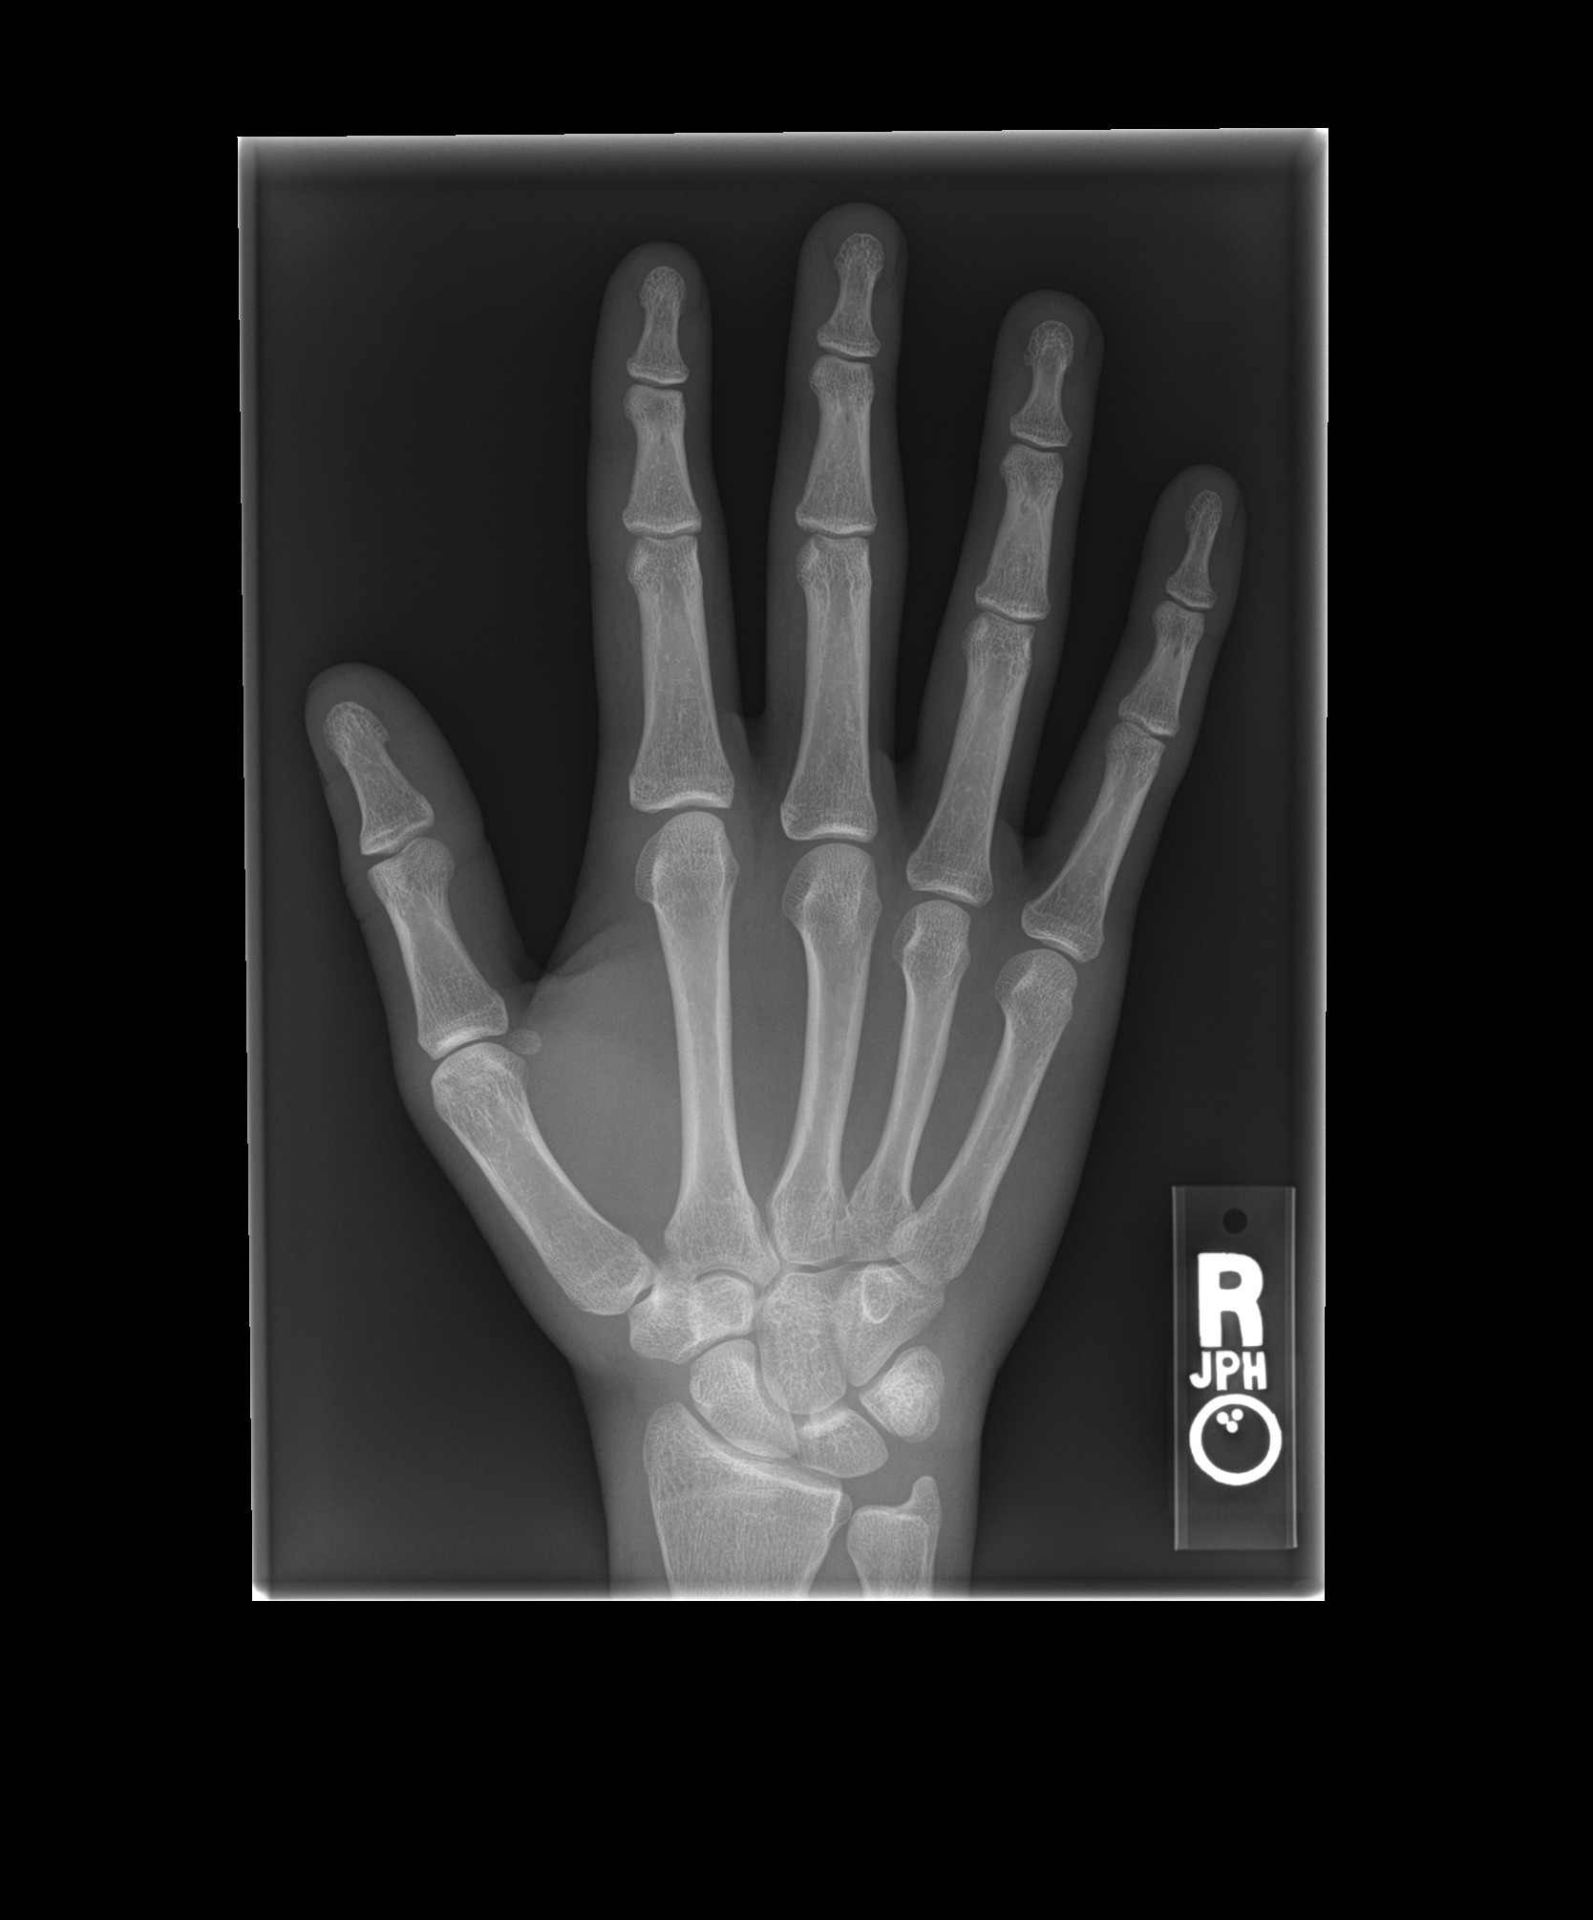
Learner Stimulus #4 - XRAYS 2 of 3

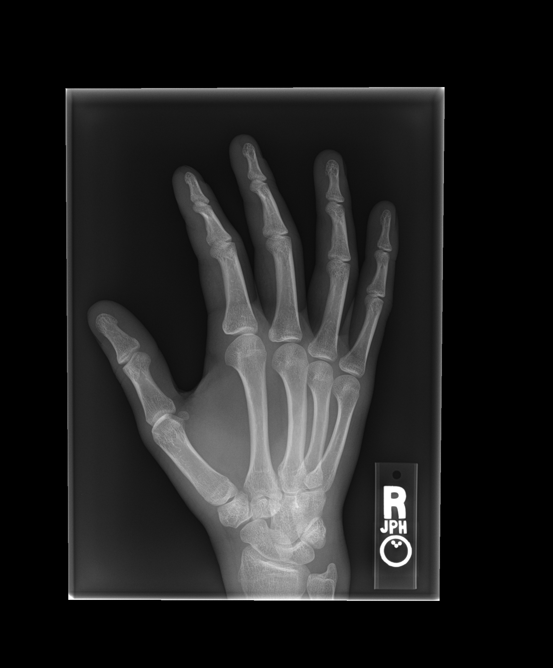

Learner Stimulus #4 - XRAYS 3 of 3

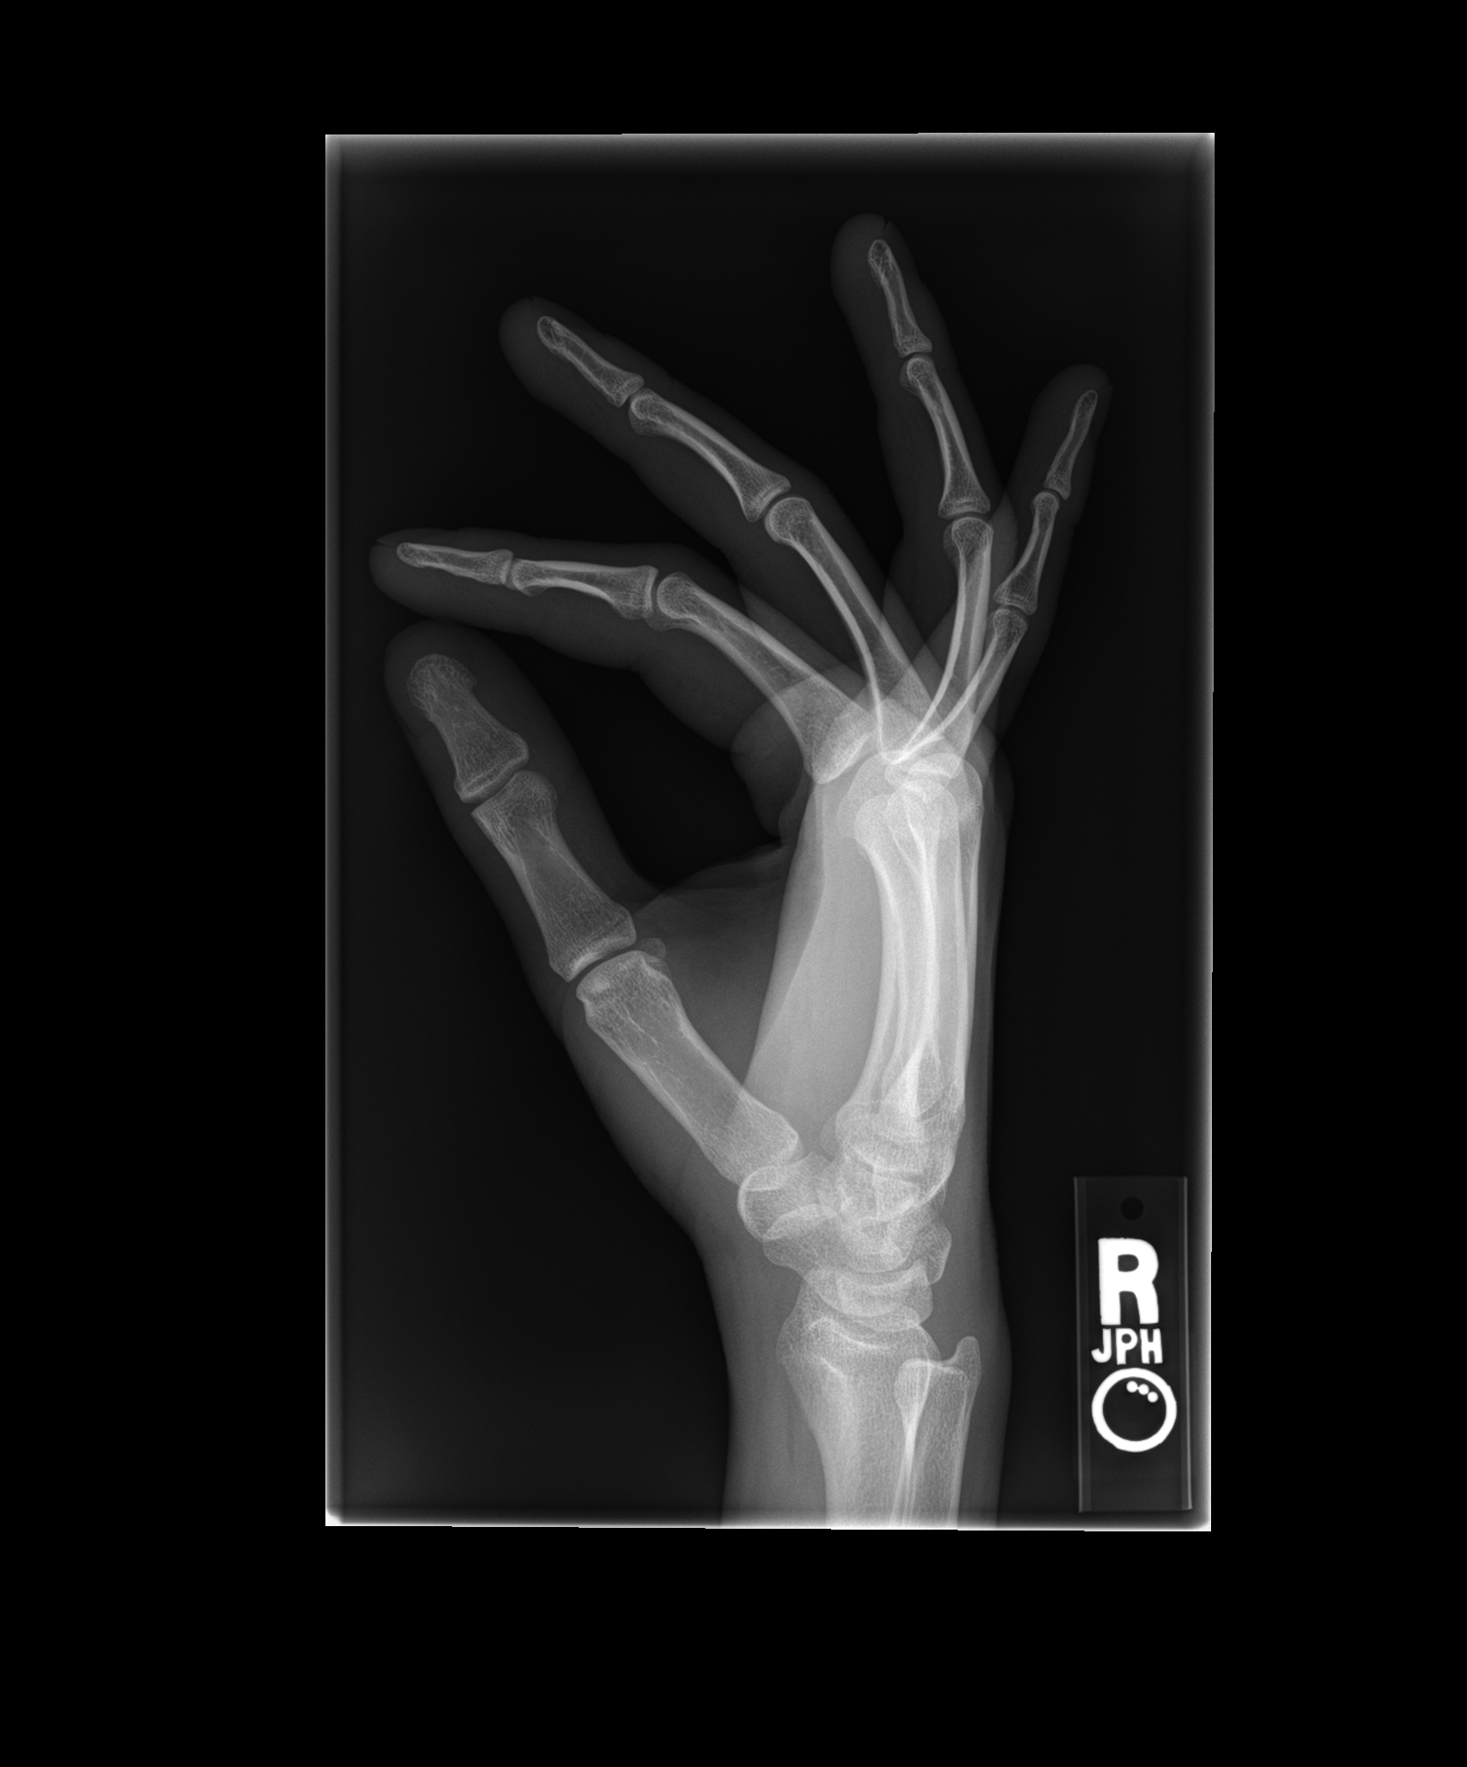

Learner Stimulus #5

NOTE TO Educational Users: The origin of the photo below is unknown. We are currently searching for a replacement photo..

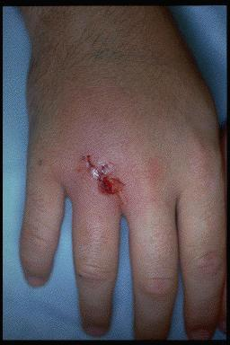

Learner Stimulus #6

Additional Questions for participant

1.Can you describe the complications of a human bite to the hand?
fracture
foreign body
tendon injury
cellulitis
deep tissue infection
septic joint
osteomyelitis

2.What are the main physicial exam findings of a deep tissue infection to the hand?
Redness, warmth, purulent drainage, swelling, increasing pain,
crepitus, tenderness, fever

3.What is the treatment for a deep tissue infection of the hand as a result of a human bite?
Wound care
- copious irrigation, debridement of devitalized tissue
- No closure
Immobilization, elevation
Analgesia
Tetanus Prophylaxis
Hepatitis Prophylaxis
Intravenous Antibiotics
Admission
Hand/Orthopedic consultation
Possible surgical intervention

For Examiner

Date: Examiner: Examinee(s):
Scoring: In accordance with the Standardized Direct Observational Tool (SDOT)

The learner should be scored (based on level of training) for each item above with one of the following:
NI = Needs Improvement
ME = Meets Expectations
AE = Above Expectations
NA= Not Assessed

Critical Actions | NI | ME | AE | NA | Category
Obtains true mechanism of injury from HPI |  |  |  |  | PC, MK, ICS, P
Obtains tetanus status/Hepatitis hx; administers Td/TdAP, HepB IgG, & starts HepB vaccination series |  |  |  |  | PC, MK, PBL
Performs proper neurovascular exam of hand |  |  |  |  | PC, MK, PBL
Initiates appropriate IV abx |  |  |  |  | PC, MK, PBL
Orders Xray of hand |  |  |  |  | PC, MK, PBL
Consultation of Hand service & provides clear summary of findings & diagnosis |  |  |  |  | PC, MK, PBL, ICS, P, SBP
Provides informative communication with patient |  |  |  |  | PC, MK, ICS, P

The score sheet may be used for a variety of learners. For example, in using the case for 4th year medical students, the key teaching points of the case may be the recognition of shock and treatment with appropriate fluid resuscitation. Other items may be marked N/A= not assessed.

Category: One or more of the ACGME Core Competencies as defined in the SDOT

PC= Patient Care
Compassionate, appropriate, and effective for the treatment of health problems and the promotion of health
MK= Medical Knowledge
Residents are expected to formulate an appropriate differential diagnosis with special attention to life-threatening conditions, demonstrate the ability to utilize available medical resources effectively, and apply this knowledge to clinical decision making
PBL= Practice Based Learning & Improvement
Involves investigation and evaluation of their own patient care, appraisal and assimilation of scientific evidence, and improvements in patient care
ICS= Interpersonal Communication Skills
Results in effective information exchange and teaming with patients, their families, and other health professionals
P= Professionalism
Manifested through a commitment to carrying out professional responsibilities, adherence to ethical principles, and sensitivity to a diverse patient population
SBP= Systems Based Practice
Manifested by actions that demonstrate an awareness of and responsiveness to the larger context and system of health care and the ability to effectively call on system resources to provide care that is of optimal value

Debriefing Materials:

Human Bites
typically three types of injuries
- closed fisted (otherwise known as "the Fight Bite"); the highest risk for complications
- occlusion
- puncture

Closed Fisted Injuries
This is a traumatic injury, also known as a fight bite, whereby the knuckles(usually MCP Jt 3/4) or PIP joints make contact with the teeth of the victim resulting in an open skin wound and introduction of skin/oral flora into the soft tissue of the hand. Extension of the fingers can lead to the passage of bacteria into deeper structures including the joint space and tendons. These wounds are high risk for deep tissue infections, septic arthritis and osteomyelitis esp. if presentation is delayed. Additional injuries include fracture, tendon injury and inclusion of foreign bodies.

History
must have a high index of suspicion for wounds to hands
screen for injuries as a result of assault or abuse

Microbiology
Bacteria include skin and oral flora
- aerobic eg. S. aureus, Streptococci, Eikenella corrodens
- anaerobic eg. Fusobacterium, Peptostretococcus
Tetanus prone
Viral
- Hepatitis B
- HIV esp. if blood present in saliva

Clinical Evaluation
perform a thorough neuromuscular and vascular exam
examine for signs of
fracture gross deformity, swelling,
foreign body palpable mass
tendon injury inability to fully extend or flex
cellulitis redness, warmth, swelling
deep tissue infection purulence, fever, swelling, increasing pain
crepitus, tenderness
septic joint fever, severe pain, tenderness, warmth
osteomyelitis fever, pain/tenderness out of proportion to injury

open wounds should be explored using local anesthetic to determine the presence of
infection, FB, joint penetration, tendon laceration. Exploration should be done with
hand in extended and flexed positions.

Debriefing Materials (cont'd):
Closed Fisted Hand Injuries
Ancillary Studies
Laboratory
- if signs of systemic infection are present, blood cultures are
useful prior to the administration of antibiotics.
- CBC, ESR, CRP may be elevated in deep tissue infections but normal values do
not rule out the possibility.
Wound Cultures
- only useful in infected bites
Radiography
- useful for fracture, foreign bodies, gas, osteomyelitis(if late presentation)
Treatment
Wound care
- copious irrigation, debridement of devitalized tissue
- No closure - due to high risk of becoming infected. Delayed primary closure could
be considered.
- Bulky dressing
Immobilization, elevation
Analgesia
Tetanus Prophylaxis
Hepatitis
- any patient who is unvaccinated or has inadequate antiH-Bs antibodies AND
bitten by an individual whose status is unknown or positive for HBsAg should
receive both Hepatitis B immune globulin and vaccine
Antibiotics
- Non infected Bites
any human bite, especially those to hands, feet, joints and cartilaginous
structures, that penetrate the epidermis likely benefit from antibiotic
prophylaxis. Treatment is usually 5 days.
- Infected Bites
Injuries that demonstrate moderate to severe cellulitis, penetrate joint space or
show signs of deep tissue infection need admission for intravenous antibiotics.
Injuries that involve lacerated tendons should be considered for admission.
Hand or Orthopedic service should be consulted for possible surgical
debridement or drainage.
Treatment involves IV antibiotics until resolved then oral agents usually 10-14
days.
- Any bite being treated with antibiotics that is considered for outpatient management
should have close follow-up.
- Antibiotic suggestions:
Oral - Single agent - Amoxcillin-clavulanate,
Two agents - Doxycycline Metronidazole
Bactrim PLUS Clindamycin
PCN VK
Ciprofloxacin
Intravenous
Ampicillin-sulbactam, Piperacillin-tazobactam, Ticarcillin-clavulanate

Keywords for future searching functions

human bite, closed fist injury, fight bite, infected human bite.

References

Baddour, L. M. (2009,June,9). Soft Tissue Infections due to Human Bites. retrieved September
16 2010, from UpToDate Web Site: http://www.uptodate.com
Barrett, J. McNamara, RM, & Spanierman, CS (2010,April,8). Human Bites. retrieved
September 21 2010, from Emedicine Web Site
http://emedicine.medscape.com/article/768978
Endom, E (2009,June, 30). Initial management of animal and human bites. retrieved
September 16 2010, from UpToDate Web Site: http://www.uptodate.com

Has this work been previously published? No

