Pediatric Limp Module Cases
Nicole Prendergast, MD

Case 1

Chief Complaint
10 month-year-old female fussiness

What does the patient look like?
The patient is a Caucasian female sitting on mom’s lap, crying when you approach her. She is able to interact with mom, appears to be acting age appropriate. No respiratory distress.

History
Source: Parents
HPI: The patient is a 10-month-old otherwise healthy female that has not been acting like herself for the last 2-3 days. Normally awake during the day, started sitting up on her own, rolls and crawls without difficulty. Now is sleeping more than usual, poor oral intake and will no longer sit up over the past few days.
PMHx: C-section at 34 weeks for PPROM, 1 week NICU stay
Meds: None
Allergies: None
FHx: Not pertinent
SHx: Lives at home with mom dad and brother who is in preschool

Action
Obtain vital signs.

Vital signs
T 40C, HR 170 bpm, RR 40 (crying) per minute, BP 90/40, Sat 99% (RA)

Additional History
Source: Mom
HPI: Patient’s brother and patient had a cold about 2-3 weeks ago that lasted about 5 days with a runny nose, low grade fever, poor appetite. For the last week has been back to baseline. No hx of trauma or falls that mom knows about and she is home during the day. Mom thinks that she is eating slightly less than normal. Only 2 wet diapers today. Activity level has decreased. She screams when mom tries to sit her up, has stopped rolling and crawling. She will only play with toys next to her. Mom says she cries when being picked up intermittently. Nothing like this has ever happened before.

If asked, mom knows patient got vaccine in the hospital, however they have moved multiple times and have had poor pediatric follow-up since that time.

Secondary Survey
General: well-nourished child sitting on mom’s lap requiring support to stay up, appears lethargic, rosy cheeks, weak cry when she moves
HEENT: No trauma, dry mucous membranes
Neck: Normal
Chest: Tachypneic at 40/minute, lungs are clear without wheezes, rales, or rhonchi
Heart: slightly tachycardia 150, regular rhythm, 3+ peripheral pulses
Abdomen: Normal
Urogenital: Normal
Extremities: left hip is flexed, abducted and externally rotated, screams when you try to move or touch this leg, the left hip appears slightly larger than the right
Back: Normal
Neuro: AAO x4, acting age appropriate
Skin: warm, no rash erythema

Instructor prompt
What is on your differential diagnosis?
-Transient Synovitis
- Septic Arthritis
- Iliopsoas Abscess
- Osteomyelitis
- Hip dysplasia
- Juvenile Idiopathic Arthritis
- Fracture
- Non-Accidental Trauma (NAT)

Action
-Tylenol, Motrin
- Place IV
- CBC, CMP, ESR, CRP
- Ultrasound L hip
- X-Ray Left hip

Nurse
-if given Motrin and vitals repeated T 37.8 C, HR 130 bpm, RR 25 per minute, BP 96/60, Sat 99% (RA)
-if observed, the patient’s vital signs are: Unchanged

Results

CBC | Result | Units
WBC | 19.3 | K/UL
RBC | 4.40 | M/UL
Hgb | 13.8 | G/DL
Hct | 42.6 | %
Platelets | 409 | K/UL
ESR | 64 | mm/h
CRP | 5 | mg/L
Chemistry | Result | Units
Na | 144 | MMOL/L
K | 4.8 | MMOL/L
Cl | 105 | MMOL/L
CO2 | 22 | MMOL/L
Anion Gap | 18 | MMOL/L
BUN | 22 | MG/DL
Cr | 0.9 | MG/DL
Glucose | 90 | MG/DL
Calcium | 8.8 | MG/DL
Albumin | 4.6 | G/DL
Alk Phos | 85 | U/L
AST | 20 | U/L
ALT | 14 | U/L
Tbili | 0.3 | MG/DL

X-Ray
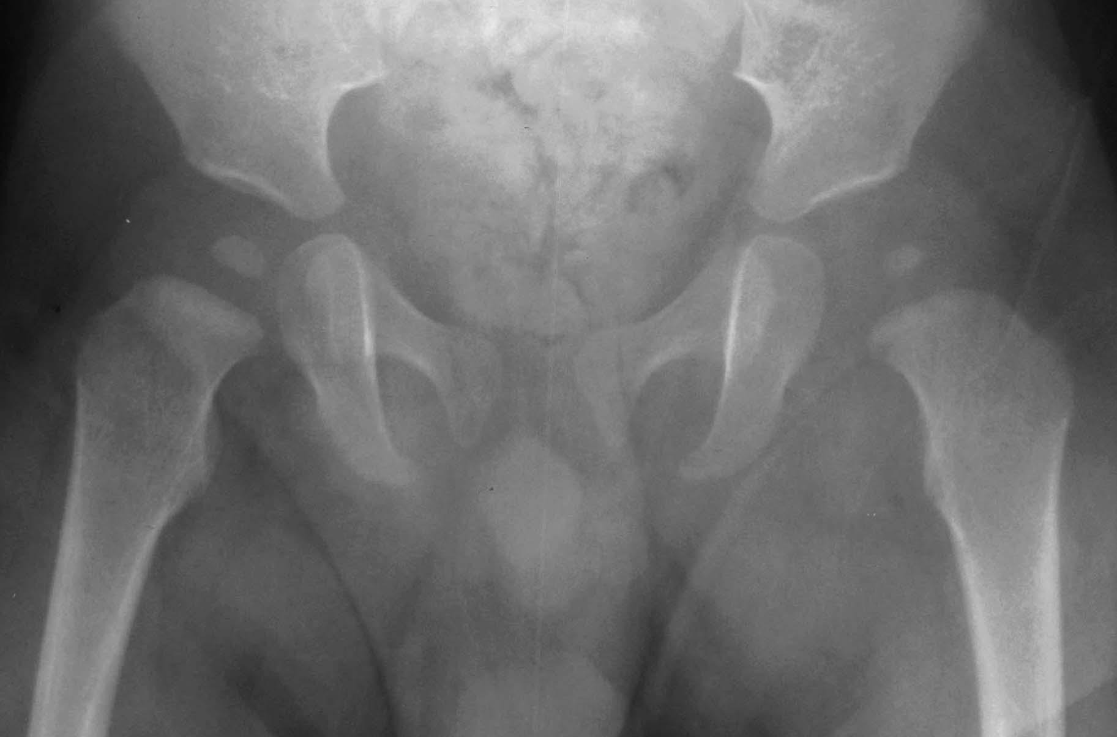
Image Credit: University of Virginia https://www.med-ed.virginia.edu/courses/rad/peds/ms_webpages/ms3dseptic.html

Ultrasound
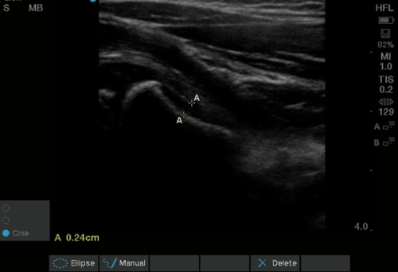

Image Credit: Pade KH, Lobo V, Gharahbaghian L. Emergency ultrasound. https://www.acep.org/how-we-serve/sections/emergency-ultrasound/news/april-2018/tips--tricks-ultrasound-in-the-diagnosis-of-a-pediatric-hip-effusion/

Action
- If perform arthrocentesis, results as noted below
Color | Turbid-Yellow
Clarity | Cloudy
WBC | 60,000/mm3
%PMNs | 80%
Glucose | 50 mg/dl
Gram stain | Positive
Culture | Positive

- If discharge patient home to follow-up with PCP in one week with NSAIDs, patient returns to ED in 24 hours

Critical actions
-Anti-pyretics for fever
-Send labs (CBC, ESR, CRP)
- Once see the results of lab tests make decision to perform arthrocentesis of L hip, call orthopedic surgery
- Admission to hospital for IV antibiotics, drainage of joint

Diagnosis
Septic Arthritis

Instructor Guide
This is a case of septic arthritis of the hip, an intra-articular infection that is considered an orthopedic surgical emergency. Bacterial infections of the lower extremities are common. These can be seen in both adult and pediatric populations and include but are not limited to abscess, osteomyelitis, cellulitis, myositis, necrotizing fasciitis, septic arthritis. Infections can be more severe in those at risk for MRSA infection, IV drug users, diabetics.
In pediatrics the incidence of septic arthritis peaks in the first few years of life, with 50% occurring in those <2 years old. 35% of these cases occur in the hip joint and another 35% occur in the knee. Risk factors include those that are born prematurely, via C-Section, or have a history of invasive procedures. Inoculation of the joint usually occurs via hematogenous spread, however can also be seen as extension from osteomyelitis. The most common organisms in infants include S. Aureus and H. Flu. In adolescents N. Gonorrhoeae is the most common and is usually preceded by migratory polyarthralgias. See Figure 1. below for further microbiological information and antibiotic treatment by age
This is a critical diagnosis as damage to the hip cartilage and blood supply to the femoral head can occur within 6-12 hours of infection onset secondary to release of proteolytic enzymes from inflammatory and synovial cells, cartilage and bacteria. These cause damage to the articular surface that can lead to osteonecrosis of the femoral head and be irreversible after 1-2 days.
Patients typically present ill-appearing with abnormal vital signs. On exam localized swelling, effusion, tenderness, and warmth may be seen. The affected hip usually rests in flexion, abduction and external rotation and there is severe pain with range of motion and unwillingness to move the joint. Usually children with septic arthritis will not be able to walk. X-Ray may be normal in early disease, however there may be widening of the joint space which is concerning for a sign of significant pus in the joint. Ultrasound will show a joint effusion, however cannot differentiate between aseptic and sterile effusion. Labs are generally notable for WBC >12,000 cells/μL, ESR > 30 mm/h, CRP >2.0. The Kocher criteria, shown in Figure 2 below can be helpful in distinguishing septic arthritis from transient synovitis and the probability of septic arthritis is as high as 99.6% if all 4 criteria are present. A hip aspiration can be performed to confirm the diagnosis. Synovial fluid samples should be sent for WBC count, gram stain and culture. The WBC is usually greater than 50,000/mm³ with >75% PMNs
Management for septic arthritis involves admission to the hospital, IV antibiotics (see below), consultation to orthopedics for surgical washout of the joint. Antibiotics are generally continued for 3 weeks. Prognosis is usually good unless there is a delay in diagnosis due to the mechanism above. Age less than 6 months, associated osteomyelitis, delay of greater than 4 days before diagnosis and infection in the hip joint is associated with a poor diagnosis.

Case teaching points
-Distinguishing Septic Arthritis from Transient Synovitis: This can be difficult. Toxic synovitis is a self-limited inflammation of the hip, generally related to a viral infection that presents very similarly to septic arthritis. However, children with transient synovitis are generally non-toxic appearing, afebrile with less acute symptoms. They may still maintain the ability to ambulate. This is in contrast to septic arthritis which is characterized by toxic appearance, high fever, and inability to ambulate. The Kocher criteria consists of four clinical parameters, WBC count, ability to bear weight, fever, ESR, and can help, as noted above, distinguish between a septic joint and transient synovitis. The higher the number of positive findings make septic arthritis more likely. Furthermore, a CRP >2.0 (mg/dl) in combination with refusal to bear weight yields a 74% probability of septic arthritis. If there is a high suspicion of septic arthritis joint fluid aspiration and analysis should be performed.
-Septic arthritis is an orthopedic EMERGENCY: Damage to the hip cartilage and blood supply to the femoral head can occur within 6-12 hours of infection with irreversible damage in 1-2 days, in contrast to transient synovitis which resolves in 7-10 days with NSAIDs and activity modification. Given the gravity of this diagnosis if unsure after laboratory testing and imaging, consider arthrocentesis and orthopedics consultation. Other pediatric orthopedic emergencies include neurovascular compromise, compartment syndrome and unstable slipped capital femoral epiphysis.

Figure 1. Approach to the antibiotic treatment in Septic Arthritis

Age | Organism | Antibiotics
<12 months | Staphylococcus sp., GBS, gram negative Bacilli | 1st generation cephalosporin (ie. Ancef)
6 months – 5 years | S. Aureus, S. pneumoniae, Group A strep, H. influenza | 2nd or 3rd generation cephalosporin (ie. ceftriaxone, ceftazidime)
5 – 12 years | S. Aureus | 1st generation cephalosporin
12-18 years | N. gonorrhoeae, S. Aureus | Oxacillin/cephalosporin

Adopted chart from Shaath K, Siegall E, Skaggs D. Hip Septic Arhtritis – Pediatric https://www.orthobullets.com/pediatrics/4032/hip-septic-arthritis--pediatric

Figure 2. Kocher Criteria

Kocher Criteria
WBC | >12,000 cells/μL
Ambulation | Inability to ambulate
Fever | >101.3˚F
ESR | >40 mm/h
  - If elements are present, the probability of septic arthritis was determined to be:
    - 0/4 = 0%
    - 1/4 = 3%
    - 2/4 = 40%
    - 3/4 = 93%
    - 4/4 = >99%

References:
- Shaath K, Siegall E, Skaggs D. Hip Septic Arthritis – Pediatric. Orthobullets, June 8, 2020. https://www.orthobullets.com/pediatrics/4032/hip-septic-arthritis--pediatric

- Naranje S, Kelly DM, Sawyer JR. A Systematic Approach to the Evaluation of a Limping Child. Am Fam Physician. 2015 Nov 15;92(10):908-16. PMID: 26554284.

- Herman MJ, Martinek M. The limping child. Pediatr Rev. 2015 May;36(5):184-95; quiz 196-7. doi: 10.1542/pir.36-5-184. PMID: 25934907.

- Abdelgawad, Amr, and Osama Naga. “Approach to a Limping Child.” Pediatric Orthopedics, Springer New York, 2013, pp. 485–92, http://dx.doi.org/10.1007/978-1-4614-7126-4_17.

Case 2

Chief Complaint
14-year-old male left sided knee pain

What does the patient look like?
The patient is an obese male adolescent, well-appearing. Limps into the exam room favoring the right leg.

History
Source: Patient
HPI: 14-year-old male who presents to the emergency department with left sided knee pain. Per patient states pain started four weeks ago moves from the groin and thigh into his left knee. He initially said he was unable to participate in gym class, however now can’t walk to his classes without limping.
PMHx: Obesity
Meds: None
Allergies: None
FHx: Mom with hypothyroid, HTN, father with HTN
SHx: Lives at home with mom, dad, brother, sister

Action
Obtain vital signs.

Vital signs
T 37C, HR 84 bpm, RR 18 per minute, BP 110/68, Sat 99% (RA) Weight 100 kg

Additional History
Source: Patient, Mom
HPI: Patient denies hx of trauma, falls. Never had any injury to his left leg. He cannot think of any triggers. He has not been sick recently.

Physical Exam
General: obese adolescent, well-appearing, sits in chair with left leg crossed over the right
HEENT: No trauma, moist mucous membranes
Neck: Normal
Chest: Lungs are clear without wheezes, rales, or rhonchi
Heart: regular rhythm, 3+ peripheral pulses
Abdomen: Normal
Urogenital: Normal
Extremities: Right LE appears larger than left, external rotation with flexion of the left leg, limited ROM left hip, full range of motion left knee
Back: Normal
Neuro: AAO x4, ambulates with waddling gait, left toe slightly rotated externally
Skin: warm, no rash, erythema

Instructor prompt
What is on your differential diagnosis?
- Slipped Capital Femoral Epiphysis
- Septic Arthritis
- Iliopsoas Abscess
- Malignancy
- Benign Tumor
- Legg-Calve-Perthes Disease
- Juvenile Idiopathic Arthritis
- Fracture

Action
-Tylenol, Motrin
- X-Ray Left hip, X-Ray Left Femur, X-Ray Left Knee

Results
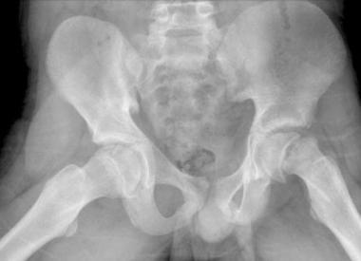

Image Credit: Basset A, Souder C., Shirley E. Slipped Capital Femoral Epiphysis (SCFE) https://www.orthobullets.com/pediatrics/4040/slipped-capital-femoral-epiphysis-scfe

Action
- If calling orthopedics, plan to admit patient for urgent orthopedic surgery.

Critical actions
- X-Ray to evaluate for fracture
- Once identify the deformity of the left proximal femur with slipping of the epiphysis from the metaphysis, call orthopedic surgery for evaluation

Diagnosis
Slipped Capital Femoral Epiphysis

Instructor Guide
Slipped capital femoral epiphysis or SCFE is a condition occurring in 10 per 100,000 adolescents, involving the displacement of the proximal femoral (capital) epiphysis from the metaphysis. It is caused by a structurally weakened physis, acted on by mechanical forces that lead to the displacement or slipping through the hypertrophic zone of the physis which histologically has sections of granulation tissue and cartilage that act as weak spots.

SCFE is more common in obese male children in the period of rapid growth from ages 10-14 with the average age being 13.4 years and 12.2 years in males and females respectively . It is more common in African Americans, Pacific Islanders, Latinos. The left hip is more common, however it can be bilateral in 17-50% of those affected. Obesity is the single greatest risk factor, however SCFE can also be associated with endocrine and metabolic disorders including but not limited to hypothyroidism, renal osteodystrophy, growth hormone deficiency, panhypopituitarism.

Generally patients present with groin and thigh pain and a limp with external rotation of the affected leg that has been present for weeks to months. Hip pain in children can also present as knee pain 15-50% due to activation of the medial obturator nerve. Sitting is more comfortable when the affected leg is crossed over the other.

Physical exam is notable for an antalgic, or Trendelenburg gait with external rotation of the affected leg. Range of motion is limited with loss of hip internal rotation, abduction and flexion. If the affected hip is passively flexed external rotation will result due to synovitis and impingement of the displaced anterior-lateral femoral metaphysis on the acetabular ring. This is known as Drehmann sing. Atrophy of the thigh is often seen.

Radiographs are the diagnostic imaging test of choice. AP and frog-leg lateral views of both hips should be done to rule out bilateral disease which, as noted above, can occur in approximately 25% of children. Findings include abnormal alignment of Klein’s line, the line drawn along the superior border of the femoral neck, which will fail to intersect the femoral head in those with SCFE. There will often be asymmetry between hips and it is possible to see growth plate widening, epiphysiolysis or blurring of the femoral metaphysis due to overlap with the displaced epiphysis.

Patients with stable SCFE should be made non-weight bearing and admitted to the hospital for surgical correction. Delay in management can result in worsening including conversion to a unstable SCFE.

Case teaching points
- Stable vs Unstable SCFE: Stable versus unstable SCFE is known as the loader classification which is based on the ability of the patient to bear weight. This classification provides prognostic information. Children with stable SCFE present with an antalgic or Trendelenburg limp with external rotation of the leg, while those with unstable SCFE present similar to an acute hip fracture and are unable to bear weight or move the hip. When managed properly, SCFE usually has a good prognosis for long-term hip function while unstable SCFE is at high risk for osteonecrosis and functional long term complications. Information summarized in Figure 1 below.
- Consider MRI if high suspicion, negative X-Ray: If high clinical suspicion for SCFE despite negative X-Ray imaging consider MRI. MRI may help diagnose a preslip condition when radiographs are negative. Findings include growth plate widening, edema in the metaphysis, decreased signal on T1 and increased signal on T2.

Figure 1. Classification (prognostic indicator)
Loader Classification (ability to bear weight)
Stable | Able to bear weight with or without crutches  Minimal risk of osteonecrosis (<10%)
Unstable | Unable to ambulate (not even with crutches)  High risk of osteonecrosis (47%, recent data 24%)
Basset A, Souder C., Shirley E. Slipped Capital Femoral Epiphysis (SCFE) https://www.orthobullets.com/pediatrics/4040/slipped-capital-femoral-epiphysis-scfe

References:

- Basset A, Souder C., Shirley E. Slipped Capital Femoral Epiphysis (SCFE) https://www.orthobullets.com/pediatrics/4040/slipped-capital-femoral-epiphysis-scfe
- Herman MJ, Martinek M. The limping child. Pediatr Rev. 2015 May;36(5):184-95; quiz 196-7. doi: 10.1542/pir.36-5-184. PMID: 25934907.

