CORD Sports Medicine Toolkit: Collapse During Exercise
Summary Handout

Background
As an Emergency Physician, you will see patients who collapse during athletic activity, both when working and when off-duty, in and out of the hospital. Understanding the differential diagnosis, historical features, and clinical presentations of patients experiencing different causes is important for identifying life threats and initiating appropriate workup and treatment.

Differential diagnosis for collapse during exercise
Exercise-associated collapse
Sickle cell trait-associated collapse
Temperature-related illness
Volume depletion
Sodium metabolism
Cardiac pathology
-structural
-electrophysiologic
Ischemic cardiac disease
-most common etiology for athletes >35 years old

Exercise-associated collapse
- most common reason athletes are treated in medical tent following endurance event
- loss of muscle pumping action + cutaneous vasodilation = postural hypotension
- usually occurs after an athlete crosses the finish line
- patient is generally awake and breathing (rarely loss of consciousness)

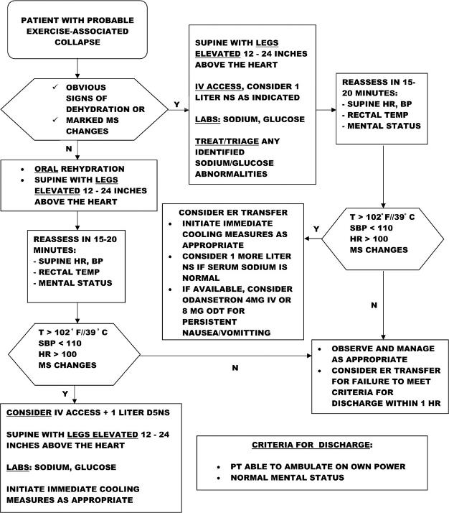
Figure 1. Exertional collapse algorithm.
Asplund CA, O'Connor FG, Noakes TD. Exercise-associated collapse: an evidence-based review and primer for clinicians. British Journal of Sports Medicine 2011;45:1157-1162.

Sickle cell trait-associated collapse
- increased risk of collapse during vigorous exercise related to sickling
- predisposes athletes to rhabdomyolysis and hyperkalemia resulting in collapse or death
  - hypoxia, dehydration, lactic acidosis, hyperthermia can all precipitate sickling

ECG interpretation in athletes
Normal changes in trained hearts
- sinus arrhythmia
- sinus bradycardia
- isolated left ventricular hypertrophy
- incomplete right bundle branch block
- 1st degree AV block or Mobitz 1 (Wenckebach)
- junctional rhythms (sinus rate is slower than junctional escape rate)
- early repolarization
- ST elevation V1-V3 in Afro-Caribbean athletes
[Distinguish it from Brugada syndrome: Zorzi A, et al. Differential diagnosis between early repolarization of athlete's heart and coved-type Brugada electrocardiogram. Am J Cardiol 2015;115:529-532.]

Cardiac conditions predisposing athletes to sudden cardiac death – structural
- hypertrophic cardiomyopathy (HCM)
  - asymmetric ventricular or septal wall hypertrophy
    - obstruction of flow from the left ventricle
    - impaired cardiac filling in diastole
    - increased risk for cardiac dysrhythmias including ventricular fibrillation
  - frequently genetic, accentuated by the hyperplastic effects of training
  - EKG findings
    - T wave inversion
    - ST segment depression
    - pathologic Q waves
    - conduction delay
    - left axis deviation
    - left atrial enlargement

T wave inversions

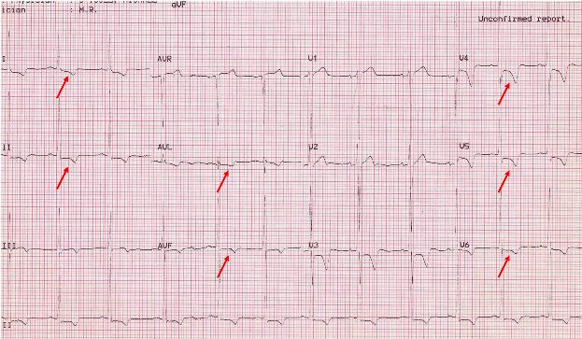
ST depression and T wave inversions

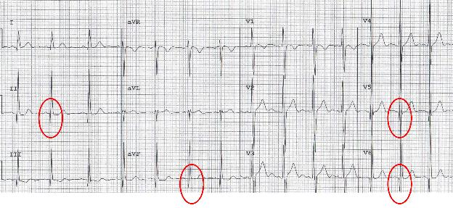
Pathologic Q waves – “dagger-like”

Left axis deviation

- arrhythmogenic right ventricular dysplasia (ARVD)
  - fibro-fatty replacement of right ventricular myocardium
    - life threatening ventricular arrhythmias or sudden cardiac death
  - progressive dilation and dysfunction predominantly involve the right ventricle
    - involvement of the left ventricle in late-stage disease
  - EKG Findings
    - inverted T waves
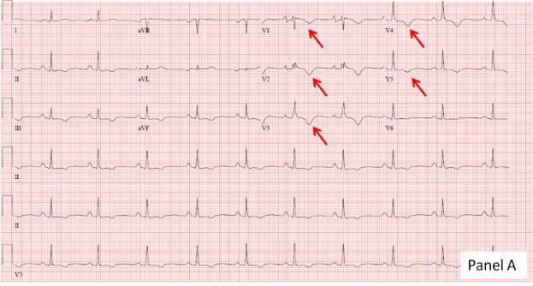
Inverted T waves

Epsilon waves

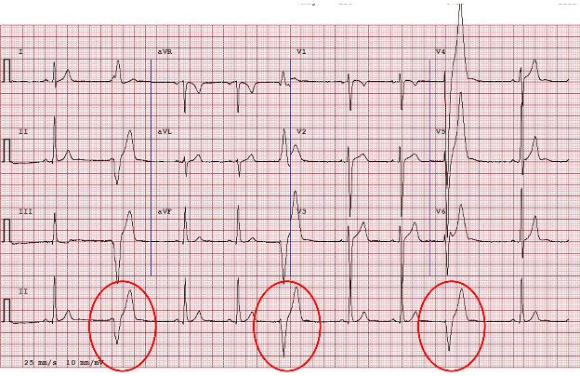
Negative LBBB in limb leads – concern for right ventricular wall pathology

Cardiac conditions predisposing athletes to sudden cardiac death - electrical
- long QT
- short QT
- Brugada syndrome
  - “high take off“ ST segment elevation in the right precordial leads
  - predisposes to ventricular fibrillation and sudden death in the absence of clinically demonstrable structural heart disease
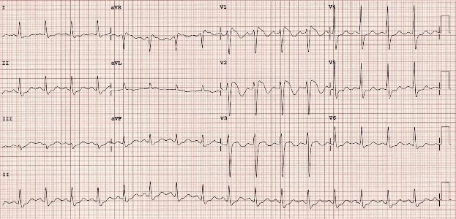
High take off ST elevations in precordial leads

- catecholaminergic polymorphic ventricular tachycardia
  - inherited arrhythmogenic disorder
  - ventricular ectopy induced by exercise or emotional stress
  - resting EKG is normal
  - Exercise stress test is diagnostic
- Wolff-Parkinson-White Syndrome
  - short PR interval (<120 ms)
  - delta wave (slurring of the initial QRS)
  - wide QRS (> 120 ms)
  - predisposes to tachydysrhythmia and sudden cardiac death
- supraventricular tachycardia (SVT)
  - atrioventricular reentrant tachycardia (AVRT)
    - accessory atrioventricular bypass pathway
      - orthodromic: the circuit typically conducts down the AV node and up the bypass pathway narrow complex tachycardia
      - antidromic: electrical circuit conducts down the accessory pathway and up the AV node wide complex tachycardia
  - atrioventricular nodal reentrant tachycardia (AVNRT)
    - circuit involving a slow and fast pathway entering & exiting the AV node
    - most common SVT

Etiologies of sudden cardiac death in US athletes

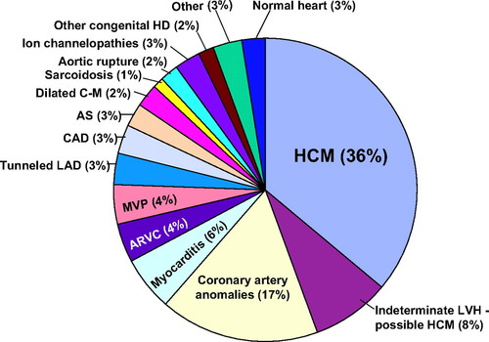
Barry J. Maron. Circulation. Recommendations and Considerations Related to Preparticipation Screening for Cardiovascular Abnormalities in Competitive Athletes: 2007 Update, Volume: 115, Issue: 12, Pages: 1643-1655, DOI: (10.1161/CIRCULATIONAHA.107.181423)

Algorithm for interpreting EKGs in athletes
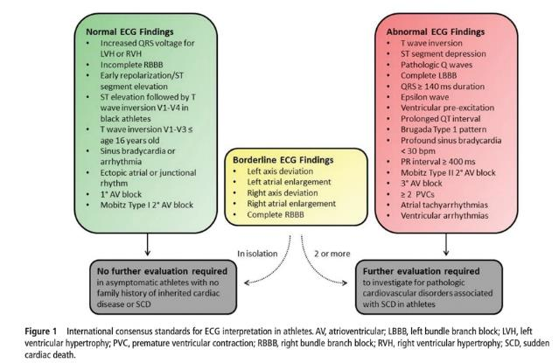
Drezner JA, et al. Br J Sports Med 2017;1:1–28. doi:10.1136/bjsports-2016-097331

References
- American Society of Hematology. (2012).
Statement on Screening for Sickle Cell Trait and Athletic Participation.
Retrieved from https://www.hematology.org/advocacy/policy-statements/2012/screening-sickle-cell-trait-athletic-participation
- Armstrong LE, Casa DJ, Millard-Stafford M, Moran DS, Pyne SW, Roberts WO. American College of Sports Medicine position stand. Exertional heat illness during training and competition. Med Sci Sports Exerc. 2007 Mar;39(3):556-72. doi: 10.1249/MSS.0b013e31802fa199. PMID: 17473783.
- Asif IM, Harmon KG. Incidence and Etiology of Sudden Cardiac Death: New Updates for Athletic Departments. Sports Health. 2017;9(3):268-279. doi:10.1177/1941738117694153
- Asplund CA, O'Connor FG, Noakes TD. Exercise-associated collapse: an evidence-based review and primer for clinicians. British Journal of Sports Medicine 2011;45:1157-1162.
- Dale B. Speedy, Timothy B. Noakes & Lucy-May Holtzhausen (2003) Exercise-Associated Collapse, The Physician and Sportsmedicine, 31:3, 23-29, DOI: 10.1080/00913847.2003.11440566
- Drezner JA, O'Connor FG, Harmon KG, et al. AMSSM Position Statement on Cardiovascular Preparticipation Screening in Athletes: Current evidence, knowledge gaps, recommendations and future directions. British Journal of Sports Medicine 2017;51:153-167.
- Emery MS, Kovacs RJ. Sudden Cardiac Death in Athletes: State-Of-The-Art Review. J Am Coll Cardiol Heart Fail. 2018 Jan, 6 (1) 30-40.
- Exercise-associated collapse: and evidence-based review and primer for clinicians https://bjsm.bmj.com/content/bjsports/45/14/1157.full.pdf
- Harmon KG, Drezner JA, Klossner D, et al. Sickle cell trait associated with a RR of death of 37 times in national collegiate athletic association football athletes: a database with 2 million athlete-years as the denominator. British Journal of Sports Medicine 2012;46:325-330.
- Harmon KG, Drezner JA, Wilson MG, et al. Incidence of sudden cardiac death in athletes: a state-of-the-art review. Heart 2014;100:1227-1234.
- Hypertrophic Cardiomyopathy. Heart.org. https://www.heart.org/en/health-topics/cardiomyopathy/what-is-cardiomyopathy-in-adults/hypertrophic-cardiomyopathy
- International criteria for electrocardiographic interpretation in athletes: consensus statement [https://bjsm.bmj.com/content/bjsports/51/9/704.full.pdf]
- LITFL athlete EKGs [https://litfl.com/tag/athlete/]
- Loosemore M, Walsh SB, Morris E, et al. Sudden exertional death in sickle cell trait. British Journal of Sports Medicine 2012;46:312-314.
- Marcus FI, et al. Diagnosis of Arrhythmogenic Right Ventricular Cardiomyopathy/Dysplasia. Circulation. 2010;121:1533–1541.
- Maron BJ. Recommendations and Considerations Related to Preparticipation Screening for Cardiovascular Abnormalities in Competitive Athletes: 2007 Update. Circulation. Volume 115, Issue 12, 27 March 2007, Pages 1643-1655. https://doi.org/10.1161/CIRCULATIONAHA.107.181423
- Meyer L, Stubbs B, Fahrenbruch C, Maeda C, Harmon K, Eisenberg M, Drezner J. Incidence, Causes, and Survival Trends From Cardiovascular-Related Sudden Cardiac Arrest in Children and Young Adults 0 to 35 Years of Age: A 30-Year Review. Circulation. 2012;126:1363–1372.
- National Athletic Trainers Association Consensus Statement: Sickle Cell Trait and the Athlete https://www.nata.org/sites/default/files/SickleCellTraitAndTheAthlete.pdf
- O'Connor, Francis G.; Casa, Douglas J.; Bergeron, Michael F.; Carter, Robert III; Deuster, Patricia; Heled, Yuval; Kark, John; Leon, Lisa; MCDermott, Brendon; O'Brien, Karen; Roberts, William O.; Sawka, Michael American College of Sports Medicine Roundtable on Exertional Heat Stroke - Return to Duty/Return to Play: Conference Proceedings, Current Sports Medicine Reports: September-October 2010 - Volume 9 - Issue 5 - p 314-321. doi: 10.1249/JSR.0b013e3181f1d183
- Raj MA, Bansal P, Goyal A. Hypertrophic Obstructive Cardiomyopathy. [Updated 2020 Jul 4]. In: StatPearls [Internet]. Treasure Island (FL): StatPearls Publishing; 2020 Jan. Available from: https://www.ncbi.nlm.nih.gov/books/NBK430820/
- Robinson A, Kramer CM. Imaging in Hypertrophic Cardiomyopathy. American College of Cardiology. Apr 24, 2018. https://www.acc.org/latest-in-cardiology/articles/2018/04/20/08/41/imaging-in-hypertrophic-cardiomyopathy.
- Terry GC, Kyle JM, Ellis JM Jr, Cantwell J, Courson R, Medlin R. Sudden Cardiac Arrest in Athletic Medicine. J Athl Train. 2001;36(2):205-209.
- WikiSM: Exercise-associated collapse, Sudden Cardiac Death
- Zorzi A, et al. Differential diagnosis between early repolarization of athlete's heart and coved-type Brugada electrocardiogram. Am J Cardiol 2015;115:529-532.

