Back Pain 1
- CC
  - 64 year old male presents with back pain
- Vital Signs
  - HR 120 BP 110/70 T 38C RR 20 Sat: 100% RA Wt: 60kg
- What does the patient look like?
  - The patient appears frail, weak, laying on his back and moaning
- Primary survey
  - Airway: Moaning, breathing normally
  - Breathing: mild tachypnea, clear lung sounds
  - Circulation: warm skin, L BKA otherwise 2+ distal pulses
- Action
  - Place patient on monitor
  - Obtain 2 large bore IV access
  - 1L IVF if ordered
  - POC glucose (284 if ordered)
- History
  - Source: patient and nursing home records
  - HPI: a 64 year old male comes from his nursing home for back pain. He has been complaining about it to the staff for one week and refusing to ambulate or be turned. He is normally AOx3 and is wheelchair bound due to his amputation. He normally voids on his own but for the last week has been urinating on himself as he refuses to get up. He has been refusing most of his meds including insulin
  - MHx: IDDM, CVA with no significant deficits, HTN
  - SHx: L BKA 10 years prior due to poorly controlled IDDM
  - Allergies: none
  - Meds: Levemir, Novolog, Lisinopril, baby ASA
  - Social: denies smoking, alcohol, drugs
  - FHx: non contributory
- Physical Exam
  - General: underweight, pale, uncomfortable
  - HEENT: Dry mucous membranes, otherwise normal
  - Lungs: normal
  - Heart: tachycardic and regular, no murmurs/rubs/gallops
  - Abdomen: soft, nontender, no masses
  - Neuro: Aox3, moving all extremities, normal muscular tone throughout
  - Extremities: L AKA, otherwise mild skin tears b/l upper extremities
  - Skin/Back: 2x2 cm deep ulcer to lower L spine with surrounding erythema
- Instructor Prompt: discuss differential diagnosis and workup
- Action:

  - Order labs
    - CBC, BMP, BHB, Osm, ESR/CRP, lactate, UA, Blood cultures x 2
  - Order meds
    - Antipyretic, analgesia, IV antibiotics, IVF
  - Consider POCUS
    - Evaluate cardiac function, IVC
  - Order imaging
    - Xray L spine/sacrum (Discuss CT vs MRI)

- Nurse
  - Vitals after 1L IVF: HR 115 BP 125/70
  - Vitals after 2L IVF: HR 100 BP 130/80
  - Labs (WBC 26, K 5, HCO3 18, AG 20, BHB 38, Cr 2.3, CRP 40, ESR 100, Lactate 2.5, UA unremarkable)
  - EKG if asked: sinus tachycardia
  - Repeat glucose if asked: 221
  - Xray: diffuse osteopenia with a lytic lesion of L3

- Instructor prompt: discuss management and treatment goals
- Actions
  - Order antibiotics: Vanc + Zosyn
  - Order insulin for DKA at 0.01u/kg/hr with KCl
  - Consult neurosurgery for surgical debridement
  - Admit to ICU
- Diagnosis
  - Primary: osteomyelitis of femur
  - Secondary: DKA, sepsis, dehydration
- Critical actions
  - Fluid resuscitation
  - Blood cultures
  - Early administration of IV antibiotics
  - NSGY consult
- Instructor guide
  - This is a case of osteomyelitis due to poorly controlled diabetes. The patients meets SIRS criteria due to his fever, tachypnea, WBC count. His exam showed concern for a skin or bone source of infection but a UA should be ordered as he has been urinating on himself. His lactate is not technically abnormal but is greater than 2 which should be concerning. His vital signs were improved with fluids which also suggests dehydration.
  - This patient’s OM was likely a complication of his poorly controlled diabetes but look for hematogenous spread
- Teaching Points
  - DDx for a poorly controlled diabetic with back pain or skin changes should include necrotizing fasciitis/ Fournier’s gangrene, fracture, osteomyelitis, SEA, gangrene
  - Contiguous spread accounts for 80% of OM cases, hematogenous for 20%
- Diagnosis of OM
  - Xrays are routinely ordered first in the ED as they are fast and cheap however OM must typically extend at least 1 cm into the bone and involve 30-50% of the bone to be visible on plain films. Xrays may be normal until 7 days of infection in children, and 10-14 days of infection in adults. Don’t use normal plain films as a rule out for OM
  - CT sensitivity and specificity is between 50-70% and even lower for chronic OM.
  - MRI is the most sensitive and specific for OM as it can detect bone marrow edema, which can be seen as early as 2 days into the disease
  - An ESR >70 has a sensitivity of 80-90% for OM, however inflammatory markers such as ESR and CRP are nonspecific to OM
  - The likelihood of OM increases if there is visible bone that can be probed
- Treatment of OM
  - Usually IV antibiotics for 6 weeks, then PO for 4-8 weeks
- What are the appropriate antibiotics for OM?
  - Most common pathogens include MRSA, MSSA, Salmonella (consider sickle cell patients), Strep, pseudomonas, and polymicrobial
  - Vancomycin and Zosyn are appropriate starting antibiotics, can be narrowed down based on cultures
  - If patients have anaphylaxis to penicillins, consider Imipenem in place of Zosyn
  - For sickle cell patients, recommend Ceftriaxone/Cefotaxime PLUS Vanc/Clindamycin/Nafcillin
  - For newborns, cover all of the above bacteria plus GBS with Vanc + Ceftazidime
- Complications of OM
  - Sinus tract formation
- References:
  - Radiopedia
  - UpToDate
  - Xray image courtesy of MedPix NIH
  - MRI image courtesy of Radiopedia
Xray L spine
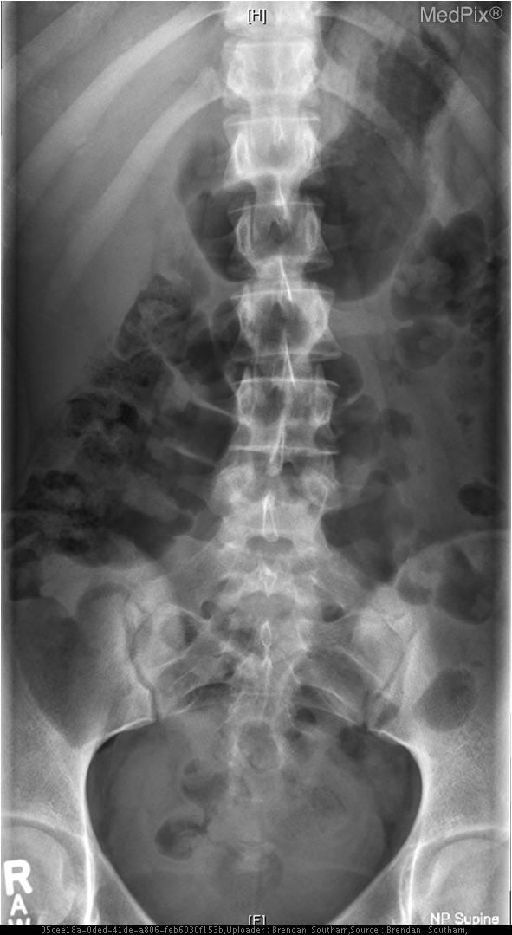
MRI L spine
