Case 1
Setting
You are working in the medical tent for a 10 km road running race.

Weather conditions
75 degrees F and 90% humidity

Chief Complaint
20s female collapsed at finish line

What does the patient look like?
The patient is a Caucasian female lying on the ground - awake with her eyes closed. She is able to interact. Very diaphoretic. Breathing heavily but able to answer questions in 4-word sentences.

Primary Survey
Airway: Intact
Breathing: Tachypneic and labored.
Circulation: 3+ Peripheral pulses. Brisk capillary refill. Tachycardic.

History
Source: Witness from the finish line
HPI: The runner crossed the finish line, staggered a bit, and slowly fell to the ground, landing on her abdomen. No head strike. No evidence of trauma. The patient was moaning incomprehensibly and breathing very heavily. You are summoned from the tent to the finish line.
PMHx: Unknown
PSHx: Unknown
Meds: Unknown
Allergies: Unknown
FHx: Unknown
SHx: Unknown
PMD: Unknown

Action
Bring the patient to the medical tent (in the shade, under cover, on a cot).
Obtain vital signs.

Vital signs
T 39C, HR 130 bpm, RR 40 per minute, BP 110/70, Sat 99% (RA)

Additional History
Source: patient
HPI: Trained for this event and raced hard. Achieved a new personal best finish time for the 10K. Feeling well prior to the race. Ate well and hydrated prior to the race, but didn’t over-hydrate. Drank to thirst only during the run. Very tired for the final mile of the race. Pushed as hard as she could. When she stopped running her legs became very weak, and she lowered herself to the ground. No loss of consciousness. No trauma.
PMHx: None
PSHx: None
Meds: None
Allergies: None
FHx: No family history of cardiac disease , sudden cardiac death, or unexplained death at a young age
Social: Occasional social alcohol use – none recently. Non-smoker. No recreational drug use.
PMD: Dr. Smith

Secondary Survey
General: fatigued, diaphoretic, generally weak
HEENT: Normal, no trauma
Neck: Normal
Chest: Tachypneic at 40/minute, lungs are clear without wheezes, rales, or rhonchi
Heart: Tachycardic in the 130s, regular rhythm, 3+ peripheral pulses
Abdomen: Normal
Urogenital: Normal
Extremities: Normal
Back: Normal
Neuro: AAO x4, ataxic, requiring help to standing
Skin: Diaphoretic, hot, flushed

Instructor prompt
What is on your differential diagnosis?
-Exercise collapse
-Heat illness
-Cardiac dysrhythmia or structural heart disease
-Hyponatremia
-Dehydration

Nurse
-if dipped in ice bath: patient is now shivering with a core temperature of 35C. RR improved, pulse now 110 bpm. Other vital signs unchanged.
-if observed, the patient’s vital signs are: T 37.5, HR 95 bpm, RR 18 per minute, BP 130/90, O2 Sat 99% (RA). The patient is now ambulatory without difficulty.

Action
-Discharge from the medical tent under her own power.

Critical actions
-Repeat vital signs and exam
-Consider heat illness in your differential
-Do not actively cool the patient with a T <40 C (risk for rebound hypothermia)

Diagnosis
Exercise-associated collapse

Instructor Guide
This is a case of exercise-associated collapse. This is a common occurrence at the finish line after endurance events, particularly running and Nordic skiing. It is defined as collapse in a conscious athlete who is unable to stand or walk independently after completion of exercise. The differential diagnosis needs to include life threats including heat stroke, hyponatremia, dehydration, and cardiac pathology, but when those are ruled out, the treatment of exercise-associated collapse is symptomatic. See Figure 1. A short period of rest in a supine or Trendelenberg position accompanied by oral hydration generally leads to complete resolution of symptoms. The etiology is generally felt to be multifactorial – depleted pre-load, baseline low heart rate and blood pressure in a trained athlete, and abrupt cessation of vigorous physical activity. During activity, peripheral vasodilation ensues to supply blood to exercising muscles and to promote heat dissipation. There is a simultaneous need for increased stroke volume and cardiac output, and this is provided by the muscular pumping of blood from the legs back to the central circulation. When activity stops, blood pools in the periphery, leading to a sudden drop in preload. This results in postural hypotension and collapse.

Case teaching points
-Exercise collapse: Exercise-associated collapse (EAC) commonly occurs after the completion of endurance running events and presents as collapse in conscious athletes who are unable to stand or walk unassisted. They complain of light-headedness, faintness and dizziness, causing a collapse that occurs after completion of an exertional event. Providers must ensure the absence of other life-threatening etiologies causing collapse prior to diagnosing the more common EAC. Cardiac arrest, exertional heat stroke, and exercise-associated hyponatremia should be ruled out before settling on EAC as the diagnosis of exclusion. EAC is believed to be principally the result of transient postural hypotension caused by lower extremity pooling of blood once the athlete stops running, resulting in impaired cardiac baroreflexes. The treatment of EAC is symptomatic and involves oral hydration and a supine or Trendelenburg position. Active cooling, intravenous hydration, or other advanced treatment, including transport to the hospital, is generally unnecessary.
-Heat stroke: Exertional heat stroke (EHS) is characterized by central nervous system dysfunction, induced by exercise, with a core body temperature of >40°C. Patients will experience collapse and altered mental status. Treatment is rapid identification, cessation of physical activity, movement of the patient to a cool, shady location, and immediate active whole body cooling using techniques such as ice bath immersion, cool-water misting, or packing of the groin and axillae with ice. Active cooling should cease when the core temperature falls below 40°C, and the patient should be monitored for rapid return of normal cognition and other neurologic function. These patients may require intravenous hydration and transport to the hospital for ongoing monitoring if they do not return to neurologic baseline promptly after cooling or if there is no means on site to perform aggressive active cooling.
-Hyponatremia: Exercise-associated hyponatremia (EAH) is a potentially life-threatening condition characterized by a decrease in serum sodium (<135 mmol/L) and mental status changes. Athletes generally develop EAH through excessive free water consumption, especially over ultra-endurance events. EAH may manifest as true syncope, confusion or disorientation associated with low serum sodium. Treatment includes free water restriction, diuresis, and, if seizures occur, hypertonic saline. Patients with EAH generally require monitoring in a hospital setting until neurologic function returns to baseline.
-Dehydration: Dehydration, or volume depletion, may occur following prolonged or vigorous physical activity and can result in orthostasis and pre-syncope or syncope. Acute kidney injury and electrolyte disturbance should be considered. Oral and/or parenteral hydration can be used for treatment.
-Cardiac arrest: An athlete presenting with cardiac arrest will present with true syncope during physical exertion. This is in contrast to EAC which generally presents after cessation of activity. The athlete in cardiac arrest will not have palpable pulses and will be unresponsive. Immediate recognition and initiation of high quality cardiopulmonary resuscitation is imperative to survival. Defibrillation should be performed as soon as possible for an athlete in ventricular fibrillation.

Figure 1. Approach to the patient with probable exercise-associated collapse. 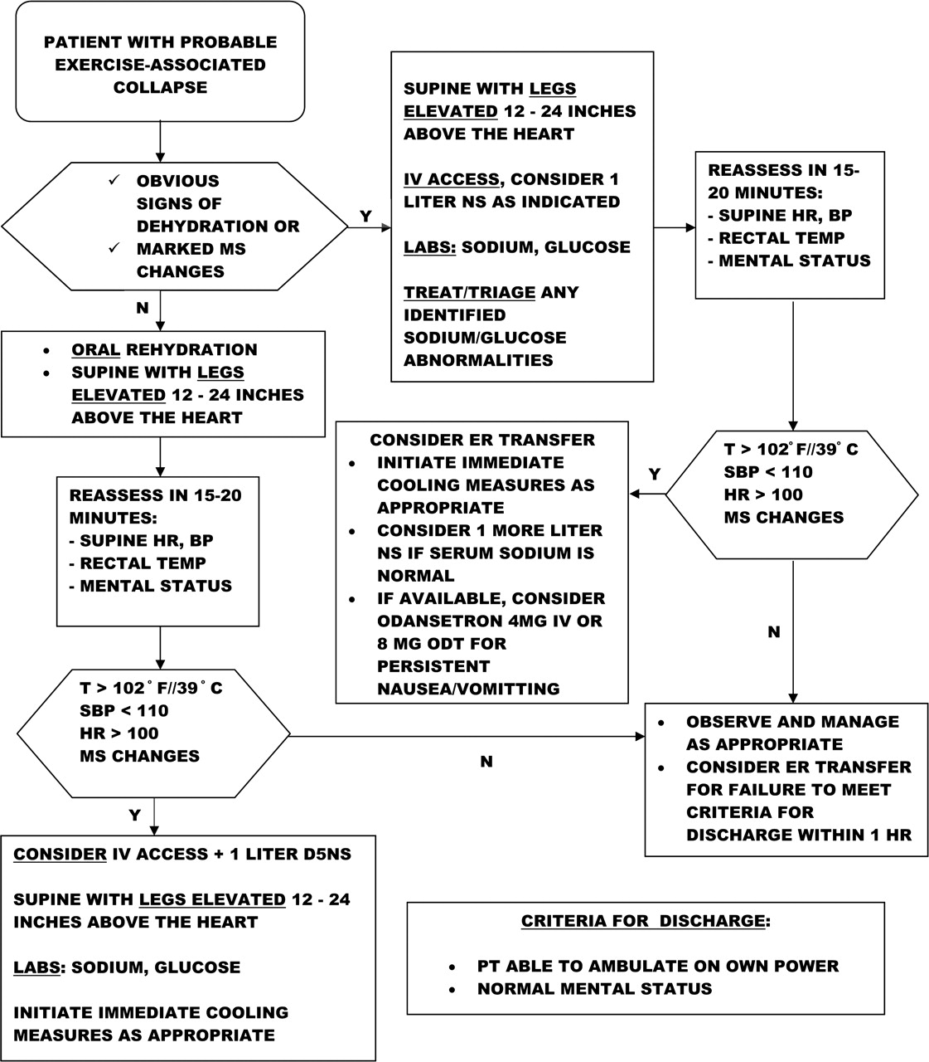
Reproduced with permission. Asplund CA, O'Connor FG, Noakes TD. Exercise-associated collapse: an evidence-based review and primer for clinicians. British Journal of Sports Medicine 2011;45:1157-1162.

References:
- Asplund CA, O'Connor FG, Noakes TD. Exercise-associated collapse: an evidence-based review and primer for clinicians. British Journal of Sports Medicine 2011;45:1157-1162.
- Asplund CA, O'Connor FG, Noakes TD. Exercise-associated collapse: an evidence-based review and primer for clinicians. British Journal of Sports Medicine 2011;45:1157-1162.
- American College of Sports Medicine, Armstrong LE, Casa DJ, Millard-Stafford M, Moran DS, Pyne SW, Roberts WO. American College of Sports Medicine position stand. Exertional heat illness during training and competition. Med Sci Sports Exerc. 2007 Mar;39(3):556-72. doi: 10.1249/MSS.0b013e31802fa199. PMID: 17473783.
- O'Connor, Francis G.; Casa, Douglas J.; Bergeron, Michael F.; Carter, Robert III; Deuster, Patricia; Heled, Yuval; Kark, John; Leon, Lisa; MCDermott, Brendon; O'Brien, Karen; Roberts, William O.; Sawka, Michael American College of Sports Medicine Roundtable on Exertional Heat Stroke - Return to Duty/Return to Play: Conference Proceedings, Current Sports Medicine Reports: September-October 2010 - Volume 9 - Issue 5 - p 314-321
doi: 10.1249/JSR.0b013e3181f1d183

Case 2
Chief Complaint
Syncope in a 17-year-old male while playing basketball.

Vital signs
T 37 C, HR 60 bpm, RR 12, BP 110/70, Sat 100% (RA)
Blood sugar (if asked): 95 mg/dL

History
Source: coach, who witnessed the event
HPI: Patient was playing in a game and doing very well. Suddenly he stopped running
and fell down on the court, unresponsive. Down for about 30 seconds and then woke
up. No seizure-like activity. No loss of continence. Not post-ictal. No one thought to feel
for a pulse or check for respirations.

What does the patient look like?
Patient is a well-developed, well-appearing, African American teenager.

Primary Survey
Airway: Intact
Breathing: unlabored, normal rate and effort
Circulation: Skin warm and well-perfused; strong peripheral pulses

Action
-Obtain stat EKG (Figure 1 – sinus rhythm, LVH, “dagger-like” Q waves in II, III, and
aVF)
-Place on cardiac monitor
-Obtain peripheral IV access and draw a rainbow of labs to hold

Additional history
Source: patient
HPI: He has been feeling well recently. No recent illnesses – no fevers, rhinorrhea, cough, nausea, vomiting, diarrhea. Eating and drinking well.
He admits to occasional chest pain and light-headedness with exertion over past 3 months (if requested).
ROS: otherwise negative
PMHx: None
PSHx: None
Meds: None
Allergies: None
Social: Does not smoke, drink, or use recreational drugs
FHx: 1st cousin with unexplained death in teens
Immunizations: Up to date
PMD: Dr. Johnson

Secondary Survey
General: No acute distress. Well appearing. Awake, alert, and oriented.
HEENT: Normal
Neck: Normal
Chest: Normal. No pectus excavatum.
Heart: HR 60s, regular. 2/6 systolic murmur heard best at the apex and left sternal border, louder with Valsalva maneuver. Strong peripheral pulses in all 4 extremities.
Abdomen: Normal
Urogenital: Normal
Extremities: Normal. Arm span is not greater than the patient’s height.
Back: Normal
Neuro: Normal
Skin: Normal

Action
-Instructor prompt: What are you worried about? What is on your differential?
-Order labs: CBC, BMP, magnesium, troponin
-Consider cardiac POCUS, but this does not negate the need for a comprehensive echocardiogram
-Cardiology consult: That EKG is concerning for HCM. Your patient needs an
echocardiogram. Can you please order that?

Results
-CBC, BMP, magnesium, troponin (Figure 2 – normal)
-echocardiogram: asymmetrical septal hypertrophy; maximal septal wall thickness 25 mm

Action
-Discharge home with very close cardiology consultation
-Advise no physical activity, including basketball, until cleared by cardiology

Diagnosis
-Hypertrophic cardiomyopathy

Critical Actions
-Obtain immediate EKG
-Recognize findings concerning for hypertrophic cardiomyopathy
-Obtain cardiology consult
-Obtain echocardiogram (either while in the ED or very close outpatient)
-Provide discharge instructions telling the patient not to engage in physical activity until
cleared by cardiology

Instructor Guide
This is a case of hypertrophic obstructive cardiomyopathy in a young athlete. The patient presents with a syncopal episode, possibly from decreased cardiac output due to decreased diastolic filling and obstruction during systole or cardiac dysrhythmia that spontaneously aborted. The diagnosis is made based on the presenting complaint, an inquiry into recent exercise-associated symptoms, a careful family history, and a suggestive EKG and echocardiogram. The learner should identify the possibility of life-threatening pathology, rapidly obtain the EKG and recognize it as abnormal, obtain an echocardiogram, and consult with cardiology. The patient should receive guidance regarding cessation of physical activity until cleared to return by cardiology. Discharge home without the echocardiogram and instructions to avoid exertion will result in a return visit in cardiac arrest.

Case Teaching Points
-Causes of sudden cardiac death in athletes:
<35 years old
-most likely congenital or acquired structural or electrophysiologic cardiac pathology
-HCM, ARVH, other cardiac dysrhythmia or cardiomyopathy
-coronary artery disease also possible
>35 years old
-most likely coronary artery disease
-Hypertrophic cardiomyopathy (HCM): HCM is an inherited disorder that results in
abnormal ventricular hypertrophy leading to decreased systolic and diastolic function and
predisposing to cardiac ischemia and electrical conduction disorders, including
ventricular fibrillation. HCM is responsible for between 8-36% of cases of sudden cardiac death in young athletes in the United States. Incidence is higher in male and African-American athletes with male college basketball players having the highest reported overall risk of sudden cardiac death at 1 in 9,000 per year. Overall, male African-American college athletes have a risk of sudden cardiac death of 1 in 16,000 per year.
-Signs and symptoms of HCM include:
-Chest pain, especially with physical exertion
-Shortness of breath, especially with physical exertion
-Fatigue
-Arrhythmias
-Dizziness
-Lightheadedness
-Syncope
-Swelling in the ankles, feet, legs, abdomen and veins in the neck
-Diagnosis is with an abnormal EKG (See Figure 1) and an echocardiogram or cardiac MRI showing unexplained, often asymmetrical, ventricular or septal wall thickening. Normal ventricular wall thickness is <15 mm, and anything greater than that is concerning for possible HCM.
-Arrhythmogenic right ventricular cardiomyopathy (ARVC): ARVC is a genetic cardiomyopathy characterized by fibrofatty replacement of the right ventricular myocardium with variable disease expression. It can increase risk of SCD, notably during exertion.
-Dilated cardiomyopathy (DCM): DCM is another potential cause of sudden cardiac death in athletes. Mild forms of DCM can be difficult to distinguish from “athlete’s heart.”
-Cardiac dysrhythmias: Several studies note higher than expected incidence of morphologically normal hearts upon autopsy of victims of sudden cardiac death. These may represent individuals with primary electrical disorders or channelopathies.

Figure 1.
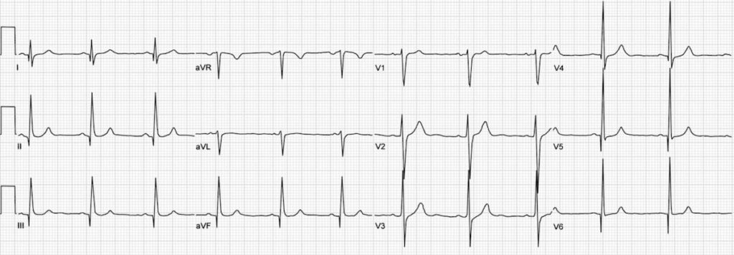

Figure 2.
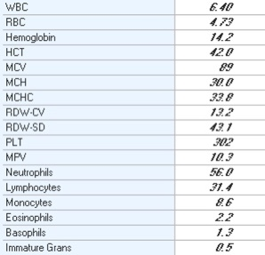

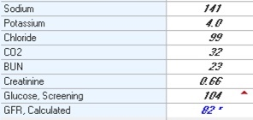

Magnesium 2.0

References:
- Drezner JA, O'Connor FG, Harmon KG, et al
AMSSM Position Statement on Cardiovascular Preparticipation Screening in Athletes: Current evidence, knowledge gaps, recommendations and future directions
British Journal of Sports Medicine 2017;51:153-167.
- Harmon KG, Drezner JA, Wilson MG, et al
Incidence of sudden cardiac death in athletes: a state-of-the-art review
Heart 2014;100:1227-1234.
- Meyer L, Stubbs B, Fahrenbruch C, Maeda C, Harmon K, Eisenberg M, Drezner J. Incidence, Causes, and Survival Trends From Cardiovascular-Related Sudden Cardiac Arrest in Children and Young Adults 0 to 35 Years of Age: A 30-Year Review. Circulation. 2012;126:1363–1372.
- Hypertrophic Cardiomyopathy. Heart.org. https://www.heart.org/en/health-topics/cardiomyopathy/what-is-cardiomyopathy-in-adults/hypertrophic-cardiomyopathy
- Asif IM, Harmon KG. Incidence and Etiology of Sudden Cardiac Death: New Updates for Athletic Departments. Sports Health. 2017;9(3):268-279. doi:10.1177/1941738117694153
- Emery MS, Kovacs RJ. Sudden Cardiac Death in Athletes: State-Of-The-Art Review. J Am Coll Cardiol Heart Fail. 2018 Jan, 6 (1) 30-40.
- Marcus FI, et al. Diagnosis of Arrhythmogenic Right Ventricular Cardiomyopathy/Dysplasia. Circulation. 2010;121:1533–1541.
- Robinson A, Kramer CM. Imaging in Hypertrophic Cardiomyopathy. American College of Cardiology. Apr 24, 2018. https://www.acc.org/latest-in-cardiology/articles/2018/04/20/08/41/imaging-in-hypertrophic-cardiomyopathy.
- Raj MA, Bansal P, Goyal A. Hypertrophic Obstructive Cardiomyopathy. [Updated 2020 Jul 4]. In: StatPearls [Internet]. Treasure Island (FL): StatPearls Publishing; 2020 Jan-. Available from: https://www.ncbi.nlm.nih.gov/books/NBK430820/

Case 3
Chief Complaint
15-year-old male collapsed during pre-season football practice

Vital Signs
T 38.3C, HR 94, RR 18, BP 134/86, O2 Sat 96% (RA)

What does the patient look like?
Teenaged African-American male lying comfortably on the stretcher

Primary Survey
Airway: Intact, no stridor, speaking in complete sentences
Breathing: No respiratory distress. No wheezes, rales, rhonchi.
Circulation: Regular rate and rhythm. No murmurs. 2+ pulses in all 4 extremities.

Action
-Place the patient on the cardiac monitor
-Place an 18g PIV in the AC
-Draw rainbow of blood to hold
-Stat EKG
-Fingerstick glucose (102 if asked)

History
Source: Patient, coach
HPI: Patient collapsed doing sprint intervals during preseason football practice. This was the end of a 3-hour practice. It is August, and the ambient temperature is 91F. Last water break was about an hour prior. Patient was feeling well prior to practice. No known sick contacts. No loss of consciousness. The patient spent his summer inside playing video games. He was not very physically active and did not spend much time outdoors in the heat.
PMHx: Sickle Cell Trait
PSHx: None
Allergies: NKDA
Meds: None
Social: High school sophomore; denies alcohol, tobacco, illicit drugs
FHx: Maternal grandmother with sickle cell disease
Immunizations: Up to date
PCP: Dr. Jones

Secondary Survey
General: No acute distress. Awake, alert, and oriented.
HEENT: Atraumatic. Mucous membranes dry.
Neck: Normal
Lungs: Normal.
Heart: Normal.
Abdomen: Normal.
GU: Normal.
Extremities: Normal.
Back: Normal.
Neuro: Normal.
Skin: Normal.
Lymph: Normal.

Action
-Instructor prompt: ask learner to discuss the differential diagnosis
-Hydrate: 2 liters crystalloid
-Order labs: CBC, BMP, CK, urinalysis

Nurse
-“The patient looks great. Don’t you think he can just go home?” – have the learner discuss concerns in the setting of collapse and sickle cell trait

Results
-CBC: normal
-BMP: creatinine 1.2, normal electrolytes
-CK: 18,684 U/L
-Urinalysis: 2+ blood, 50-100 RBC/hpf

Action
-Admit to medical floor for rhabdomyolysis

Diagnosis
-Sickle cell trait with heat illness and rhabdomyolysis

Critical Actions
-Recognize hyperthermia but absence of heat stoke
-Order EKG
-Obtain CK
-Recognize rhabdomyolysis
-Admit the patient

Instructor Guide
This is a case of rhabdomyolysis in the setting of heat illness with underlying sickle cell trait. The patient has not acclimated to heat or physical activity. The day is hot, and he is exerting maximally for a long time with inadequate hydration and rest. The learner must recognize that the patient is hot, dehydrated, and at risk for rhabdomyolysis. A careful family history will also reveal that this patient may have sickle cell trait. The patient should get an EKG and CK measured and be admitted to the hospital for hydration and monitoring of renal function.

Case Teaching Points
-80,000 -100,000 Americans, mostly, but not all, of African ancestry, have sickle cell disease. Eight to ten percent of African American have sickle cell trait (SCT). Complications such as exertional rhabdomyolysis have been reported in individuals with sickle cell trait. These incidents generally occur with high intensity physical activity or severe dehydration. The risk of exertional death in Division I football players with sickle cell trait in one study was 1:827 - 37 times higher than in athletes without SCT.
-Intense exercise immediately precedes a rapid decline and death within minutes or hours. Heat stroke and rhabdomyolysis are often implicated as the cause of collapse, but these can also occur independently from SCT, and up to one third of cases exhibit neither. Profound hyperkalemia is frequently identified in patients with SCT who experience collapse, occurring with or without associated rhabdomyolysis. In sickle cell trait, strenuous exercise evokes four forces that in concert foster sickling, 1) severe hypoxemia, 2) metabolic acidosis; 3) hyperthermia in muscles, and 4) red-cell dehydration.
-Sickling collapse should be distinguished from cardiac collapse or heat collapse. Unlike sickling collapse, cardiac collapse, caused by ventricular fibrillation, is instantaneous, and the patient is no longer responsive or interactive. Unlike heat collapse, sickling collapse often occurs early in exertion, in the absence of considerably elevated core temperature.
-Athletes with sickle-cell trait are not disqualified from sport. Rather, it is advised that all athletes, regardless of sickle cell status, adhere to the following to avoid preventable exertion-related deaths
-No sickle-trait athlete is ever disqualified from athletics, because simple precautions such as extended rest, cessation of activity if symptoms develop, hydration, pre-season conditioning, and heat acclimatization seem to suffice for prevention.
-In the event of a sickling collapse, treat using high-flow supplemental oxygen. Actively cool the patient, if needed. Expect rhabdomyolysis and hyperkalemia, and check a creatinine kinase and a metabolic panel. Establish IV access and initiate parenteral hydration.

References:

- https://www.hematology.org/advocacy/policy-statements/2012/screening-sickle-cell-trait-athletic-participation
- Harmon KG, Drezner JA, Klossner D, et al. Sickle cell trait associated with a RR of death of 37 times in national collegiate athletic association football athletes: a database with 2 million athlete-years as the denominator. British Journal of Sports Medicine 2012;46:325-330.
- Loosemore M, Walsh SB, Morris E, et al. Sudden exertional death in sickle cell trait.
British Journal of Sports Medicine 2012;46:312-314.
- National Athletic Trainers’ Association Consensus statement: sickle cell trait and the athlete. Available: https://www.nata.org/sites/default/files/SickleCellTraitAndTheAthlete.pdf

