Pediatric Fractures
Pre/Post Quiz
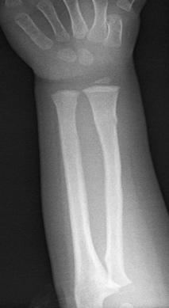
- A 3-year-old child is brought to your emergency department after a fall off a playground structure with R arm pain. They appear to be protecting the wrist and forearm and refuse to use it. You get an x-ray and the film is as shown (right). What is the most likely diagnosis?
  - Salter-Harris Type II fracture
  - Torus (buckle) fracture
  - Greenstick fracture
  - Salter-Type IV fracture

- A 7-year-old boy is found to have a type I supracondylar fracture on an x-ray done in your community emergency department at 9pm. You do not have orthopedics or pediatrics consults readily available. What is the most appropriate management for this patient?
  - Long-arm splint, non-weight bearing, transfer to a trauma center
  - Short arm splint, weight bearing as tolerated, discharge with primary care follow-up
  - Long-arm splint, non-weight bearing, discharge with orthopedic follow-up
  - Short arm splint, weight bearing as tolerated, transfer to a hospital with orthopedic consult available

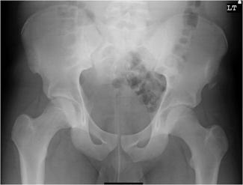
- A 14-year-old female presents with L hip pain after participating in the long jump competition at her high school track meet. She is able to bear weight but each step hurts. She is neurovascularly intact and is tender at the anterior superior iliac spine (ASIS). Based on her x-ray shown (right), what is the most appropriate next step in management?
  - Immediate orthopedic consult for operative fixation
  - Hip splint and non-weight bearing, discharge with orthopedic follow-up
  - Limited activity, discharge with primary care follow-up
  - NSAIDs, weight bearing as tolerated, discharge with orthopedic follow-up

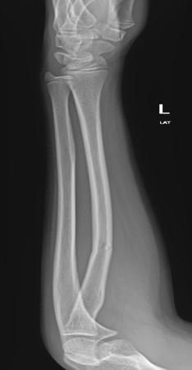
- A 4-year-old child presents with L arm pain after a fall off a table. They refuse to move the arm and have tenderness along the midshaft. You get an x-ray as shown (right). What is the most likely diagnosis?
  - Greenstick fracture
  - Salter-Harris Type III fracture
  - Apophyseal avulsion fracture
  - Torus (buckle) fracture

