CORD Sports Medicine Toolkit:
Pediatric Fractures
Summary Handout

Background: As an Emergency Physician, you will see pediatric patients with musculoskeletal injuries concerning for a fracture. Understanding the differential diagnosis, clinical presentations, and potential complications of various fracture patterns is essential to initiating appropriate workup and optimizing initial and definitive orthopedic treatment.

Purpose: This summary handout is not intended to be all-inclusive. Rather, it will be organized by anatomical region and focus on important injuries while also suggesting differential diagnoses for further independent review.

Basics of Pediatric Fractures
1. A child’s skeleton is composed of significant amounts of growing cartilage which is radiolucent. Therefore, injury is often inferred from widening of growth plates and/or displacement of nearby bony structures seen on plain radiographs.

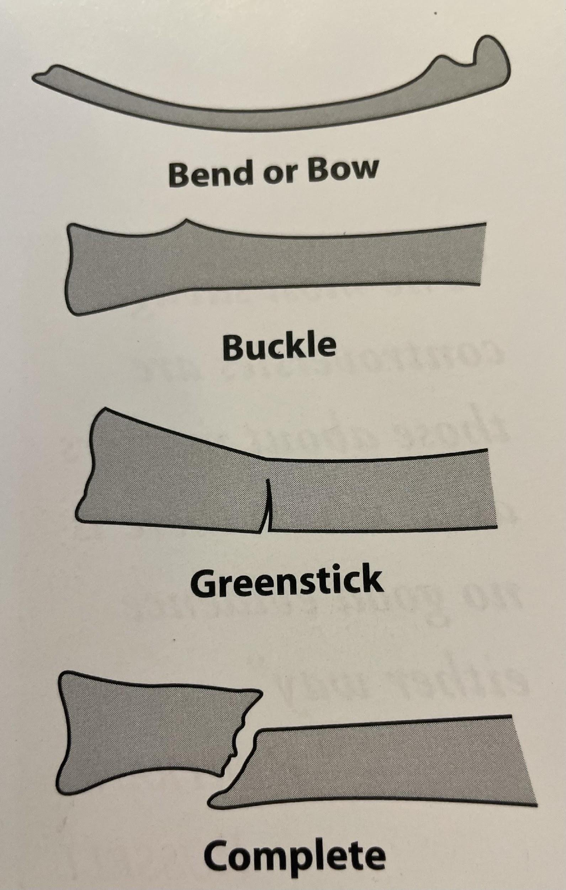
2. Young bone is more porous and thus more flexible than adult bone allowing for greater deformation before failure. Consequently, while compact adult bone fails in tension, pediatric bone can fail in both tension and compression which produces more variation in fracture patterns.

3. Pediatric Fracture Patterns:
- Traumatic Bowing results from the plastic deformation of bone, typically seen in the ulna and the fibula. Pediatric bones have been shown to bend as far as 45° without failure of the cortical bone. Without an actual fracture, there is no bleeding, no repair cascade, no new periosteal bone formation, and no remodeling.
- Buckle or Torus Fractures are the result of compression failure. (Picture stepping on a soda can). The deformity results in a “raised band” appearance near the end of the bone (metaphysis).
- Greenstick Fracture occurs when a bone is angulated beyond its limits of bending. The tension side of the bone fails while the compression side bends but does not fail.
- Complete Fractures occur with failure of both the tension and compression components. Due to the plasticity of pediatric bone, comminuted fracture patterns are rare.
- Spiral Fractures occur in twisting mechanisms of injury. For example, a planted foot/ankle and a twisting of the lower leg.

4. The Physeal Injuries
- 1/3 of skeletal traumatic injuries in pediatrics involve the physis (“growth plate”)
- The area generally repairs well, but has significant potential for complications:
  - Angular deformity
  - Limb-length discrepancies
  - Joint incongruity
- Salter-Harris Classification of physeal injuries:
  - Rule of thumb: Type III and above patterns often require operative fixation.

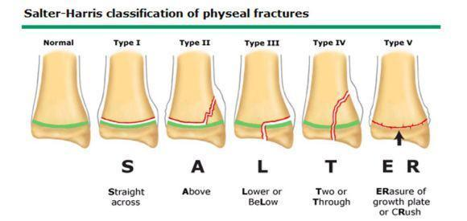

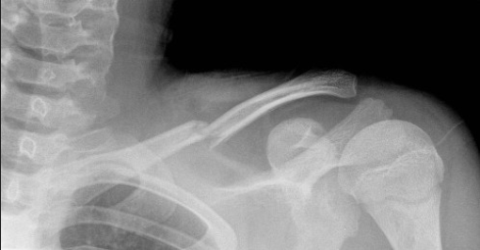
Clavicle:

DDx Clavicle Fractures
- Clavicle shaft fracture (80%)
- Medial clavicle physeal fracture
- Distal clavicle physeal fracture

Clavicle Shaft Fractures
- Incidence: Very common, ~ 15% of pediatric upper extremity injuries
- Demographics: common in active children, all ages, sports and recreation injuries
- MOI:
  - Direct trauma to lateral aspect of shoulder (often in sports)
  - Fall on outstretched upper extremity
- Injury Patterns:
- Non-displaced Fractures
- Displaced Fractures
  - Sternocleidomastoid muscle pulls medial fragment posterior and superior
  - Pectoralis and weight of arm pull lateral fragment inferior medial
  - Consider dedicated Zanca View X-rays (15° cephalic tilt) to determine superior/inferior displacement. You can also have patient hold 5-10 lbs weight in ipsilateral hand
- Open Fractures will generally push through the platysma
- Associated injuries:
- Neurovascular injury (Subclavian vessels)
- Brachial plexus injury
- Treatment:
- Non-operative:
  - Sling or shoulder immobilizer
    - Do not attempt reduction
    - Sling vs. figure-8 brace shown to be equivocal
  - Progressive motion:
    - After 2-4 weeks begin gentle ROM exercises
    - Strength training can begin ~ 6-10 weeks
  - < 12 years of age = high remodeling potential
  - Fracture callus often prominent for 6-12 months post-injury but become less apparent
- Operative:
- ORIF for:
- Displaced fractures that compromise overlying soft-tissue (“skin tenting”)
- Open Fractures
- Vascular injury (Subclavian artery or vein)

Elbow:

DDx Elbow Injuries
- Supracondylar fracture
- Medial epicondyle fracture
- Lateral condyle fracture
- Olecranon fractures
- Radial head/neck fractures
- Elbow dislocation
- Nursemaid’s elbow

Ossification centers of elbow
- Age of radiographic appearance of the ossification center and age of fusion are independent events and must be differentiated

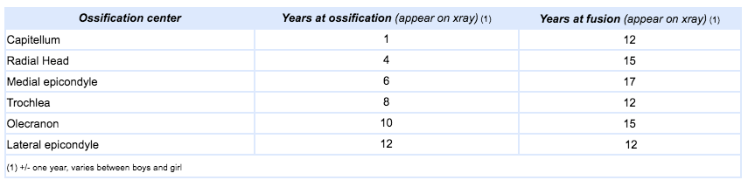
Ref: https://www.orthobullets.com/pediatrics/4007/supracondylar-fracture--pediatric
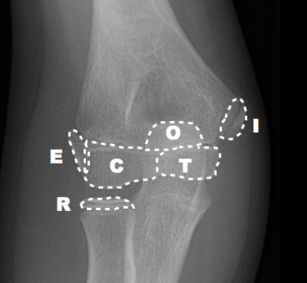
“CRITOE”

Capitellum ~ 1
Radial head ~ 3
Internal (medial) condyle ~ 5
Trochlea ~ 7
Olecranon ~ 9
External (lateral) condyle ~ 11

Dr. Andrew Dixon, Radiopaedia.org, rID: 20908

- For the sake of simplicity, most people will use a 1-3-5-7-9-11 rule for the appearance of ossification centers as listed in the chart above

Supracondylar (SCH) Fractures
- Incidence: Most common traumatic fractures see in children
- Demographics: Usually 5-7 years of age; M = F
- MOI: fall on outstretched extremity
- Two types: extension type most common (95-98%), flexion type less common (<5%)
- Associated injuries:
  - Neuropraxia
  - Anterior Interosseous Nerve (AIN) neurapraxia (branch of median n.)
- Unable to flex thumb IP AND the DIP of the index finger (can't make A-OK sign)
  - Radial Nerve palsy
  - Inability to extend wrist, MCP joints, and thumb IP joint
    - Finger PIP and DIP can still be extended via intrinsic function (ulnar)
  - Ulnar nerve palsy (particularly w/ flexion-type injuries)
  - Virtually all cases of neurapraxia after SCH fractures resolve spontaneously
- 10 Sec Neuro Hand Exam: https://www.youtube.com/watch?v=jYvBlK3KZWc
  - Vascular compromise (5-17%)
  - Potential for Brachial artery injury but rich collateral circulation can maintain circulation despite vascular injury
  - Ipsilateral distal radius fractures
- Treatment: typically closed reduction and percutaneous pinning (CRPP)
- Urgency depending on perfusion of hand
- Based on Gartland Classification:
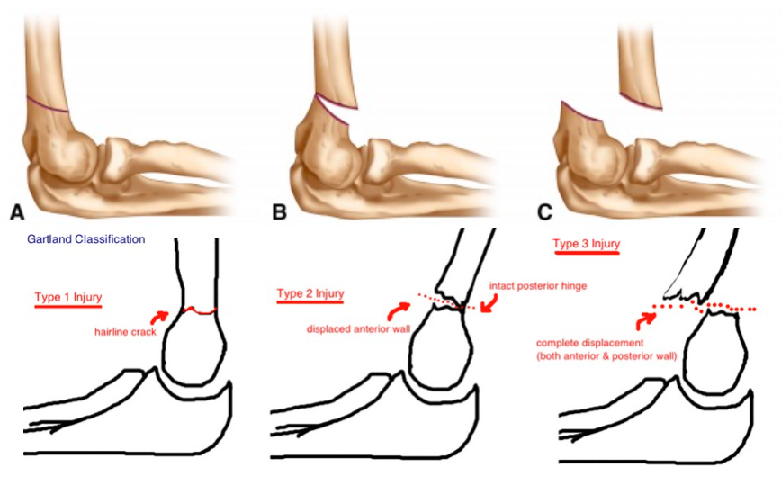
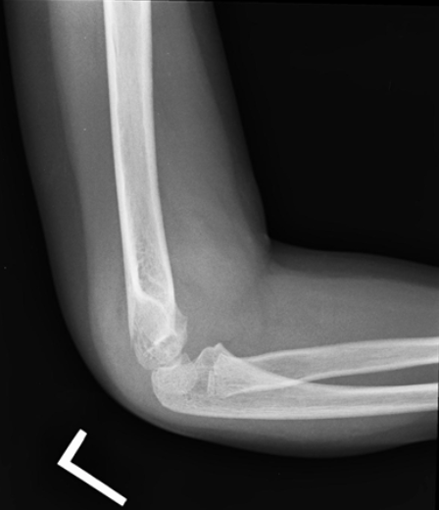
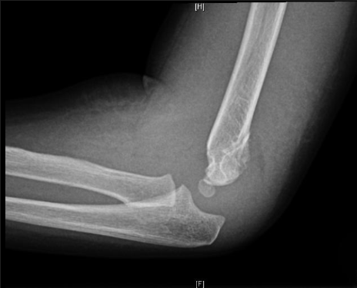
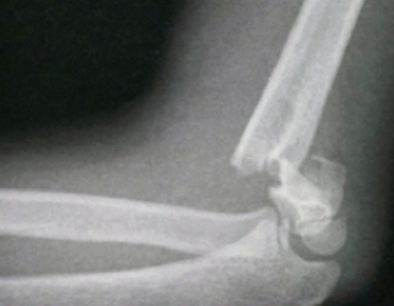

Type I

Type II

Type III
Type I:
  - Non-displaced
  - Anterior humeral line bisects capitellum
  - “Sail sign,” posteriorly (posterior fat pad)
- Treated with long-arm cast/splint immobilization x 3-4 wks
- Orthopedic surgery referral
- Repeat x-rays at 1 week

Type II:
- Displaced
- Posterior cortex/periosteal hinge still intact
- Anterior humeral line does not bisect capitellum
- Immobilize in long-arm splint
- Orthopedic surgery consult
- CRPP

Type III:
- Displaced (often in multiple planes)
- Immobilize in long-arm splint
- Orthopedic surgery consult
- CRPP or open reduction as indicated

Forearm:

DDx Forearm Fractures:
- Both Bone Forearm Fracture (BBFA)
- Monteggia Fracture
- Galeazzi Fracture
- Distal radius fractures

- Forearm fractures are very common in pediatric orthopedics
- Treatment of closed fractures in the pediatric population typically involves closed reduction and splinting in a sugar-tong splint, a long-arm cast, or a short-arm cast depending on fracture location.
- If placed in a circumferential cast, serious consideration should be given to cutting the cast on two sides (“bivalving” the cast) to allow for soft tissue swelling in the acute phase, thereby mitigating risk of compartment syndrome and its complications. The cast may then be “over-wrapped” in a few days at initial orthopedic follow-up.

Closed Reduction Tolerances:
Age Angulation Rotation Bayonet*** Apposition
<10 yo <15° <45° Yes, if < 1 cm shortening
≥ 10 yo <10° <30° No

**If within two years of skeletal maturity (~13 yo) zero angulation, rotation, and shortening are tolerated, especially if fractures are proximal, owing to decreasing remodeling potential with age.
***Bayonet Apposition is an overlap of the two ends of a fracture

- Both Bone Forearm Fracture (BBFA):
- Demographics: Approximately 40% of all pediatric fractures, Boys > Girls
- MOI: falls onto outstretched upper extremity (from a height, sporting events, or off of playground equipment)
- Injury Patterns:
  - Fracture of both radius and ulna
  - Fracture of one bone with plastic deformation of the other
  - No fracture, but plastic deformation (suggested by atypical bowing pattern)
- Torus
- Green Stick
- Plastic Deformation
- Complete Fractures
- Open Fractures – Often-subtle small poke-holes, don’t miss!
- Associated injuries:
  - “Floating Elbow” if with concomitant ipsilateral SCH fracture (~15%)
  - Median nerve injury is most common neurologic injury, but rare (~1%)
  - Compartment syndrome

- Treatment:
- Non-operative:
  - Most pediatric forearm fractures can be treated non-operatively using closed reduction with anesthesia and splint/cast immobilization
  - Three-point molding and interosseous mold are essential to hold reduction.
  - Short arm casts for distal both bone forearm fractures are as effective as long arm casts and have fewer complications associated with them.
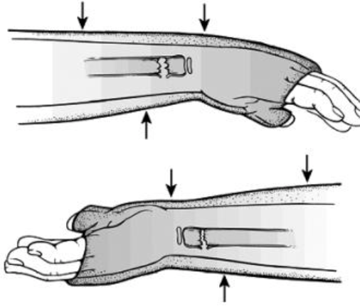

Splint/cast in pronation for apex volar fractures
Splint/cast in supination for apex dorsal fractures

- Operative: CRPP vs. ORIF indicated if:
- Fail to achieve acceptable reduction tolerances with closed reduction
- BBFA fractures in children > 13 yo
- Open fractures
- Re-fractures
- Highly displaced or comminuted fractures

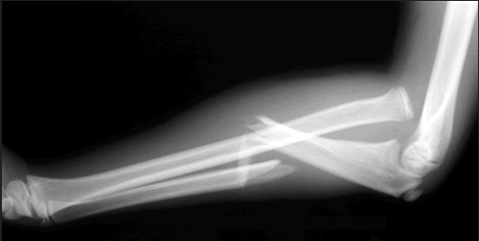
- Monteggia Fracture:
- Radial head dislocation plus
- Proximal ulna fracture (or plastic deformation without obvious fracture)
- Demographics: most commonly 4-10 yo
- MOI: fall on outstretched upper extremity
- Key Points:
- Radial head may spontaneously reduce, so always palpate radial head when ulna fractures are seen.
- Radial head dislocations rarely occur in isolation, so obtain forearm films
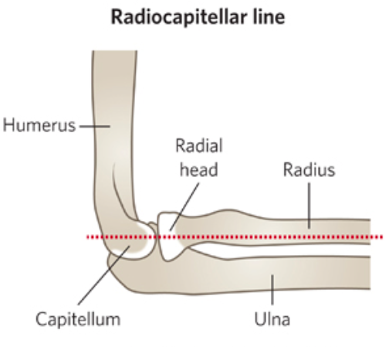
- Radiocapitellar Line: line drawn down midshaft of radius should bisect capitellum.
- Treatment:
- Non-operative:
  - Radial head will reduce spontaneously with ulna reduction provided restoration of length is achieved
  - Radial head (RH) reduction and ulna length restoration are essential; otherwise, operative intervention is indicated.
  - Apex anterior/anterior RH dislocation = splint/cast in full supination and 110° of elbow flexion.
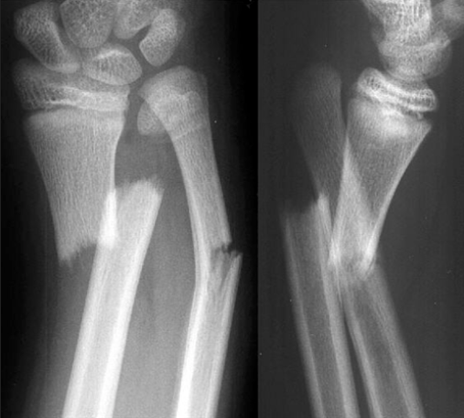
  - Apex posterior/posterior RH dislocation = splint/cast in full elbow extension.
  - Apex lateral/lateral RH dislocation = splint/cast in full elbow extension w/ valgus mold.
- Operative:
  - Open fractures
  - Children ≥ 10 yo if closed reduction is not stable
  - Closed physes

- Galeazzi Fracture
- Fracture of the distal radius at the distal metaphyseal-diaphyseal junction with associated disruption of the distal radioulnar joint (DRUJ)
- Demographics: Rare with only ~3% of distal radius fractures having associated DRUJ disruption. Peak incidence between 9 and13 yo
- MOI: fall on outstretched upper extremity, axial loading with forearm rotation to extreme supination or extreme pronation.
- Associated injuries: Rare peripheral nerve injuries.
- Treatment:
- Non-operative:
  - Closed reduction and splinting/casting in pediatrics (unlike adults) is primary treatment modality.
  - Long-arm cast/splint in supination required to immobilize DRUJ.
- Complications:
- Missed/delayed diagnosis
- Chronic DRUJ instability or stiffness in pronation-supination

Pelvis, Hip & Femur:

DDx Pelvis/Hip/Femur Injury:
- Apophyseal Avulsion
- Traumatic Hip Dislocation
- Proximal femur/Hip fractures
- Femoral shaft fractures
- Distal femoral physeal fractures

Pelvic Ring Fractures are uncommon in pediatrics. When they do occur it is typically in the setting of a high-energy MOI (e.g. MVC). In these cases, ATLS protocols should be followed and particular focus should include assessing for associated abdominal viscera and spinal cord injuries.

Pediatric Femur Fractures
- Will vary by location (neck, proximal, shaft, distal)
- On the athletic field/court, reduction should be accomplished with a long leg splint or a traction splint. (The latter can only be maintained for a few hours due to potential skin necrosis from the ankle cuff).
- Patients should be transported to the hospital with a plan for admission and intervention in the OR by either spica cast placement or operative fixation depending on the patient’s age and status of physis.

In the pediatric athlete, apophyseal avulsion and traumatic hip dislocations are not unusual.

- Apophyseal Avulsion

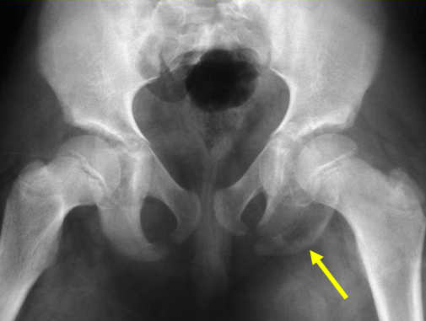
- MOI: Avulsion injuries occur when a tendon is pulled along with its boney origin. In the pediatric pelvis, this is becoming more common in today’s competitive youth athletics. The muscles about the hip overpower the open pelvic apophyses during quick, powerful muscle actuation during activities such as sprinting, kicking, and jumping, creating avulsion fractures.

Ischial Avulsion

- Demographics:
- (54%) Hamstrings and adductors- Ischial avulsion fractures (hurdlers and gymnasts)
- (22%) Rectus femoris-Anterior Inferior Iliac Spine (AIIS) avulsion (football and rugby)
- (19%) Sartorius- Anterior Superior Iliac Spine (ASIS) avulsion (sprinters)

- Treatment:
- Non-operative:
  - Protected weight bearing for 2-4 weeks
  - Stretching and strengthening 4-8 weeks
  - Return to sport and activity after 8 weeks when asymptomatic
- Operative:
- Displaced avulsion fractures >2-3 cm
- Painful nonunion may require operative fixation or fracture fragment excision.

- Traumatic Hip Dislocation
- MOI: Due to low-energy sports injury in children <10 yo or high-energy (MVC) in children > 10 yo.
- Although not a pediatric case, the most famous athletic-related traumatic hip dislocation was NFL and MLB star Bo Jackson, when he was tackled awkwardly from behind in a football game, leading to an early end to his athletic career due to avascular necrosis of the femoral head.
- Injury Patterns:
- Posterior Dislocation
  - Mild flexion, adduction, and internal rotation
  - Limb length discrepancy (shortened)
- Anterior Dislocation
  - Slight flexion, abduction, and external rotation
  - Can appear normal limb length
- Associated injuries:
- Avascular necrosis of the femoral head.
- Rare sciatic or gluteal nerve injury (palsy)
- Acetabulum fractures (less common than in adults due to cartilaginous structure)
- Femoral head, femoral neck, and/or proximal femoral physis fractures
- Treatment:
- Orthopedic Emergency:
- Urgent closed reduction under general anesthesia or sedation in < 6 hour
- Open reduction if there is an intraarticular fragment following or preventing reduction

Knee and Lower Leg:

DDx Fractures Near the Knee
- Tibial tubercle fracture
- Tibial eminence fracture
- Knee dislocation
- Patella dislocation
- Patella sleeve fracture
- Proximal tibia epiphyseal fractures
- Proximal tibia metaphyseal fractures
- Tibial Shaft Fractures

- Fractures near the knee involving the distal femur, the proximal tibia/fibula, and the patella are common. Fortunately, in pediatric patients, these injuries heal quite well. In adolescents, as skeletal maturity is approached and reached, ligamentous injuries become more worrisome as injuries can be varied and outcomes less certain.
- On the field or court, bony and ligamentous injuries near the knee should be assessed for neurovascular compromise.
- Suspected dislocations, especially knee dislocations, are orthopedic emergencies and should be immediately reduced. The leg should then be placed in a knee immobilizer or long leg splint (posteriorly from gluteal fold to foot).
- In the ED radiographs should include the full femur, knee, and tibia/fibula and a CT angiogram of the lower extremity is necessary to rule out vascular injury, even with a normal vascular exam
- Tibial shaft fractures should be similarly splinted in long leg splint as described above as well as a stirrup/”U” piece for varus/valgus support. Definitive treatment is closed reduction and long-leg casting or operative fixation depending on age and degree of displacement.

Tibial Tubercle Fracture
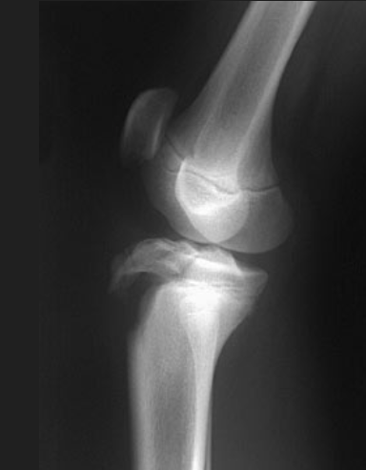
- Demographics: Common athletic injury in boys 13-15 yo (near skeletal maturity). Basketball, football, track events (sprinting and high jump)
- MOI:
- Concentric contraction of quadriceps while jumping
- Eccentric contraction of quadriceps with forced knee flexion
- The knee extensor mechanism exerts large forces on the tibial tubercle (patella tendon insertion site)
- The tubercle is a secondary ossification center of tibia, and the last part of tibia to fuse, thus it is at increased risk of injury in older children
- Assess for intact extensor mechanism with straight-leg raise
- Associated Injuries:
- Recurrent Anterior Tibial Artery can be lacerated
- Compartment syndrome
- Meniscal tears
- Treatment:
  - Non-operative:
- Minimally displaced fractures ( < 2 mm)
- Long leg cast in extension for 6 weeks
  - Operative:
- ORIF, possible arthrotomy/arthroscopy, soft tissue repair
- Must visualize joint surface for anatomic reduction and to evaluate for intraarticular injury (meniscal tears, etc.)

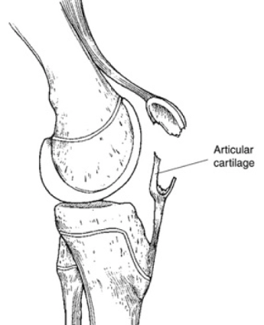
Patella Sleeve Fracture
- Separation of the cartilage “sleeve" from the ossified patella
- Demographics:
  - Rare but significant injury (~1% of peds fractures)
  - Children 8-12 yo (when patellar ossification is almost complete)
  - M>F (5:1)
- MOI:
- Non-contact/no direct blow.
- Forceful contraction of quadriceps with knee flexed
- Will have trouble extending knee, palpable defect/gap at inferior patella
- Treatment:
  - Non-operative:
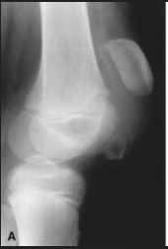
- Rare, non-displaced treated in cylindrical cast x 6 weeks

“Patella Alta”
- In ED, place in knee immobilizer and consult orthopedic surgery
  - Operative:
- Most require ORIF in order to repair soft tissues and achieve anatomic reduction of articular fragment
Ankle:

DDx Ankle Fractures
- Ankle Fractures
- Tillaux Fracture
- Triplane Fractures

Ankle fractures
- Pediatric ankle fractures differ substantially from adult injuries for three reasons:
    - Physis is a plane of weakness which directs fracture lines in patterns different from adult fractures.
    - Pediatric ligaments are stronger than bone so ligamentous injuries are less common than in adults, who have stronger bones and weaker ligaments.
    - Certain injuries will adversely affect normal bone growth.
- Around age 14-15 yo, pediatric ankle fracture patterns resemble their adult counterparts
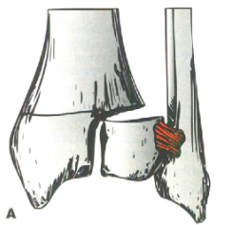
- Pediatric ankle fractures are common and tend to follow the classic Salter-Harris classifications.
- Generally, non-displaced fractures are treated as non-weight bearing in a walking boot or a short-leg cast. Displaced fractures require operative fixation (CRPP or ORIF).
- Two subtypes of ankle fractures require particular attention:
- Tillaux fractures (a SH III fracture)
- Triplane fractures (a SH IV fracture)

Tillaux Fractures
- Salter-Harris III fracture of anterolateral distal tibia epiphysis
- Demographics: 12-14 yo children, nearing skeletal maturity
- MOI:
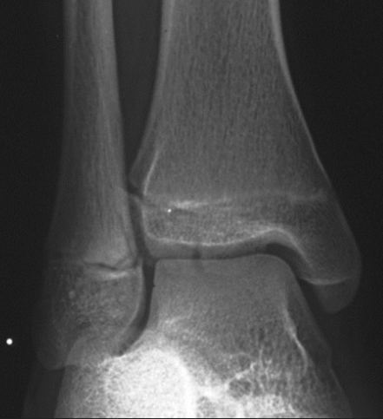
- Supination-external rotation injury
- Avulsion of the anterior inferior tibiofibular ligament
- Result of manner in which distal tibial physis closes:
- Central > Anteromedial > Posteromedial > Lateral
- Injury Patterns: Absence of coronal plane fracture in the posterior distal tibial metaphysis distinguishes it from Triplane fracture
- Associated Injuries:
  - Distal fibular fracture (usually SH I or II)
  - Ipsilateral tibial shaft fracture
- Treatment:
  - Non-operative:
- Closed reduction and casting if <2-mm displacement (Rare)
- Long-leg cast initially x 4 weeks for rotational control
- SLC or walking boot x 2-4 weeks
  - Operative:
- CRPP vs ORIF if >2-mm displacement
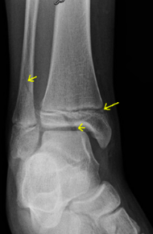

SH IV pattern on AP
Triplane Fractures
- Complex Salter-Harris IV ankle fracture pattern with fractures in multiple planes
- Demographics:
  - Children 10-17 yo during physeal closure
  - 5-15% of pediatric ankle fractures
  - Boys more common
- MOI:
- Lateral Triplane fractures- similar to Tillaux in that it is a supination-external rotation injury
- Medial Triplane fractures- adduction injury
- Injury Patterns:
- 2, 3, or 4 part fractures are possible
- Epiphysis fractured at lateral aspect in the sagittal plane (like Tillaux fracture) seen on AP
- Physis separated in the axial plane (widened on AP view)
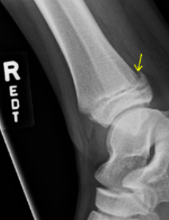
- Metaphysis is fractured on the posterior aspect in coronal plane seen lateral view

Plus posterior coronal fracture on lateral
- Associated Injuries:
- Distal fibular fracture (often spiral, unstable requiring ORIF)
- Ipsilateral tibial shaft fracture
- Treatment:
  - Non-operative:
- Displacement < 2 mm
- Closed reduction maneuvers:
- Reduce fibula fracture prior to tibia
- Lateral Triplane – reduce with internal rotation
- Medial Triplane – reduce with eversion
- Long-leg cast initially x 4 weeks for rotational control
- SLC or walking boot x 2-4 weeks
  - Operative:
    - Displacement > 2 mm
    - CRPP vs ORIF

Rang’s Children’s Fractures, 3rd Ed., Wenger, D. and Pring, M., 2005, pp. 3
OrthoBullets reference and photos, accessed March 16, 2020 https://www.orthobullets.com/pediatrics/322128/clavicle-shaft-fracture--pediatric
OrthoBullets reference and photos, accessed March 16, 2020 https://www.orthobullets.com/pediatrics/4007/supracondylar-fracture--pediatric
OrthoBullets reference and photos, accessed March 16, 2020 https://www.orthobullets.com/pediatrics/4126/both-bone-forearm-fracture--pediatric
Ibid.
OrthoBullets reference and photos, accessed March 16, 2020 https://www.orthobullets.com/pediatrics/4015/monteggia-fracture--pediatric
OrthoBullets reference and photos, accessed March 16, 2020 https://www.orthobullets.com/pediatrics/4016/galeazzi-fracture--pediatric
Rang’s, 176.
OrthoBullets reference and photos, accessed March 16, 2020 https://www.orthobullets.com/pediatrics/3000/pelvis-fractures--pediatric
Ibid.
Ibid.
Rangs, 178.
OrthoBullets reference and photos, accessed March 16, 2020 https://www.orthobullets.com/pediatrics/4023/tibial-tubercle-fracture
OrthoBullets reference and photos, accessed March 16, 2020 https://www.orthobullets.com/pediatrics/4120/patella-sleeve-fracture
Rang, 227.
OrthoBullets reference and photos, accessed March 16, 2020 https://www.orthobullets.com/pediatrics/4027/ankle-fractures--pediatric
Rang, 235.
OrthoBullets reference and photos, accessed March 16, 2020 https://www.orthobullets.com/pediatrics/4028/tillaux-fractures

