Teaching Case Template

Author: Esther H Chen Reviewer: Miriam Kulkarni

Case Title: AMI with Cardiogenic Shock

Target Audience: Medical students, Interns, Residents

Primary Learning Objectives: key learning objectives of the scenario
(suggested maximum of five)
1. To demonstrate knowledge of the indications and contraindications for emergent reperfusion therapy (percutaneous coronary intervention and thrombolysis)
2. To recognize and initiate appropriate treatment for cardiogenic shock
3. To effectively use vasopressor and inotropic agents and demonstrate understanding of their pharmacology

Critical actions checklist – a list to ensure the educational /assessment goals are met.
This may include:

1. Obtain immediate bedside electrocardiogram
2. Recognize anterior wall STEMI and obtain emergent interventional cardiology consultation: the resident should also be initiating anti-platelet therapy and analgesia
3. Initiate thrombolytics after discovering interventional cardiology is unavailable: the resident should ask the patient for any potential contraindications to thrombolytic therapy
4. Recognize shock and initiate vasopressor therapy: the resident should initially treat with IVF bolus, followed by vasopressor therapy along with an inotropic agent
5. Urgent transfer to nearest hospital with interventional cardiology availability:

***Editor’s Comment: This case may be modified by making the cath lab available.

Environment (if using as a simulation case)
- Room Set Up – ED, trauma bay, decon room, in sim lab or in situ
  - (if used) Manikin Set Up – type of simulator, moulage, lines needed, drugs needed
  - Props – ECGs needed, X-rays, CT scans, EMS equip, decon equipment, airway equipment, code blue cart
- Distractors – list here any environmental or background distractors

Actors (optional)
- Roles – paramedic, nurse, consultant
- Who may play them – other residents, other students, actors
- Action Role – what role do they serve in the scenario?

For Examiner Only

Author: Esther H Chen Reviewer: Miriam Kulkarni

Case Title: AMI with Cardiogenic Shock

CASE SUMMARY

CORE CONTENT AREA

Cardiovascular Disorders: Acute Myocardial Infarction with Cardiogenic Shock

SYNOPSIS OF HISTORY/ Scenario Background
The patient presents with three days of shortness of breath on exertion, intermittent left sided chest pain that radiates to both arms with numbness in both forearms, associated with lightheadedness and nausea. She called the paramedics because her shortness of breath was acutely worse today. She has no significant past medical history or surgical history. She takes no medications and has no allergies. Her family history is significant for HTN in her dad. She does not smoke, drink alcohol, or take any drugs. En route, the patient was given ASA but no nitroglycerin because of her low blood pressure.

SYNOPSIS OF PHYSICAL
On exam, the patient is diaphoretic and very anxious, but not altered. Her vital signs are significant for hypotension and tachypnea, with normal oxygen saturation. Her cardiovascular exam is normal and without murmurs. She has no crackles on lung exam and no lower extremity edema. Her peripheral pulses are present but weak. Her ECG shows an anterior wall STEMI and her labs are significant for an elevated troponin.

For Examiner Only

CRITICAL ACTIONS
Scenario branch points/ PLAY OF CASE GUIDELINES

Key teaching points or branch points that result in changes in patient’s condition

- Obtain immediate bedside electrocardiogram

The resident should ask the nurse for a bedside ECG, ideally while obtaining the history, but definitely within 10 minutes of patient arrival.

Cueing Guideline: If the resident does not ask for an ECG within 10 minutes from arrival, the nurse should ask the resident if there’s anything else that she or he wants to order.

- Recognize anterior wall STEMI and obtain emergent interventional cardiology consultation

After reading the ECG, the resident should immediately recognize the STEMI and ask for interventional cardiology consultation.

Cueing Guideline: If the resident does not verbalize the ECG findings, the nurse should ask what the ECG shows.

- Initiate thrombolytics after discovering interventional cardiology is unavailable : see comments above

Once the resident is told that there is no cath lab available at the hospital, he/she should initiate thrombolytic therapy. The resident should ask the patient whether she has any contraindications to receiving thrombolytics.

Cueing Guideline: If the resident does not order thrombolytic therapy, the nurse should ask if there is anything else he/she wants to give the patient.

- Recognize shock, give small amount of IVF, and quickly initiate vasopressor therapy: How will the patient respond to vasopressors?

When the patient’s vital signs do not improve with reperfusion therapy and a small amount of IVF, the resident should initiate vasopressor therapy with dopamine and dobutamine.

Cueing Guideline: The nurse should remind the resident that the patient’s repeat blood pressure is still 70/55.

- Urgent transfer to nearest hospital with interventional cardiology availability:see comments above

The resident should ask the transfer coordinator to assist in transferring the patient to the nearest hospital with a cath lab.

Cueing Guideline: The nurse should say to the resident that admission papers need to be submitted for the patient and ask where he/she wants the patient to go.

SCORING GUIDELINES
(Critical Action No.)
1. Obtain immediate bedside electrocardiogram
2. Recognize anterior wall STEMI and obtain emergent interventional cardiology consultation
3. Initiate thrombolytics after discovering interventional cardiology is unavailable
4. Recognize shock and initiate vasopressor therapy
5. Urgent transfer to nearest hospital with interventional cardiology availability

For Examiner Only

HISTORY

Onset of Symptoms: Three days ago

Background Info: The patient presents with three days of shortness of breath with exertion, intermittent left sided chest pain that radiates to both arms with numbness in both forearms, associated with lightheadedness and nausea. She called the paramedics to bring her to the hospital because her shortness of breath was acutely worse today.

Chief Complaint: Shortness of breath

Past Medical Hx: None

Past Surgical Hx: None

Habits: Smoking: None
ETOH: One glass of wine with dinner
Drugs: None

Family Medical Hx: Father with hypertension

Social Hx: Marital Status: Married
Children: None
Education: College
Employment: Teacher

ROS: No syncope, vomiting, abdominal pain, hemoptysis, cough.

For Examiner Only

PHYSICAL EXAM

Patient Name: Janet Pain Age & Sex: 64 F

General Appearance: Well-developed, well-nourished woman, diaphoretic and anxious

Vital Signs: BP 78/56 P 95 R 20 T 37.2ºC O₂ Sat 100% on 2L O₂

Head: Normal

Eyes: Normal

Ears: Normal

Mouth: Normal

Neck: No jugular venous distension

Skin: Clammy, cool

Chest: Normal

Lungs: Clear to auscultation bilaterally

Heart: RRR, S1, S2 no murmurs, gallops, or rubs

Back: Normal

Abdomen: Normal

Extremities: No edema, 1+ peripheral pulses

Rectal: Deferred

Pelvic: Deferred

Neurological: Normal

Mental Status: Awake, alert, answers questions appropriately

For Examiner Only

STIMULUS INVENTORY

#1 Emergency Admitting Form

#2 CBC

#3 BMP

#4 U/A

#5 ABG

#6 Cardiac Enzymes

#7 Coagulation profile

#8 Toxicology (Urine)

#9 ECG

#10 CXR

For Examiner Only

LAB DATA & IMAGING RESULTS

Stimulus #2 Stimulus #5
Complete Blood Count (CBC) Arterial Blood Gas (ABG)
WBC 10,400 /mm³ pH 7.16
Hgb 12.2 g/dL pCO₂ 36 mm Hg
Hct 36 % pO₂ 185 mm Hg
Platelets 220,000 /mm³ O₂ Sat 100 %

Stimulus #3 Stimulus #6
Basic Metabolic Profile (BMP) Cardiac Enzymes
Na 134 mEq/L Myoglobin 50 ng/ml
K⁺ 3.4 mEq/L Troponin 4.3 ng/ml
CO₂ 23 mEq/L
Cl⁻ 104 mEq/L Stimulus #7
BUN 25 mg/dL Coagulation Profile
Creatinine 0.9 mg/dL PT/inr 11.0 sec/1.0
PTT 27 sec
Stimulus #4
Urinalysis (U/A) Stimulus #8
Color yellow Toxicology (Urine)
Sp gravity 1.010 Cocaine Neg
Glucose neg Cannabinoids Neg
Protein neg PCP Neg
Ketone neg Amphetamines Neg
Leuk. Est. neg Opiates Neg
Nitrite neg Barbiturates Neg
WBC 0-1 Benzodiazepines Neg
RBC 0-1
Stimulus #9
Electrocardiogram
Normal sinus rhythm
Left atrial enlargement
Nonspecific intraventricular block
Lateral infarct. Possibly acute T wave abnormality.
Consider inferior ischemia. Actue MI

Diagnostic Imaging
Stimulus #10
CXR Negative

Learner Stimulus #1

ABEM General Hospital

Emergency Admitting Form

Name: Janet Pain
Age: 64 years
Sex: Female
Method of Transportation: Fire Rescue
Person giving information: Patient, Medics
Presenting complaint: Shortness of breath

Background: The patient presents with three days of shortness of breath with exertion, intermittent left sided chest pain that radiates to both arms with numbness in both forearms, associated with lightheadedness and nausea. She called the paramedics to bring her to the hospital because her shortness of breath was acutely worse today.

Triage or Initial Vital Signs
BP: 78/56
P: 95
R: 20
T : 37.2 ºC
O₂ Sat: 100% on 2L O₂

Learner Stimulus #2

Complete Blood Count (CBC)

WBC 10,400 /mm³
Hgb 12.2 g/dL
Hct 36 %
Platelets 220,000 /mm³

Learner Stimulus #3

Basic Metabolic Profile (BMP)

Na 134 mEq/L
K⁺ 3.4 mEq/L
CO₂ 23 mEq/L
Cl⁻ 104 mEq/L
BUN 25 mg/dL
Creatinine 0.9 mg/dL

Learner Stimulus #4

Urinalysis (U/A)

Color yellow
Sp gravity 1.010
Glucose neg
Protein neg
Ketone neg
Leuk. Est. neg
Nitrite neg
WBC 0-1
RBC 0-1

Learner Stimulus #5

Arterial Blood Gas (ABG)

pH 7.34
pCO₂ 36 mm Hg
pO₂ 185 mm Hg
O₂ Sat 100 %

Learner Stimulus #6

Cardiac Enzymes

Myoglobin 50 ng/ml
Troponin 4.3 ng/ml

Learner Stimulus #7

Coagulation Profile

PT/inr 11.0 sec/1.0
PTT 27 sec

Learner Stimulus #8

Toxicology (Urine)

Cocaine Neg
Cannabinoids Neg
PCP Neg
Amphetamines Neg
Opiates Neg
Barbiturates Neg
Benzodiazepines Neg

Learner Stimulus #9

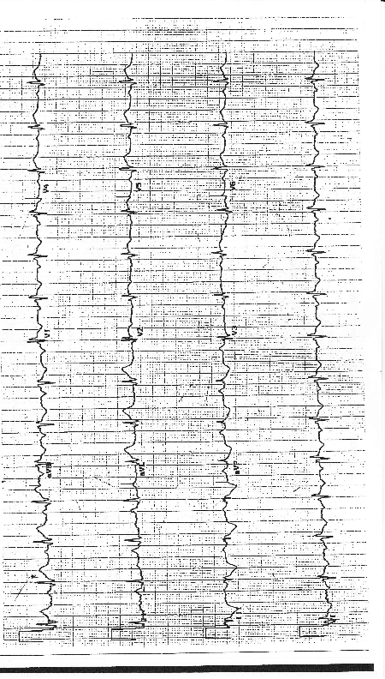
Learner Stimulus #10

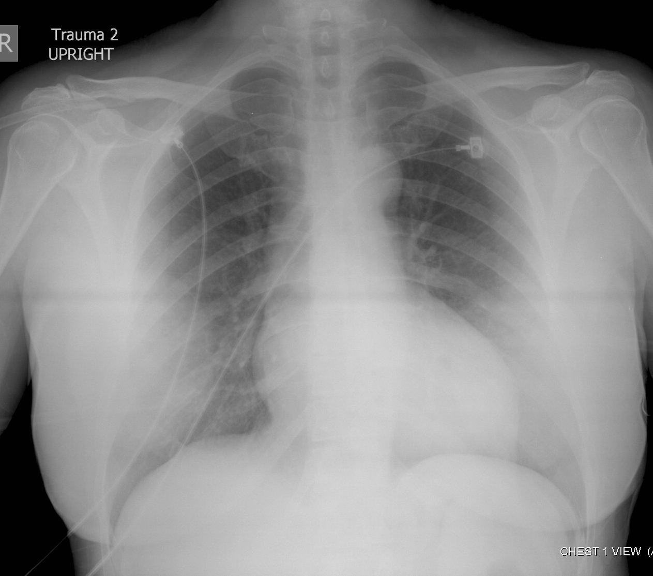
Core Competency Assessment

Case Name Here

Candidate ________________________ Examiner _________________________

 | Does Not Meet Expectations | Meets Expectations | Exceeds Expectations
Patient Care
Medical Knowledge
Interpersonal Skills and Communication
Professionalism
Practice-based Learning and Improvement
Systems-based
Practice

For Examiner

Date: Examiner: Examinee(s):
Scoring: In accordance with the Standardized Direct Observational Tool (SDOT)

The learner should be scored (based on level of training) for each item above with one of the following:
NI = Needs Improvement
ME = Meets Expectations
AE = Above Expectations
NA= Not Assessed

Critical Actions | NI | ME | AE | NA | Category
Obtain immediate bedside ECG |  |  |  |  | PC, MK
Recognize anterior wall STEMI and obtain emergent interventional cardiology consultation |  |  |  |  | PC, MK, ICS, SBP
Initiate thrombolytics after discovering interventional cardiology is unavailable: see comments above |  |  |  |  | PC, MK
Recognize shock and initiate vasopressor therapy |  |  |  |  | PC, MK
Urgent transfer to nearest hospital with interventional cardiology availability |  |  |  |  | PC, SBP, ICS

The score sheet may be used for a variety of learners. For example, in using the case for 4th year medical students, the key teaching points of the case may be the recognition of shock and treatment with appropriate fluid resuscitation. Other items may be marked N/A= not assessed.

Category: One or more of the ACGME Core Competencies as defined in the SDOT

PC= Patient Care
Compassionate, appropriate, and effective for the treatment of health problems and the promotion of health
MK= Medical Knowledge
Residents are expected to formulate an appropriate differential diagnosis with special attention to life-threatening conditions, demonstrate the ability to utilize available medical resources effectively, and apply this knowledge to clinical decision making
PBL= Practice Based Learning & Improvement
Involves investigation and evaluation of their own patient care, appraisal and assimilation of scientific evidence, and improvements in patient care
ICS= Interpersonal Communication Skills
Results in effective information exchange and teaming with patients, their families, and other health professionals
P= Professionalism
Manifested through a commitment to carrying out professional responsibilities, adherence to ethical principles, and sensitivity to a diverse patient population
SBP= Systems Based Practice
Manifested by actions that demonstrate an awareness of and responsiveness to the larger context and system of health care and the ability to effectively call on system resources to provide care that is of optimal value

Debriefing Materials:

Please attach any powerpoint lectures, diagrams, images or other pertinent material the instructor may use for debriefing material.

Add 4-6 keywords for future searching functions

Acute myocardial infarction
Cardiogenic shock

References

Kushner FG, et al. 2009 focused updates: ACC/AHA guidelines for the management of patients with ST-elevation myocardial infarction and ACC/AHA/SCAI guidelines on percutaneous coronary intervention, a report of the American College of Cardiology Foundation/American Heart Association Task Force on Practice Guidelines. J Am Coll Cardiol. 54(23):2205-2241, 2009.

Has this work been previously published? No

