Author: Yonathan Habtemariam, MD Reviewer: Sharon Griswold, MD MPH
Edward A Ramoska, MD, MPH

Case Title: Brugada Syndrome

Target Audience: med students, nurses, paramedics, residents, other

Primary Learning Objectives: key learning objectives of the scenario

1. Identification of patients with risk factors for dangerous causes for syncope
2. Appropriate interpretation of EKG suggestive of Brugada syndrome
3. Management and disposition of patients with symptomatic Brugada syndrome

Secondary Learning Objectives: detailed technical goals, behavioral goals, didactic points

1. Obtain EKG on all patients with syncope
2. Have a strategy to look for findings that increase the risk for serious outcomes in patients that present with syncope (eg. San Francisco syncope rule)

Critical actions checklist – a list to ensure the educational /assessment goals are met.

- Put patient on cardiac monitor.
- Obtain a 12-lead ECG.
- Identify ECG suggestive of patient having Brugada syndrome.
- Give an antipyretic.
- Obtain immediate cardiology consultation.
- Admit patient to bed with continuous cardiac monitor.

For Examiner Only

Author: Yonathan Habtemariam, MD Reviewer: Sharon Griswold, MD MPH
Edward A Ramoska, MD, MPH

Case Title: Brugada Syndrome

CASE SUMMARY
CORE CONTENT AREA

Cardiovascular

SYNOPSIS OF HISTORY/ Scenario Background

41 year old Asian male presents to ER stating that he blacked out for about a minute while sitting on his couch watching Monday night football just prior to arrival. His wife drove him to the hospital. He had subjective fever, dry cough, runny nose, body aches for past 3 days. His 5 year old daughter recovered from a viral illness 4 days ago.

Past medical history: No known medical problems.

Medications and allergies: No medications, including no over-the-counter medications. NKDA.

Family and social history: Father had mild heart attack at age 60, also has hypertension, DM type II. Mother has hypertension. Cousin died in his sleep last year at age 40 (unknown reasons).

SYNOPSIS OF PHYSICAL
Initial scenario conditions: 100.6 F Oral, BP 145/85, HR 99, RR 18, Pox 100 % on RA, Accu Check 145.

Patient is in no acute distress, normal physical exam except for nasal congestion and mild pharyngeal erythema (Detailed physical exam in physical exam section).

For Examiner Only

CRITICAL ACTIONS
Scenario branch points/ PLAY OF CASE GUIDELINES

Key teaching points or branch points that result in changes in patient’s condition

- Critical Action

Put patient on cardiac monitor and obtain EKG

Cueing Guideline: I blacked out today.

- Critical Action

Identify EKG suggestive of patient having Brugada syndrome

Cueing Guideline: Does my EKG look okay? I’m kind of scared because my cousin died in his sleep a year ago.

- Critical Action

Give an antipyretic. Among other reasons, fever is known to induce arrhythmias in Brugada patients.

Cueing Guideline: What should I do about this cold? I feel like I have a fever.

- Critical Action

Obtain immediate cardiology consultation.

Cueing Guideline: So are you going to fix my heart?

- Critical Action

Admit patient to bed with continuous cardiac monitor.

Cueing Guideline: So can I go home and see my family doctor next week?

SCORING GUIDELINES
(Critical Action No.)
- Put patient on cardiac monitor
- Obtain a 12-lead ECG
- Identify ECG suggestive of patient having Brugada syndrome
- Give an antipyretic
- Obtain immediate cardiology consultation
- Admit patient to bed with continuous cardiac monitor
For Examiner Only

HISTORY

Onset of Symptoms: I had been feeling sick for past three days, today I blacked out

Background Info: I have had cough, runny nose, fever for the past 3 days. My 5 year old daughter has a cold so I figured I caught it from her. Today I was sitting on my couch watching Monday night football on TV and everything went dark. My wife was in the room and says I was out for about a minute.

Chief Complaint: I blacked out today

Past Medical Hx: None

Past Surgical Hx: None

Habits: Smoking: Never
ETOH: One drink per night on average (beer or wine)
Drugs: Never

Family Medical Hx: Father, Age 70 – Hypertension, Diabetes, Mild heart attack at age 60
Mother, Age 65 – Hypertension
Male cousin on maternal side died when he was 40 (died in his sleep for unknown reasons)

Social Hx: Marital Status: Married
Children: 2 daughters (Age 5, Age 3)
Education: Master’s Degree in Computer Science
Employment: Computer Programmer, desk job at a big company

ROS: Pertinent Positives: Heart felt like it was skipping beats prior to blacking out (now if feels normal), subjective fever, runny nose, dry cough, sore throat 2 days ago but improved today, generalized body aches
Pertinent Negatives: No headache, neck pain/stiffness, focal weakness, vision changes, shortness of breath, chest pain, abdominal pain, nausea/vomiting, diarrhea, constipation, urinary symptoms, back pain, leg pain/swelling, rash, no bowel or bladder incontinence, no tongue injuries.

For Examiner Only

PHYSICAL EXAM

Patient Name: Robert Tran Age & Sex: 41, Male

General Appearance: Well-developed, well-nourished Asian male in no acute distress.

Vital Signs: T 100.6 F Oral (101.4 F Rectal), BP 145/85, HR 99, RR 18, Pox 100% on RA,

Orthostatic vitals (if requested): Laying BP 145/85, HR 99; Standing BP 138/80, HR 105.

Accucheck (if requested): 145.

Head: Normocephalic, Atraumatic.

Eyes: Conjunctiva normal, Sclera normal, PERRLA (4mm to 3 mm).

Ears: Normal external exam, normal auditory canal and TM.

Nose: Congested.

Mouth/Throat: Moist mucous membranes, Mild pharyngeal erythema without any exudates or petechiae, no injuries.

Neck: Supple, full range of motion, no cervical lymphadenopathy.

Skin: Normal, no rash.

Chest: Normal.

Lungs: Clear to auscultation bilaterally, good air movement.

Heart: Regular rate and rhythm, no murmurs, rubs or gallops, PMI felt at 5th intercostal space at left midclavicular line.

Back: Normal.

Abdomen: Normal inspection, normal bowel sounds, soft, no tenderness, no distention, no organomegaly, no pulsating mass.

Extremities: Good pulses, no clubbing, cyanosis or edema.

Rectal: Good rectal tone, no masses or tenderness, traces of brown stool in rectal vault which is guaiac heme negative.

Neurological: AAOX3, CN II-XII normal, strength 5/5 all 4 extremities, normal sensation, normal cerebellar exam, normal reflexes.

Mental Status: Normal.

For Examiner Only

STIMULUS INVENTORY

#1 Emergency Admitting Form

#2 EKG

#3 Chest X-ray

#4 CBC

#5 BMP

#6 Troponin

#7 Urine Drug Screen

For Examiner Only

LAB DATA & IMAGING RESULTS

Stimulus #2 EKG Attached –Brugada Syndrome Type 1
ECG available at http://en.ecgpedia.org/wiki/Main_Page. All ECG are posted and can be used in accordance with the Creative Commons License. Retrieved July 31, 2011.

Stimulus #3 Chest X-ray Attached - normal

Stimulus #4
Complete Blood Count (CBC)
WBC 9,000/mm³
Hgb 14 g/dL
Hct 42 %
Platelets 200 /mm³
Differential
Segs 59%
Lymphs 32%
Monos 7%
Eos 2%

Stimulus #5
Basic Metabolic Profile (BMP)
Na⁺ 145 mEq/L
K⁺ 4.3 mEq/L
CO₂ 24 mEq/L
Cl⁻ 110 mEq/L
Glucose 150 mg/dL
BUN 19 mg/dL
Creatinine 1.0 mg/dL

Stimulus #6
Cardiac Markers
Troponin < 0.01 ng/ml

Stimulus #7
Urine Drug Screen Negative

Learner Stimulus #1

ABEM General Hospital

Emergency Admitting Form

Name: Robert Tran
Age: 41 years
Sex: Male
Method of Transportation: Private car
Person giving information: Patient
Presenting complaint: I blacked out today

Background: I have had cough, runny nose, and fever for the past 3 days. Today I was sitting on my couch watching Monday night football on TV and everything went dark. My wife was in the room and says I was out for about a minute.

Triage or Initial Vital Signs
BP: 145/85
P: 99
RR: 18
T : 100.6 F (oral)
Pox: 100 % on RA

Learner Stimulus #2

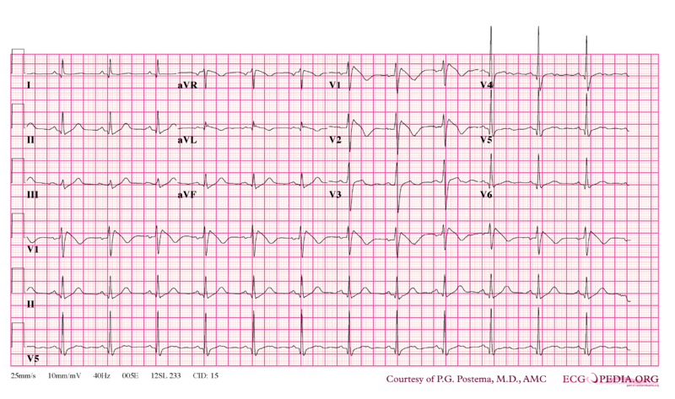
ECG available at http://en.ecgpedia.org/wiki/Main_Page. All ECG are posted and can be used in accordance with the Creative Commons License. Retrieved July 31, 2011.
Learner Stimulus #3

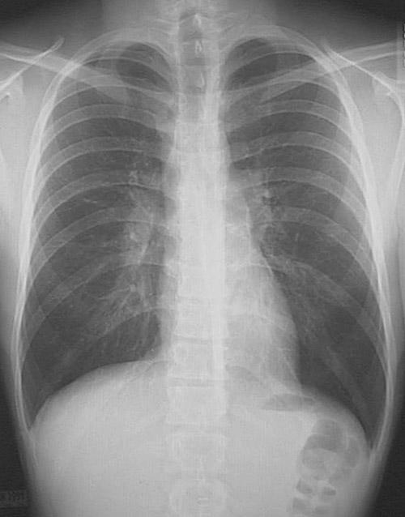

Learner Stimulus #4

CBC
WBC 9,000/mm³
Hgb 14 g/dL
Hct 42 %
Platelets 200 /mm³
Differential
Segs 59%
Lymphs 32%
Monos 7%
Eos 2%
Learner Stimulus #5

Basic Metabolic Profile (BMP)
Na⁺ 145 mEq/L
K⁺ 4.3 mEq/L
CO₂ 24 mEq/L
Cl⁻ 110 mEq/L
Glucose 150 mg/dL
BUN 19 mg/dL
Creatinine 1.0 mg/dL

Learner Stimulus #5

Troponin < 0.01 ng/ml
Learner Stimulus #7

Urine Drug Screen: negative

Feedback/ Assessment Form

Brugada Syndrome

Candidate ________________________ Examiner _________________________

Critical Actions:

- Put patient on cardiac monitor.
- Obtain a 12-lead ECG.
- Identify ECG suggestive of patient having Brugada syndrome.
- Give an antipyretic.
- Obtain immediate cardiology consultation.
- Admit patient to bed with continuous cardiac monitor.

Dangerous Actions: (Performance of one dangerous action results in failure of the case)

- Failure to place patient on cardiac monitor.
- Failure to obtain a 12-lead ECG.
- Discharge patient from the ED.

Overall Score:

- Pass
- Fail

For Examiner

Date: Examiner: Examinee(s):
Scoring: In accordance with the Standardized Direct Observational Tool (SDOT)

The learner should be scored (based on level of training) for each item above with one of the following:
NI = Needs Improvement
ME = Meets Expectations
AE = Above Expectations
NA= Not Assessed

Critical Actions | NI | ME | AE | NA | Category
Place patient on cardiac monitor |  |  |  |  | PC, MK, PBL
Obtain bedside ECG |  |  |  |  | PC, MK
Recognize Brugada Sydrome pattern on EKG |  |  |  |  | PC, MK, PBL
Administer antipyretic |  |  |  |  | PC, MK, PBL
Admit patient to monitored floor |  |  |  |  | PC, MK, PBL
Initiate appropriate consultation with cardiology |  |  |  |  | PC, MK, ICS

The score sheet may be used for a variety of learners. For example, in using the case for 4th year medical students, the key teaching points of the case may be the recognition that all patients with syncope should have an ECG performed. Other items may be marked N/A= not assessed.
Category: One or more of the ACGME Core Competencies as defined in the SDOT

PC= Patient Care
Compassionate, appropriate, and effective for the treatment of health problems and the promotion of health
MK= Medical Knowledge
Residents are expected to formulate an appropriate differential diagnosis with special attention to life-threatening conditions, demonstrate the ability to utilize available medical resources effectively, and apply this knowledge to clinical decision making
PBL= Practice Based Learning & Improvement
Involves investigation and evaluation of their own patient care, appraisal and assimilation of scientific evidence, and improvements in patient care
ICS= Interpersonal Communication Skills
Results in effective information exchange and teaming with patients, their families, and other health professionals
P= Professionalism
Manifested through a commitment to carrying out professional responsibilities, adherence to ethical principles, and sensitivity to a diverse patient population
SBP= Systems Based Practice
Manifested by actions that demonstrate an awareness of and responsiveness to the larger context and system of health care and the ability to effectively call on system resources to provide care that is of optimal value

Debriefing Materials: PowerPoint slides attached.

Keywords for future searching functions: Brugada syndrome, Syncope, Dysrhythmia.

Has this work been previously published? No

Simulation Equipment Checklist

ENVIRONMENT
This scenario requires (checked boxes):
Simulator
Type:
 | Standardized Patient
 |  | Non-Invasive BP Cuff | X |  | ETT
 |  | 2 lead EKG | X |  | LMA
 |  | Pulse Oximeter | X |  | Laryngoscope
 |  | Arterial Line |  |  | Fiberoptic scope
 |  | CVP |  |  | Gum Bougie
 |  | PA Catheter
 |  | Temperature Probe |  |  | Crash Cart
 |  | Capnograph |  |  | Central line set up
 |  | Resp Rate Monitor | X |  | Chest tube set up
 |  |  |  |  | Ultrasound Machine

SP for family member
Additional nurse SP
Other SP
References

Benito, Begona., et al. (2009). Brugada Syndrome. Rev Esp Cardiol. 62(11):1297-315. http://www.revespcardiol.org/cardio/ctl_servlet?_f=40&ident=13145482. Retrieved Nov. 29, 2010.

Dizon, Jose M., et al. (April 2010). Brugada Syndrome. Emedicine.com. http://emedicine.medscape.com/article/163751-overview. Retrieved Nov. 29, 2010.

Postema, P.G. (May 2010). Brugada Syndrome En.ecgpedia.org. http://en.ecgpedia.org/wiki/Brugada_Syndrome. Retrieved Nov. 29, 2010.

