Author: Zachary Sturges, MD Reviewer: Gregory Polites, MD

Case Title: “I just fell over and now it’s hard to breath.”

Target Audience: Emergency medicine residents and medical students and others involved in hospital based acute care medicine

Primary Learning Objectives:
1. Identify characteristic patterns of right heart strain on ECG.
2. Identify massive PE on CTA (or TTE) and explain the complications this particular diagnosis carries.
3. Recognize hemodynamic instability in a patient with massive PE and differentiate the care of this patient from the submassive or hemodynamically stable patient.
4. Initiate anticoagulation and thrombolytic therapy or surgical management for the acutely unstable patient with massive PE.

Secondary Learning Objectives:
1. Communicate risks and benefits of thrombolysis clearly to family
2. State or be able to reference contraindications to thrombolysis for PE
3. Place arterial line and CVC for monitoring/vasoactive medication administration

Critical actions checklist:
- Place 2 large bore IVs, O2 and monitor (<3 minutes).
- ECG (<10 minutes): identify right heart strain pattern
- Identify massive PE on CTA (or TTE if advanced learners) with hemodynamic instability
- Review contraindications/indications to thrombolysis with patient and family
- Administer thrombolytic or initiate surgical management of massive PE (once hemodynamic compromise presents)
6. Consult and admit to ICU

Environment

Room Set Up – ED, in sim lab or in situ
  - Manikin Set Up: Any hi-fidelity manikin with vital signs generator/monitor. No moulage needed. Vital signs monitor will need arterial line input and PA catheter (if placed) input.
    - Lines: CVC and arterial line.
    - Meds: standard ACLS code cart + tPA + heparin + induction agents/paralytics.
  - Props:
    - ECGs (sinus tach and R heart strain patterns)
    - Normal CXR, intubated CXR
    - CT Angio chest showing saddle embolism
    - TTE showing dilated RV with poor RV function (still images or video)
    - Standard ED resuscitation bay equipment including ETT, Ambu bag and mask, suction, OPAs/NPAs.
- Distracters – patient’s husband will be asking for updates and acting as surrogate decision maker if the patient is unable to interact.

Actors (optional)
- Roles – Nurse, husband, intensivist, CT/vascular surgeon.
- Who may play them – anyone may play these roles.
- Action Role – Nurse will perform whatever tasks are required. Husband will be concerned but not overly aggressive and can provide history and act as a decision maker if needed. The intensivist will accept the patient but not until thrombolysis or surgical embolectomy is initiated. The CT/vascular surgeon will agree to perform the embolectomy.
For Examiner Only

Author: Zachary Sturges Reviewer: Gregory Polites, MD

Case Title: “I just fell over and now it’s hard to breath.”

CASE SUMMARY

CORE CONTENT AREA

Pulmonary, Cardiovascular, Hematology

SYNOPSIS OF HISTORY/ Scenario Background
An elderly woman presents with her husband to the ED after she passed out at the mall. Her husband caught her in his arms and she quickly regained consciousness. She was able to walk to the car with some difficulty and noted increasing difficulty with breathing.

Chief Complaint: “I just fell over while we were shopping.”
Past medical history: Breast CA (active), DM2, GERD
Past surgical history: R lumpectomy
Medications: Metformin, omeprazole, naproxen
Allergies: NKDA
Family and social history: Remote tobacco history. Otherwise negative. No history of VTE.

SYNOPSIS OF PHYSICAL
Initial scenario conditions:
Vital signs: BP 120/90 HR 114 RR 34 SpO2 78% RA T 37.9
Physical examination: pale, slightly diaphoretic and tachypneic. No retractions but the patient is sitting up and appears to be straining to breath. Cardiac exam shows some JVD and tachycardia. Lung exam reveals short breaths with some basilar rales.

For Examiner Only

CRITICAL ACTIONS
Scenario branch points/ PLAY OF CASE GUIDELINES

- Critical Action

Place 2 large bore IVs, NRB O2 and cardiac monitor (<2 minutes).

Cueing Guideline: The nurse is concerned about the patient’s oxygen saturation and heart rate.

- Critical Action

ECG (<10 minutes)

Cueing Guideline: The nurse is concerned about the patient’s heart rate and difficulty breathing.

- Critical Action

Identify massive PE on CTA (or TTE if advanced learners) with hemodynamic instability

Cueing Guideline: Nurse asks “is there something on the CT that could explain the patient’s low blood pressure?”

- Critical Action

Review contraindications/indications to thrombolysis with patient and family

Cueing Guideline: Pharmacy will not release thrombolytic until pre-screen checklist is completed.

- Critical Action

Administer thrombolytic or initiate surgical management of massive PE (once hemodynamic compromise presents)

Cueing Guideline: Nurse and or husband ask “is there anything you can give her to make her better?” or “does [the patient] need the clot removed?”

6. Critical Action

Admit to ICU/consult intensivist.

Cueing Guideline: Charge nurse asks where the patient will be admitted.

For Examiner Only

HISTORY

Onset of Symptoms: Syncopal episode 45 minutes PTA. Dyspnea and chest tightness began shortly thereafter while walking to the car.

Background Info: An elderly female arrives with her husband after passing out at the mall. Her husband caught her and she quickly regained conscious. While walking to the car she began noticing increasing difficulty with breathing.

Chief Complaint: “I just fell over while we were shopping”.

Past Medical Hx: Breast CA (active), DM2, GERD

Past Surgical Hx: R lumpectomy.

Medications: Metformin, omeprazole, naproxen.

Allergies: NKDA

Habits: Smoking: remote, none current
ETOH: none
Drugs: none

Family Medical Hx: No significant familial illness.

Social Hx: Marital Status: married, accompanied by husband
Children: 2 boys
Education: college degree
Employment: accountant

ROS: No fevers, chills, headache, cough, history of syncope, PND, orthopnea. No recent surgeries, history of AVMs or intracranial pathology. Positive for chest tightness, dyspnea and unilateral (right) lower extremity edema. Patient recently travelled cross-country by car.

For Examiner Only

PHYSICAL EXAM

Patient Name: Anne Vershow Age & Sex: 64, female

General Appearance: Well-developed, well-nourished female in moderate distress

Vital Signs: 120/90 114 34 78% RA 37.9

Head: NCAT.

Eyes: PERRL. EOMI. Lids/lashes/conjunctiva normal.

Ears: TMs clear bilaterally.

Mouth: Moist without lesions or exudates.

Neck: JVD at 10cm. No adenopathy, thyromegaly. Trachea midline. C spine nontender.

Skin: Cool, diaphoretic. No ecchymoses or rash.

Chest: Nontender, symmetric.

Lungs: Rales in bilateral bases. Tachypneic. No retractions, dullness to percussion.

Heart: Tachycardic. Normal S1/S2 with no evidence of S3 or other murmur. No rubs. Apex not displaced.

Back: Nontender, no step-offs or crepitus. Normal alignment.

Abdomen: Soft, nontender, nondistended. No organomegaly.

Extremities: Normal ROM. No clubbing, cyanosis. 2+ edema in RLE to knee. + PT/DP pulses. CR 3 secs.

Rectal: Guiaic negative. Normal tone.

Pelvic: Normal external genitalia. No CMT, vaginal discharge, vulvar or vaginal lesions.

Neurological: GCS 15. CN 2-12 intact. Normal sensation and motor function in all nerve and muscle groups. Gait normal.

Mental Status: A & O x3

For Examiner Only

STIMULUS INVENTORY

#1 Emergency Admitting Form

#2 CBC

#3 BMP

#4 U/A

#5 ABG

#6 Cardiac Enzymes

#7 Coagulation studies

#8 BNP

#9 ECG and rhythm strip

#10 CXR

#11 CT Angio of chest

#12 TTE images/video clip

#13 Debriefing materials

For Examiner Only

LAB DATA & IMAGING RESULTS

Stimulus #2 Stimulus #3
Complete Blood Count (CBC) Basic Metabolic Panel (BMP)
WBC 12.0 /mm³ Na+ 141 mEq/ml
Hgb 13 g/dL K+ 3.8 mEq/ml
Hct 39 % CO2 23 mEq/ml
Platelets 256 /mm³ Cl- 109 mEq/ml
Differential Glucose 196 mg/dL
Segs 80% BUN 28 mg/dL
Bands 0% Creatinine 1.2 mg/dL
Lymphs 14%
Monos 5%
Eos 1%

Stimulus #4 Stimulus #5
Urinalysis (UA) Arterial Blood Gas (ABG)
Color yellow pH 7.46
Sp gravity 1.010 pCO2 31 mm Hg
Glucose neg pO2 48
Protein neg O2 Sat 80% on RA
Ketone neg
Leuk. Est. neg
Nitrite neg
WBC 0-1
RBC 0-1

Stimulus #6 Stimulus #7
Cardiac Enzymes Coagulation Studies
Troponin 0.3 ng/ml PT 12 secs
PTT 40 secs
INR 1.0

Stimulus #8 Stimulus #9
Brain Natrurietic Peptide (BNP) ECG: right heart strain pattern; inverted t waves inferior leads and V1-3. S1Q3T3.
BNP 597 pg/ml

Stimulus #10 Stimulus #11
Chest Xray (CXR): normal CT Angio chest: large saddle embolus involving both pulmonary arteries

Stimulus #12
Transthoracic echocardiogram (TTE): Dilated RV, RV overload, McConnell’s sign

Learner Stimulus #1

ABEM General Hospital

Emergency Admitting Form

Name: Anne Vershow
Age: 64 years
Sex: Female
Method of Transportation: Private car
Person giving information: Patient, husband
Presenting complaint: Syncopal episode

Background: An elderly female arrives with her husband after passing out at the mall. Her husband caught her and she quickly regained conscious. While walking to the car she began noticing increasing difficulty with breathing.

Triage or Initial Vital Signs
BP: 120/90
P: 114
R: 34
T : 37.9 tympanic

Learner Stimulus #2

Complete Blood Count (CBC)
WBC 12.0 /mm³
Hgb 13 g/dL
Hct 39 %
Platelets 256 /mm³
Differential
Segs 80%
Bands 0%
Lymphs 14%
Monos 5%
Eos 1%

Learner Stimulus #3

Basic Metabolic Profile (BMP)
Na+ 141 mEq/ml
K+ 3.8 mEq/ml
CO2 23 mEq/ml
Cl- 109 mEq/ml
Glucose 196 mg/dL
BUN 28 mg/dL
Creatinine 1.2 mg/dL

Learner Stimulus #4

Urinalysis (UA)
Color yellow
Sp gravity 1.010
Glucose neg
Protein neg
Ketone neg
Leuk. Est. neg
Nitrite neg
WBC 0-1
RBC 0-1

Learner Stimulus #5

Arterial Blood Gas (ABG)
pH 7.46
pCO2 31 mm Hg
pO2 48
O2 Sat 80% on RA

Learner Stimulus #6

Cardiac Enzymes
Troponin 0.3 ng/ml

Learner Stimulus #7

Coagulation Studies
PT 12 secs
PTT 40 secs
INR 1.0

Learner Stimulus #8

Brain Natrurietic Peptide (BNP)
BNP 597 pg/ml

Learner Stimulus #9

Electrocardiogram (ECG)

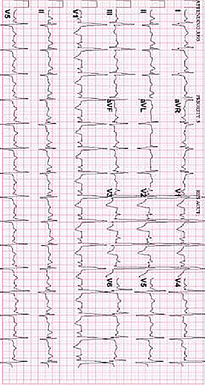

Learner Stimulus #10

Chest Xray (CXR)

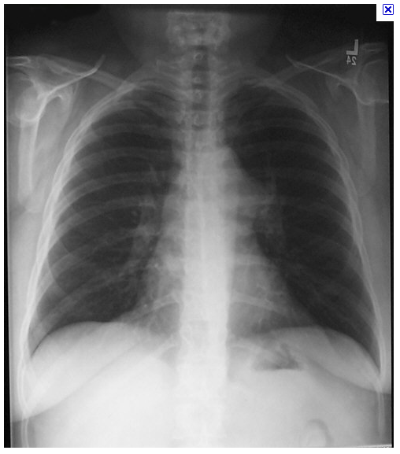

Learner Stimulus #11

CT Angio Chest

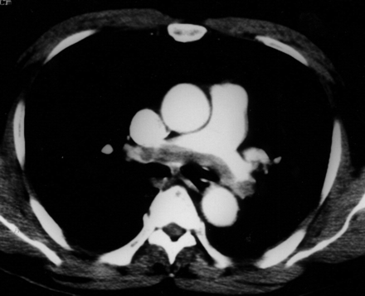

Learner Stimulus #12

Transthoracic echocardiogram (TTE)

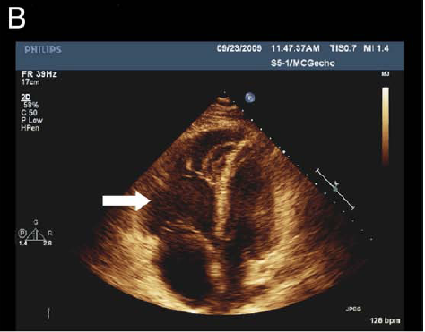

Kanjanauthai, S et al. Saddle pulmonary embolism visualized by transthoracic echocardiography. 2010. Journal of the American College of Cardiology. 56(11): 21.

Video clips available online.

Feedback/ Assessment Form

Saddle Embolism

Candidate ________________________ Examiner _________________________

Critical Actions:

- Place 2 large bore IVs, O2 and monitor (<3 minutes).
- ECG (<10 minutes)
- Identify massive PE on CTA (or TTE if advanced learners) with hemodynamic instability
- Review contraindications/indications to thrombolysis with patient and family
- Administer thrombolytic or initiate surgical management of massive PE (once hemodynamic compromise presents)
- Consult and admit to ICU

Dangerous Actions: (Performance of one dangerous action results in failure of the case)

- Administering thrombolytics without reviewing contraindications for doing so.
- Failure to heparinize the patient.
- Admitting the patient to a non-ICU bed

Overall Score:

- Pass
- Fail

For Examiner

Date: Examiner: Examinee(s):
Scoring: In accordance with the Standardized Direct Observational Tool (SDOT)

The learner should be scored (based on level of training) for each item above with one of the following:
NI = Needs Improvement
ME = Meets Expectations
AE = Above Expectations
NA= Not Assessed

Critical Actions | NI | ME | AE | NA | Category
Place patient on cardiac monitor with pulse oximetry |  |  |  |  | PC, MK, PBL
Supply supplemental oxygen to correct hypoxemia |  |  |  |  | PC, MK, PBL
Obtain bedside ECG and recognize right heart strain pattern |  |  |  |  | PC, MK, PBL
Identify pulmonary embolism on CTA |  |  |  |  | PC, MK, PBL
Identify right heart dilation, right heart failure on TTE (advanced learners only) |  |  |  |  | PC, MK, PBL
Fluid boluses for hypotension |  |  |  |  | PC, MK, PBL
Recognize hemodynamic instability as indication for thrombolytics in acute PE |  |  |  |  | PC, MK, PBL
Recite or reference contraindications to thrombolytic administration |  |  |  |  | PC, MK, PBL
Admit patient to intensive care unit or OR for embolectomy |  |  |  |  | P, PC, MK, ICS, SBP
Demonstrate / utilize effective communication techniques in communicating risks/benefits of thrombolysis to patient and family. |  |  |  |  | P, MK, ICS

The score sheet may be used for a variety of learners. For example, in using the case for 4th year medical students, the key teaching points of the case may be the recognition of shock and treatment with appropriate fluid resuscitation. Other items may be marked N/A= not assessed.

Category: One or more of the ACGME Core Competencies as defined in the SDOT

PC= Patient Care
Compassionate, appropriate, and effective for the treatment of health problems and the promotion of health
MK= Medical Knowledge
Residents are expected to formulate an appropriate differential diagnosis with special attention to life-threatening conditions, demonstrate the ability to utilize available medical resources effectively, and apply this knowledge to clinical decision making
PBL= Practice Based Learning & Improvement
Involves investigation and evaluation of their own patient care, appraisal and assimilation of scientific evidence, and improvements in patient care
ICS= Interpersonal Communication Skills
Results in effective information exchange and teaming with patients, their families, and other health professionals
P= Professionalism
Manifested through a commitment to carrying out professional responsibilities, adherence to ethical principles, and sensitivity to a diverse patient population
SBP= Systems Based Practice
Manifested by actions that demonstrate an awareness of and responsiveness to the larger context and system of health care and the ability to effectively call on system resources to provide care that is of optimal value

Keywords for future searching functions:
Saddle embolism, massive pulmonary embolism, thrombolysis, hemodynamic instability.

References
1. Kucher N, Rossi E, De Rosa M and Goldhaber SZ. (2006) Massive pulmonary embolism. Circulation 113: 577-582.
2. Kearon C, Kahn SR, Agnelli G, et al. (2008) Antithrombotic therapy for venous thromboembolic disease. Chest 133(suppl):454S–545S.
3. Todd, JL and Tapson, VF. (2009) Thrombolytic therapy for acute pulmonary embolism: a critical appraisal. Chest 135: 1321-1329.
4. Jenkins PO, Sultanzadeh J, Bhagwat M and Jenkins PF. (2009) Should thrombolyis have a greater role in the management of pulmonary embolism? Clinical Medicine 9(5): 431-435.
5. Meneveau N et al. (2006) Management of unsuccessful thrombolysis in acute massive pulmonary embolism. Chest 129: 1043-1050.
6. Samoukovic G, Malas T and de Varennes B. (2010) The role of embolectomy in the treatment of acute pulmonary embolism: a literature review from 1968 to 2008. Interact CardioVasc Surg 11: 265-270.

Has this work been previously published?
No

Intubation may be considered at any point for expected clinical course. Husband will act as surrogate decision maker. Intubation will be uncomplicated assuming standard RSI technique.
Patient will continue to have hypotension and tachycardia/V-tach after intubation.

ENVIRONMENT
This scenario requires (checked boxes):
Simulator
Type: any hi-fi
 | Standardized Patient
x |  | Non-Invasive BP Cuff |  |  | ETT | x
x |  | 2 lead EKG |  |  | LMA
x |  | Pulse Oximeter |  |  | Laryngoscope | x
x |  | Arterial Line |  |  | Fiberoptic scope
 |  | CVP |  |  | Gum Bougie
x |  | PA Catheter
 |  | Temperature Probe |  |  | Crash Cart | x
 |  | Capnograph |  |  | Central line set up | x
x |  | Resp Rate Monitor |  |  | Chest tube set up
 |  |  |  |  | Ultrasound Machine | x

x | SP for family member
x | Additional nurse SP
 | Other SP

